Exporting BB grades to an MS Excel File on your Windows computer
Updated 12/7/2011
- In the BB course open the “Full Grade Center”
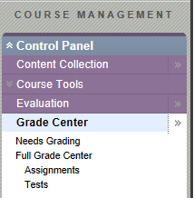
- Hover the mouse over the “Work Offline” button and select “Download”
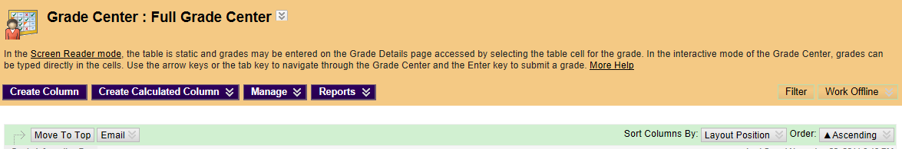
- Use the default options and click “Submit”
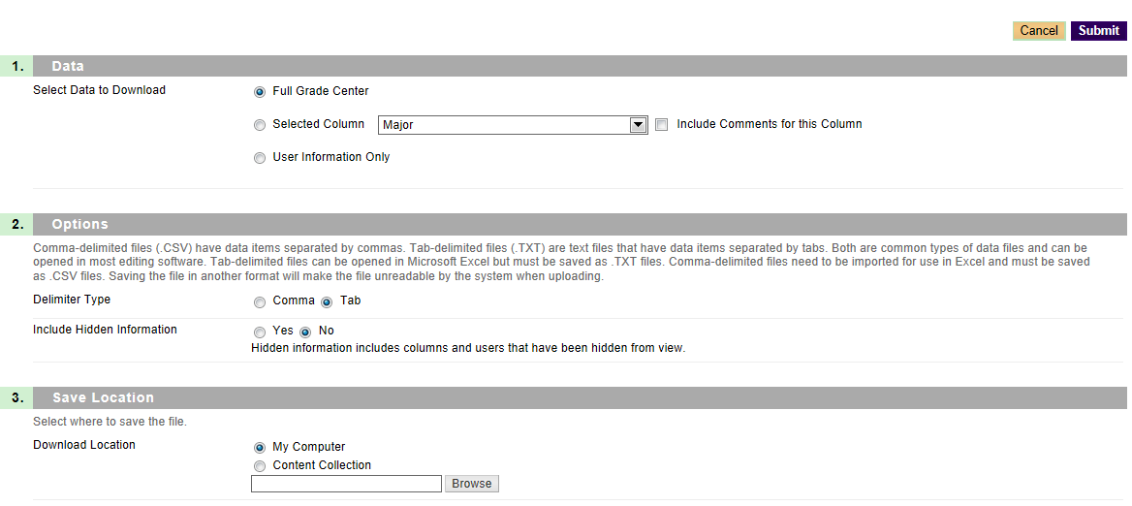
- It is now saved as file in BB, you need to copy to your computer. Click the “Download” button.
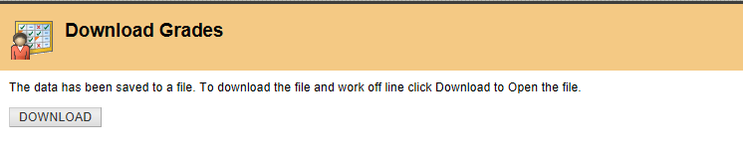
- Us the down arrow to select “Save As”
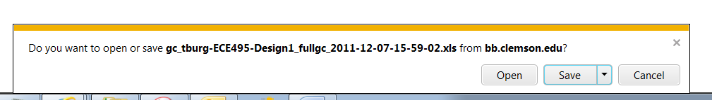
- Select a location on your computer
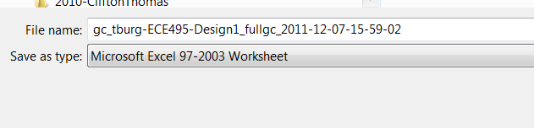
- Open the file and you get the following message box. Click “Yes”. (In Windows you can probably just double-click the file name in the file explorer as it is associated with Excel) 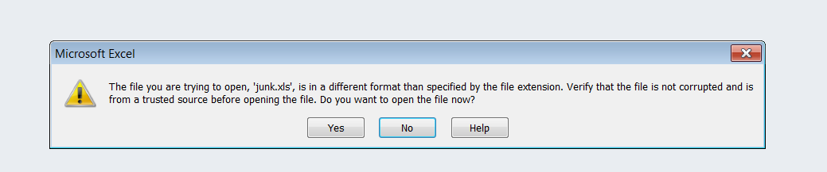
- Within Excel, save as an “Excel Workbook”
