Environmental Engineering
and Earth Sciences

EEES Department Seminar

The Essential Expansion of
Environmental Engineering and Science
Education

Dr. Perry McCarty
Silas H. Palmer Professor Emeritus
Stanford University

For the first seminar of the Spring 2022 seminar, we will watch a recording of Dr. Perry McCarty’s talk from the iFAST Environmental Biotechnology seminar organized by the Institute for Environmental Genomics at the University of Oklahoma to celebrate his 90th birthday and honor his outstanding contributions to environmental biotechnology. The recording will be preceded by some words from Dr. Sudeep Popat and Dr. David Freedman, who will share a history of Dr. Perry McCarty’s contributions to the field of environmental engineering.
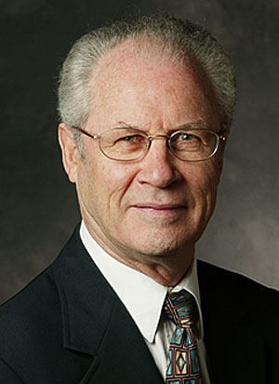
Dr. McCarty is the Silas H. Palmer Professor Emeritus at Stanford University. He joined Stanford in 1962 to develop the environmental engineering and science program. From 1980 to 1985 he was Chairman of Stanford's Department of Civil and Environmental Engineering, and from 1989 to 2002 served as Director of the Western Region Hazardous Substance Research Center. He has a B.S. Degree in civil engineering from Wayne State University (1953), and M.S. (1957) and Sc.D. (1959) degrees in sanitary engineering from M.I.T.

The focus of Dr. McCarty’s research and teaching has been on water with a primary interest in biological processes for the control of environmental contaminants. His early research was on anaerobic treatment processes, biological processes for nitrogen removal, and water reuse. Current interests are on aerobic and anaerobic biological processes for treatment of domestic wastewaters, and movement, fate, and control of groundwater contaminants. He has hundreds of publications and is co-author of the textbooks, Chemistry for Environmental Engineering and Science, and Environmental Biotechnology - Principles and Applications.
He was elected to membership in the National Academy of Engineering in 1977 and the American Academy of Arts and Sciences in 1996. He received the John and Alice Tyler Prize for Environmental Achievement in 1992, the Athalie Richardson Irvine Clarke Prize for Outstanding Achievements in Water Science and Technology in 1997, and the Stockholm Water Prize in 2007.

2:30 PM
Friday, January 14, 2021

This seminar will be online-only
https://clemson.zoom.us/j/5783910968

Attendance is mandatory for graduate students enrolled in EES 8610, EES 9610, and GEOL 8510.

