Environmental Engineering
and Earth Sciences

EEES Department Seminar

Drinking Water Treatment Using Reverse Osmosis: A Case Study

David Bennett, PE
Project Engineer
Wooten, Raleigh, NC

Brunswick Regional H2GO, a regional water authority, was purchasing potable water from a neighboring public utility to supply its customers. Based on increasing demand in their service area, H2GO made the decision to investigate future water supply options. Three options were considered to meet future potable water demand: 1) do nothing, continue to purchase water from the neighboring utility; 2) construct a traditional surface water treatment plant; 3) tap into a new brackish groundwater source and construct a new reverse osmosis (RO) water treatment plant. Based on an evaluation considering source water availability and vulnerabilities, future growth potential, and types of treatment required, H2GO chose to construct a new supply well network, and new RO treatment plant and raw and treated water transmission mains. The design of the RO plant required evaluating the aquifers underlying the service area to determine which were capable of producing adequate water supply and that were isolated from potential contaminant sources. Two deep groundwater sources (PeeDee at 350 ft bgs and Black Creek at 550 ft bgs) were selected for use as water supply for the new RO plant. Each of the five water supply sites has two nested wells, one in each aquifer. The RO plant design capacity is 6 MGD expandable to 8 MGD to allow for future growth. This talk will examine the design challenges and opportunities encountered during the study, evaluation, and design of the RO treatment plant.

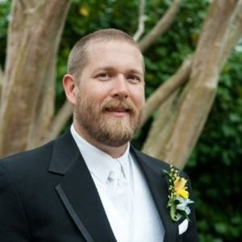
About the Speaker:
David graduated from Clemson University in 2002 with a degree in Chemical Engineering. He returned briefly to the EE&ES department and worked with Jim Castle on constructed wetlands for wastewater treatment. David began his professional career at the Savannah River Site in 2007 working on soil and groundwater remediation at radioactivity contaminated sites. David continued working on soil and groundwater remediation in Houston, TX where he began to transition to water and wastewater treatment design. He currently works in Raleigh, NC for the The Wooten Company where he is a project manager.

2:30 PM
Friday, February 3, 2023
Brackett Hall 100
Attendance is mandatory for graduate students enrolled in EES 8610, EES 9610, and GEOL 8510.

