Environmental Engineering
and Earth Sciences

EEES Department Seminar

The Earth System through the Lens of Geochronology

Professor David L. Barbeau, Jr.
School of the Earth, Ocean, and Environment
University of South Carolina

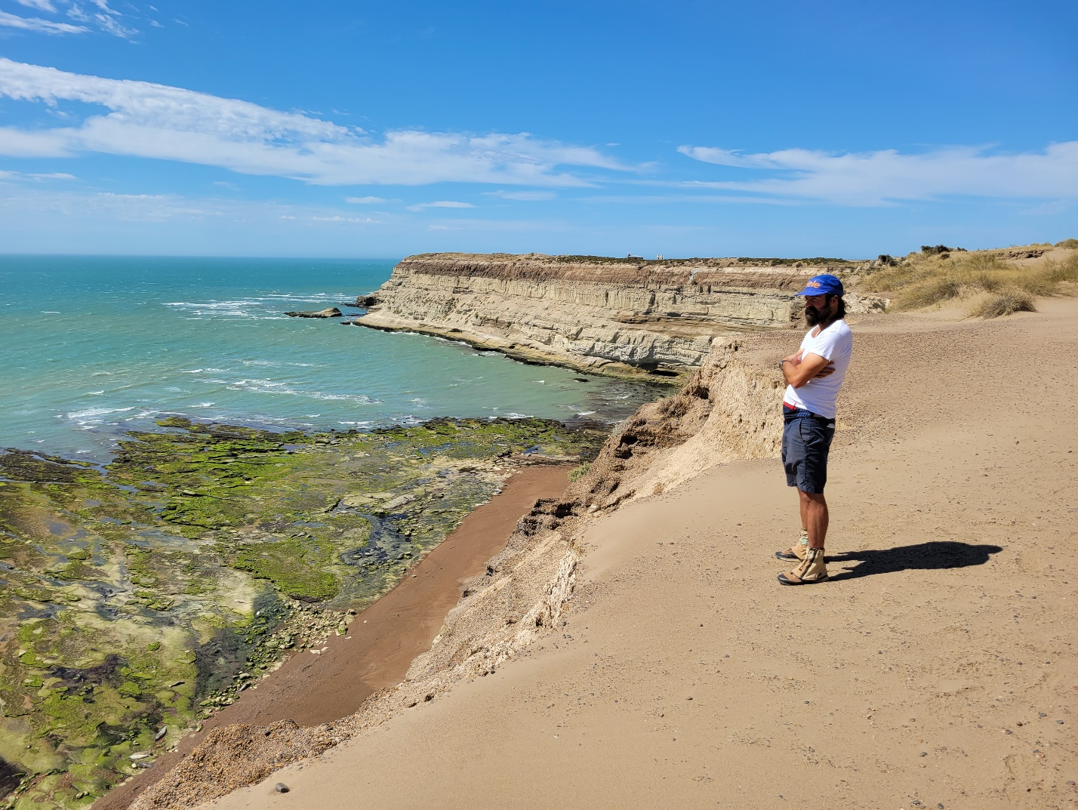

For centuries, humans have recognized the interconnectedness of different realms or ‘spheres’ of Earth. As analytical methods advance and datasets grow, the details and expanses of these interconnections become increasingly clear, and fascinating. In this talk, I explore ways that the radiometric dating of minerals and rocks can provide critical insight into fundamental Earth system processes. Drawing on geochronologic data collected from bedrock and detrital sediments from the Americas and Antarctica, I examine how such approaches can elucidate interconnections between the geosphere, biosphere, hydrosphere, cryosphere, atmosphere and anthroposphere.

2:30 PM
Friday, February 10, 2023
Brackett Hall 100
Attendance is mandatory for graduate students enrolled in EES 8610, EES 9610, and GEOL 8510.
Refreshments after seminar.

