Environmental Engineering
and Earth Sciences

EEES Department Seminar

A Framework for Research on Recurrent Acute Disasters

Dr. Gary Machlis
University Professor of Environmental Sustainability
Clemson University

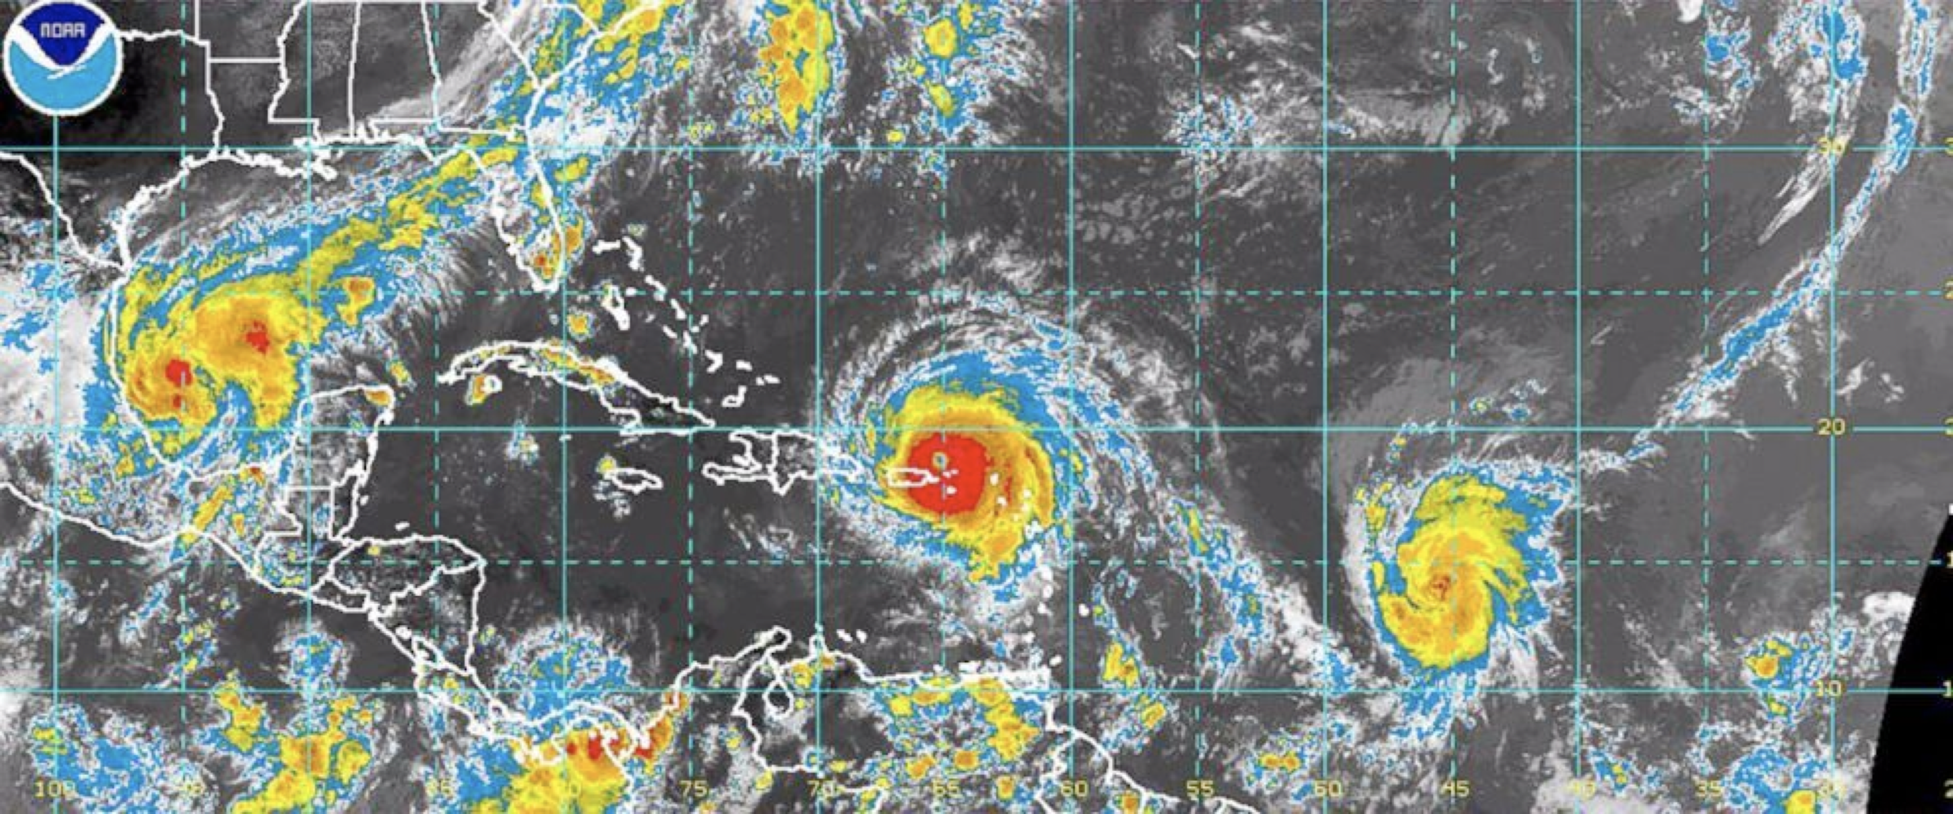

Disaster science examines the causes, behaviors, and consequences of hazardous events, from hurricanes to wildfires, flooding, and major industrial accidents. Individual disasters are recurring more frequently and with greater intensity. Recurrent acute disasters (RADs) are sequential disasters that affect a specific locale over time. While disaster science has matured in recent years, understanding of the distinctive characteristics of RADs varies by discipline and lacks predictive power. A theoretical framework is presented by borrowing in part from the social sciences, mathematical topology, and disturbance ecology. A key variable is the complex characteristics of legacy conditions created by one disaster that influence the effects of subsequent disasters. Substantial improvements in disaster response, recovery, and preparedness can be gained by adopting a RAD-based approach.

About the Speaker

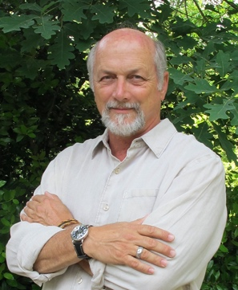 | Dr. Gary Machlis is University Professor of Environmental Sustainability at Clemson University. Prior to joining the Clemson faculty, he served both terms of the Obama administration as Science Advisor to the Director of the National Park Service and co-led the Secretary of the Interior's Strategic Sciences Group. His research focuses on science policy, sustainability, and disaster science. His next book, Sustainability for the Forgotten, will be published in late 2023. He is an elected Fellow of the American Association for the Advancement of Science, and serves on the National Academies of Sciences, Engineering, and Medicine's Board on Environmental Change and Society.

2:30 PM
Friday, February 17, 2023
Brackett Hall 100
Attendance is mandatory for graduate students enrolled in EES 8610, EES 9610, and GEOL 8610.
Refreshments after seminar.

