Environmental Engineering
and Earth Sciences

EEES Department Seminar

Electric Utility: Groundwater Protection and Legacy Remediation

Tyler Hardin, P.E.
Carolinas Waste and Groundwater Programs Manager
Duke Energy, Charlotte, NC

Everyone uses electricity in their daily lives and relies on power being available at the click of a button or flip of a switch; but how is electricity generated, and what happens to waste products from energy generation? In the early 1900s, coal was first used to generate power for factories and homes. When coal is burned, a waste called coal ash is produced. Coal ash was historically wet, sluiced, and stored in ash basins; now, it is handled dry and stored in lined landfills. As part of evolving federal and state environmental regulations, utilities nationwide are implementing more robust groundwater monitoring networks and remedial systems to address impacts from historic ash basins. In North Carolina, the Coal Ash Management Act (CAMA) started large-scale groundwater investigations, assessments, and corrective action at 14 coal-fired power plants in 2015. This presentation will focus on professional experience with an electric utility from an environmental perspective, the evolving regulations and groundwater investigations for coal ash, and groundwater remedial efforts in North Carolina.

About the speaker:

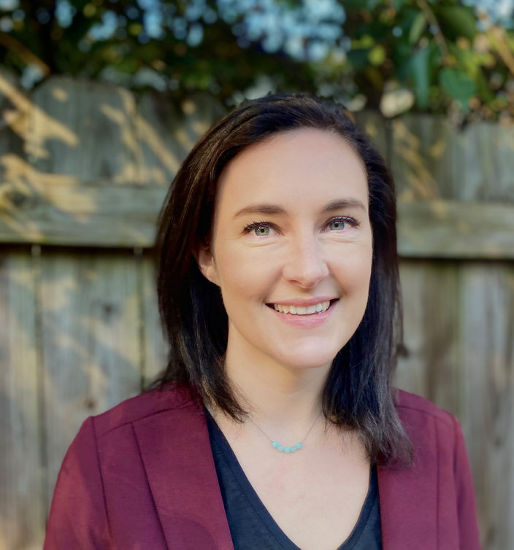
Tyler Hardin is a Licensed Professional Engineer with 7+ years of experience in environmental compliance, environmental engineering, landfill permitting, and negotiating with regulatory agencies. She has experience managing a team and working with external and internal stakeholders on large projects involving groundwater investigations and remedial planning. She has directed consultants and managed the Comprehensive Site Assessment and Corrective Action Plans at Marshall Steam Station. She has led numerous negotiations with regulatory agencies, including the investigation of groundwater and soil and remedial plans for South Carolina ash basins. She leads the Federal Coal Combustion Residuals (CCR) Groundwater Program for Duke Energy.

2:30 PM
Friday, March 10, 2023
Brackett Hall 100
Attendance is mandatory for graduate students enrolled in EES 8610, EES 9610, and GEOL 8610.
Refreshments after seminar.

