Environmental Engineering
and Earth Sciences

EEES Department Seminar

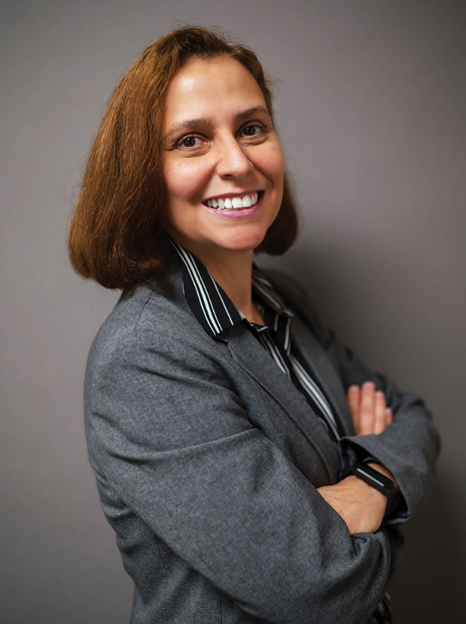

Research Overview and EEES Vision: Professor Debora Frigi Rodrigues

Ezekiel Cullen Professor
Civil and Environmental Engineering Department
Cullen College of Engineering,
University of Houston

Houston, TX

About Professor Rodrigues:
Professor Rodrigues is the Ezekiel Cullen Professor in the Civil and Environmental Engineering Department in the Cullen College of Engineering at the University of Houston and the President of the Association of Environmental Engineering and Science Professors.

Professor Rodrigues has a BS in Biology and Biology Education, University of São Paulo, Brazil; M.S. in Sciences, Microbiology, University of São Paulo, Brazil; and a Ph.D. in Microbiology and Molecular Genetics, Michigan State University. While at Michigan State University, Professor Rodrigues received the Marvis A. Richardson Fellowship (2006) awarded for quality of research and contributions to the department. Following her Ph.D., Professor Rodrigues was a post-doctoral researcher under Professor Elimelech in Environmental and Chemical Engineering at Yale University.

Professor Rodrigues secured over $7.6 million (her share only) and currently has approximately $3.3 million in active grants (her share) which has resulted in more than 110 publications.

Professor Rodrigues will present an overview of her research along with her vision for the EEES Department within the School of Civil and Environmental Engineering and Earth Sciences.

11:05 PM
Friday, April 5, 2024
Rich Lab Auditorium
Attendance is strongly encouraged for graduate students enrolled in
EES 8610, EES 9610, and GEOL 8610.

