Environmental Engineering
and Earth Sciences

EEES Department Seminar

Microwave Reactivation of PFAS-Laden GACs

Tanju Karanfil
Professor, EEES
Vice President of Research
Clemson University

Adsorption by granular activated carbon (GAC) is one of the most common methods for removing per- and polyfluoroalkyl substances (PFAS) from water. However, there is a need for GAC regeneration methods that are faster and more energy efficient. This talk will introduce the use of microwave (MW) technology as an alternative method of GAC regeneration, and focus on research to: (1) explore the effectiveness of MW heating compared to existing thermal processes, (2) investigate the effects of multi-cycle MW treatment on GAC characteristics and PFAS defluorination, (3) evaluate MW technology for regeneration of GAC samples collected from full-scale treatment systems, and (4) conduct cost and feasibility assessments.

About the speaker:

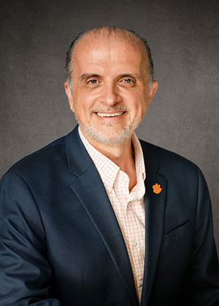
Dr. Karanfil is the Vice President for Research and a Professor of Environmental Engineering and Earth Sciences at Clemson University. He is a registered professional engineer in the State of South Carolina, a Board-Certified Environment Engineer by American Academy of Environmental Engineers, and a Fellow of International Water Association. Professor Karanfil received his bachelor’s degree in environmental engineering from Istanbul Technical University in Turkey in 1988. He completed his graduate work (M.Sc., 1991, Ph.D., 1995, Post-doc., 1996) at the University of Michigan in Environmental Engineering under the supervision of Professor Walter J. Weber, Jr., a member of National Academy of Engineering. Professor Karanfil has been an Environmental Engineering and Earth Sciences faculty as an instructor (1996-1998), Assistant Professor (1998-2002), Associate Professor (2002-2006), and Professor (2006-present). He served as the Department Chair of Environmental Engineering and Earth Sciences (2008-2014) and the Associate Dean for Research and Graduate Studies in the College of Engineering and Science (2014-2016). Since February 2016, he is the Vice President for Research of Clemson University. He also serves as a consultant to water and wastewater utilities and consulting companies.

2:30 PM
Friday, April 7, 2023
Rich Lab Auditorium
Note the change in venue.
Attendance is mandatory for graduate students enrolled in EES 8610, EES 9610, and GEOL 8510.
Refreshments after seminar.

