Environmental Engineering
and Earth Sciences

EEES Department Seminar

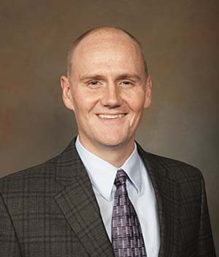

Research Overview and EEES Vision: Professor David Ladner

Professor
Environmental Engineering and Earth Sciences
School of Civil and Environmental Engineering and Earth Sciences
Clemson University

Clemson, SC

About Professor Ladner:
Dr. Ladner is a Professor in the Environmental Engineering and Earth Sciences Department in the School of Civil and Environmental Engineering and Earth Sciences at Clemson University. Professor Ladner is a registered professional engineer.

Professor Ladner has a BS in Environmental Engineering, New Mexico Institute of Mining and Technology; and a M.S. and Ph.D. in Environmental Engineering, University of Illinois at Urbana-Champaign. Following his Ph.D., Professor Ladner was a Postdoctoral Researcher Associate under Professor Paul Westerhoff in School of Sustainable Engineering and The Built Environment at Arizona State University.

Professor Ladner has gained a national reputation, especially through his service to
the Association of Environmental Engineering and Science Professors (AEESP) and the American Water Works Association (AWWA). Professor Ladner has gained an international reputation as Principal Investigator of a National Science Foundation (NSF) Partnerships for International Research and Education (PIRE) project.

Professor Ladner will present an overview of his research along with his vision for the EEES Department within the School of Civil and Environmental Engineering and Earth Sciences.

10:30 AM
Tuesday, April 9, 2024
Rich Lab Auditorium
Attendance is strongly encouraged for graduate students enrolled in
EES 8610, EES 9610, and GEOL 8610.

