0
Environmental Engineering
and Earth Sciences
EEES Department Seminar

“welcome Seminar”

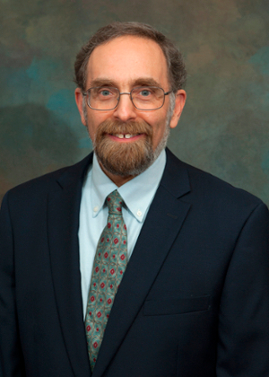

Presented By
Dr. David L. Freedman, Ph.D.
Professor and Chair

2:30 PM

Friday, August 20, 2021

Rich Lab Auditorium
Picnic following Seminar

