0
Environmental Engineering
and Earth Sciences
EEES Department Seminar

“welcome Seminar”

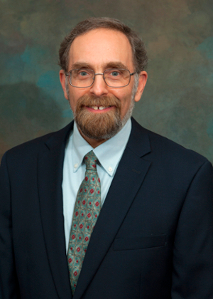

Presented By
Dr. David L. Freedman, Ph.D.
Professor and Chair

2:30 PM

Friday, August 26, 2022

Rich Lab Auditorium

A department photo and picnic will follow the seminar.

“Attendance is mandatory for graduate students enrolled in
EES 8610, EES 9610, and GEOL 8510.”

