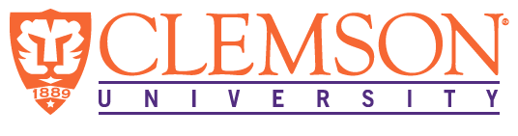
Environmental Engineering
and Earth Sciences

EEES Department Seminar
AAEES Kappe Lecture

Converting Waste Into Resources: Environmental Challenges and Sustainable Solutions

Wendy Wert, P.E., BCEE
Los Angeles County Sanitation Districts

Water scarcity, population growth, and aging infrastructure are impacting water security around the world. Experiencing severe drought during the COVID-19 pandemic, California faces all of these challenges. Utilities must not “waste” resources, rather environmental engineers and scientists are challenged to imagine, research, design, and build a better future. One agency, the Sanitation Districts of Los Angeles County (Sanitation Districts), are fortunate to manage several historical “waste” streams including: sewage, trash, and stormwater. Come discover the synergies among these sources that help amplify resource recovery, thereby, contributing to sustainable regional solutions in Southern California. Annually, the Sanitation Districts of Los Angeles County (Sanitation Districts) turn wastewater trash, and stormwater into:
- 49 Billion Gallons of Recycled Water
- 77 Megawatts of Electricity
- 177,000 Tons of Recycled Commodities
- 145,000 Tons of Compost

About Wendy Wert:
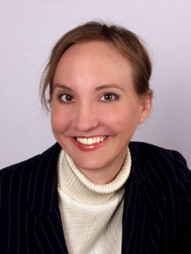
Wendy is a Board-Certified Environmental Engineer with the Los Angeles County Sanitation Districts. For the past 21 years, she has been working on programs that rely on public participation to integrate water supply, water reuse wastewater facilities planning. She received a B.S in environmental engineering and an M.S. in water resources engineering from the University of Central Florida (UCF).
Her studies gave her opportunities to collaborate with others. It was during this time that Wendy developed an interest in effectively communicating math and science to diverse groups.

Today, she uses her position as an engineer to support outreach and education programs that explain how the work of the Sanitation Districts identifies community needs and then applies engineering and scientific principles to meet them. Wendy is an award-winning transformative leader anchored in integration, innovation, and inclusion.

2:30 PM
Friday, September 16, 2022
Rich Laboratory Auditorium
Attendance is mandatory for graduate students enrolled in EES 8610, EES 9610, and GEOL 8610.
Refreshments after the seminar.

