Environmental Engineering
and Earth Sciences

EEES Department Seminar

Engineering Challenges of Difficult Environments:
There is a Treatment Plant in Charleston Harbor

Jared Hartwig
Colby Cash

The Plum Island Water Pollution Control Plant sits in Charleston Harbor and treats the wastewater for the city of Charleston, West Ashley, and James, Johns, and Folly Islands. Hazen and Sawyer was commissioned to design the Phase 3 and Phase 4 capital improvements projects at the site and will share design challenges and solutions for such a unique environment.

About Jared Hartwig:
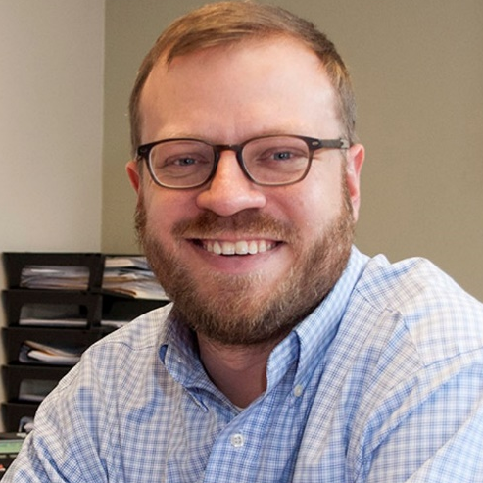
Jared graduated from Clemson in 2008 and specializes in the planning and design of water and wastewater treatment facilities and sanitary sewer force mains, gravity lines, and pump stations. His experience also includes hydraulic analysis, preliminary treatment facility design, solids handling facilities, and construction administration. He currently serves as the Corporate lead for Preliminary Treatment.

About Colby Cash:

Colby graduated from Clemson in 2014 (and 2019, and hopefully again in 2025?) and specializes in the process mechanical design of wastewater treatment plants and pump stations. His experience also includes hydraulic modeling, clarifier design, and disinfection facility design.

2:30 PM
Friday, September 30, 2022
Rich Lab Auditorium
Attendance is mandatory for graduate students enrolled in EES 8610, EES 9610, and GEOL 8610.
Refreshments following the seminar.

