Environmental Engineering
and Earth Sciences

EEES Department Seminar

“research in decision making and education for sustainability”
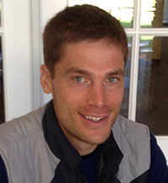

PRESENTED BY
Leidy E. Klotz, Ph.D.
Associate Professor, Civil Engineering

Bio: Leidy Klotz is a civil engineering faculty member at Clemson University, where he does research on decision making and education for sustainability, in particular how sustainability topics can empower new types of students to major and persist in engineering. He developed and teaches courses in Sustainable Construction, Sustainable Restoration, and Sustainable Energy Innovation. Before becoming an academic, Leidy worked managing some pretty unsustainable school construction projects in New Jersey and before that he played for the Pittsburgh Riverhounds professional soccer team. He lives with his wife, Monica and 15-month-old son Ezra, and the majority of their climate-changing emissions come from traveling to see family oar the beach.

Abstract: Through stories of the Ph.D. students who do most of the heavy-lifting, I will discuss my research on decision-making and education for sustainability in engineering. Topics covered will include: engineering design processes to produce sustainable solutions; decision influences on engineers designing for sustainability; teaching approaches for sustainability in engineering; and sustainability topics as a route to recruit underrepresented groups to engineering. By the end of this presentation, I hope to have communicated enough about what I am working on that attendees can give me more ideas. With any luck, this presentation may even spark collaboration.

2:30 PM

Friday, January 22, 2016 201 Kinard Hall
Refreshments following Seminar

