Environmental Engineering
and Earth Sciences

EEES Department Seminar

“co₂ from the nuclear fuel cycle”

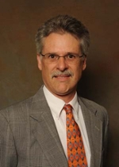
PRESENTED BY

Dr. Timothy DeVol, CHP
Toshiba Professor of Nuclear Engineering

Abstract: With the monumental agreements made at the COP21 conference in Paris six weeks ago, this seminar will present to you some of the facts about Nuclear Power. Specifically the interest is in conveying the several important aspects of nuclear power production and how CO₂ emissions from nuclear power stack up to other sources of electrical energy production. Following a brief introduction to rising CO₂ concentrations a rising global temperatures, the rest of the presentation will focus on how nuclear power stacks up to other electrical energy sources.

2:30 PM

Friday, January 29, 2016
201 Kinard Hall
Refreshments following Seminar

