Environmental Engineering
and Earth Sciences
EEES Department Seminar

“International Opportunities for Environmental Professionals: Case Study in Brazil”

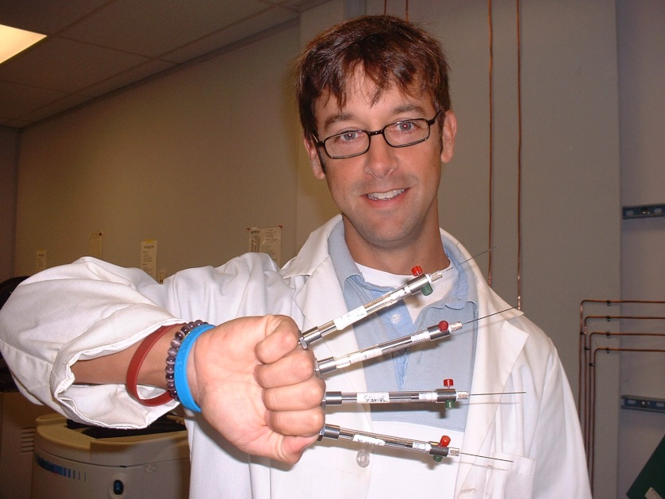

Presented By
Dr. James Henderson
Project Director
DuPont Corporate Remediation Group in Latin America

Biography: Dr. James Henderson is the Project Director for the DuPont Corporate Remediation Group in Latin America. Dr. Henderson earned his bachelor's degree in Spanish from Dickinson College in Carlisle, PA, his Master's degree in Environmental Studies from California State University and his Doctorate degree in Environmental Engineering and Science from Clemson University. Dr. Henderson taught English as a second language in Bogotá, Colombia, and worked with an international environmental consulting firm and the USEPA prior to joining DuPont. He currently leads all of DuPont's site characterization and remediation efforts in Latin America, as well as strategic research programs to address contamination issues for DuPont properties in the region.
2:30 PM

Friday, April 1, 2016
201 Kinard Hall
Refreshments following Seminar

