Environmental Engineering
and Earth Sciences
EEES Department Seminar

“life cycle assessment: viewing industrial processes and products with a system lens”

Presented By
Mary Ann Curran, Ph.D.
LCA & Sustainability Consulting
Rock Hill, SC 29730

Abstract: Dr. Curran is an internationally-recognized expert in Life Cycle Assessment (LCA) and Editor-in-Chief of the International Journal of Life Cycle Assessment (Springer). Since 1990, she has been a major contributor to LCA methodology development and practice both through her early pioneering work and later by participating in workgroups and development of the standards that all LCA studies now follow. Through years of research, networking, and publishing, she developed an in-depth knowledge of the field and created an extensive network of LCA researchers and practitioners world-wide. Before retiring from the US EPA in late 2012, Dr. Curran’s research activities included the development of LCA methodology, the performance and review of life-cycle case studies, planning life-cycle workshops and conferences, and the development of a life cycle data and resources. She now offers her knowledge and experience as an independent consultant. Dr. Curran has authored and co-authored numerous papers and book chapters which address the LCA concept and its applications. She has presented LCA-related talks at technical meetings across the US and in Europe, South America, South Africa, Asia, and Australia. Dr. Curran is a Fellow of the American Institute for Chemical Engineers.
Environmental management strategies have evolved through the development of laws and regulations that limit pollutant releases to the environment. Since its inception in 1970, the US Environmental Protection Agency has made important progress toward improving the environment in every major category of environmental impact caused by pollutant releases. However, despite the combined achievements of the federal government, States and industry in controlling waste emissions which have resulted in a healthier environment, the further improvement of the environment has slowed. In some cases, there is evidence of increasing impact, such as global climate change. Furthermore, over the years, the instances in which one problem was solved but caused another are numerous. Compact fluorescent bulbs reduce electricity consumption by 75% but come with a dash of mercury. Biobased fuels reduce greenhouse gas emissions but contribute to air, water and soil quality impacts in the agricultural stage.
It has become increasingly evident that we must look holistically at our actions in order to more effectively protect human health and the environment in the short and long-term and to, therefore, contribute to the development of more sustainable societies. This expanded view of interactions between human activity and the environment is prompting environmental managers and policy makers to look at products and services from cradle to grave.
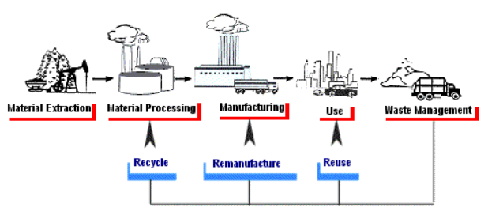

Life Cycle Assessment (LCA) is a standardized approach that helps decision makers identify the potential transfer of environmental impacts from one medium to another (e.g., eliminating air emissions by creating a wastewater effluent instead) and/or from one life cycle stage to another (e.g., from use and reuse of the product to the raw material acquisition stage). Through broad system boundaries, LCA can help decision-makers select the product or process that causes the least impact to the environment. What started as an approach to compare the environmental goodness (greenness) of products has developed into a standardized method for providing a sound scientific basis for environmental sustainability in industry and government

Friday, March 17, 2017 2:30 PM Hardin Hall
Refreshments following Seminar

