EEES Departmental Seminar

Spring 2019 Seminar Series

San Diego (CA) North City Water Reclamation Facility
Integrated Dynamic Modeling

Thomas Johnson, PE
Jacobs
Charlotte, NC

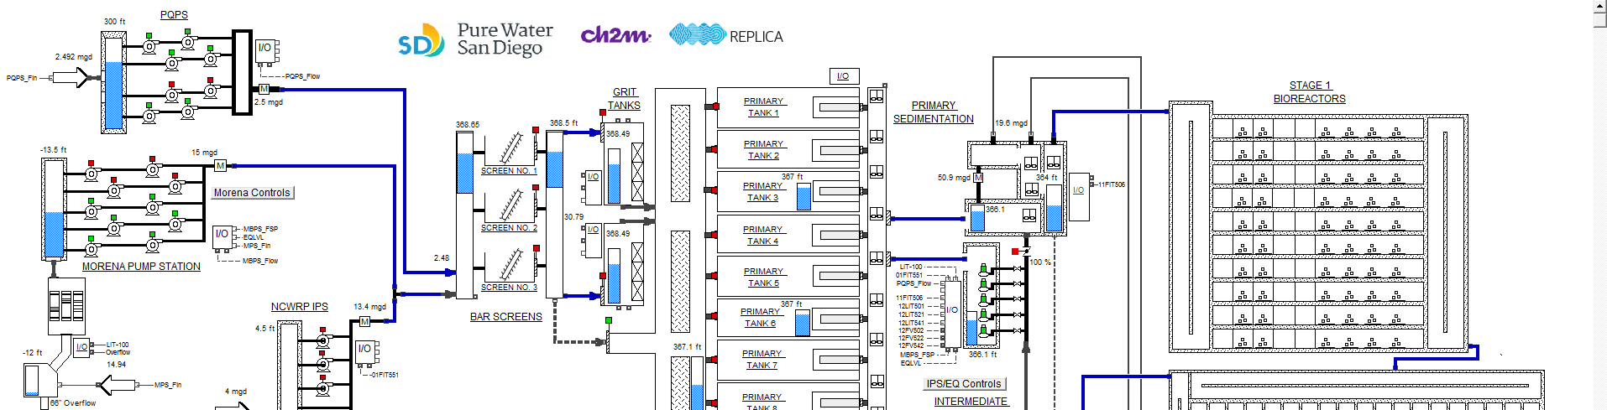
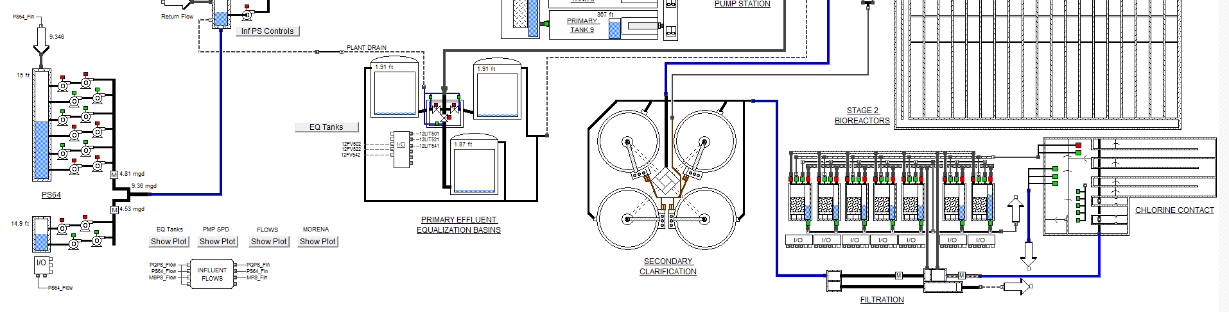
In this presentation, I will discuss how an integrated modelling approach was utilized to develop and verify holistic operational strategies that would deliver constant flow out of the North City Water Reclamation Plant (NCWRP) in the City of San Diego, CA, and minimize energy costs. NCPWR is undergoing expansion to increase treatment capacity from 30 MGD to 50 MGD, which will provide up to 42 MGD of treated wastewater effluent to North City Pure Water Facility (NCPWF), while still meeting the primary objective of the NCWRP of providing non-potable reclaimed water to customers. I will describe our integrated modeling approach including details on how we used three model programs – SUMO, Pro2D2, and Replica – to develop our integrated model. Lastly, this I will discuss some pertinent results from the modeling efforts and lessons learned during design.

About the Speaker:
Thomas Johnson, PE, is the Global Technology Leader for Wastewater Process Simulation with Jacobs in Charlotte, NC. Tom has an undergraduate degree from the University of Vermont (Civil Engineering), an M.S. degree from the University of North Carolina (Environmental Engineering), and has worked in the industry for 20 years, 14 with Jacobs. Tom is an avid Ultimate Frisbee player and an amateur brewer.

April 19, 2019 – 2.30 pm to 3.30 pm
Brackett Hall 100

Attendance is mandatory for those enrolled in EES 8610 and GEOL 8510

