Environmental Engineering
and Earth Sciences

EEES Department Seminar

“Water Disinfection Using Locally Enhanced
Electric Field Treatment (LEEFT)”
PRESENTED BY

Dr. Xing Xie
Assistant Professor
School of Civil and Environmental Engineering
Georgia Institute of Technology

https://clemson.zoom.us/j/96285842795

Water is a basic human need. Nevertheless, more than 10% of the world’s population lacks access to safe drinking water. An effective water disinfection method is still not readily accessible to these people. In developed urban areas, water is typically disinfected in a centralized facility through chlorine-based methods that inevitably generates carcinogenic disinfection byproducts. In addition, current water disinfection systems are vulnerable to natural disasters. Therefore, a more accessible and reliable water disinfection method is needed. The recently developed water disinfection approach based on locally enhanced electric field treatment (LEEFT) has a great potential to transform current water disinfection strategies and systems. The LEEFT is a physical treatment process that aims to utilize a strong electric field to disrupt cell membranes and thus inactivate pathogens. The electrodes installed in a LEEFT device are typically modified with one-dimensional nanostructures so that the electric field is not uniform but enhanced locally near the tips of the nanostructures. The LEEFT can potentially be applicable at all scales, from portable devices to point-of-use household units and from distributed community-scale treatment clusters to centralized treatment plants. This talk will cover the recent progress on the development of the LEEFT technology.

About Dr. Xie:
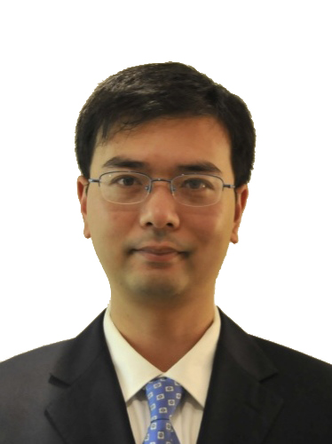
Dr. Xing Xie is an assistant professor and the Carlton S. Wilder Junior Professor in the School of Civil and Environmental Engineering. Prior to joining GT, he was a postdoc at Caltech. Dr. Xie received his B.S. (2006) and M.S. (2008) degrees in Environmental Science & Engineering from Tsinghua. He received his Ph.D. degree (2014) in Civil & Environmental Engineering and his second M.S. degree (2012) in Materials Science & Engineering from Stanford. He has been applying environmental biotechnology and materials science to address challenges at the nexus of water and energy, such as developing low-cost water treatment technologies that improve global access to safe drinking water. He has published 60 peer-reviewed articles in leading journals, including PNAS, Energy & Environmental Science, and Nature Communications. His work has been cited over 6000 times with an H-index of 24. Dr. Xie is a recipient of the NSF CAREER award in 2019.

2:30 PM

Friday, September 18, 2020
Online via Zoom
“Attendance is mandatory for graduate students enrolled in EES 8610, EES 9610, and GEOL 8510

