Environmental Engineering
and Earth Sciences

EEES Department Seminar

“Kiss the Ground”
A Documentary

https://clemson.zoom.us/j/5783910968

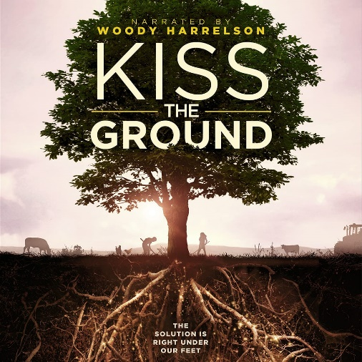
A revolutionary group of activists, scientists, farmers, and politicians band together in a global movement of "Regenerative Agriculture" that could balance our climate, replenish our vast water supplies, and feed the world.

Note: The running time for the documentary is 84 min, so we will go until 4 pm; it is not mandatory to stay on Zoom until 4 pm however.

About the documentary:

Kiss the Ground is a full-length documentary narrated by Woody Harrelson that sheds light on an alternative approach to farming called “regenerative agriculture” that has the potential to balance our climate, replenish our vast water supplies, and feed the world.

2:30 PM

Friday, October 2, 2020
Online via Zoom
“Attendance is mandatory for graduate students enrolled in EES 8610, EES 9610, and GEOL 8510

