Environmental Engineering
and Earth Sciences

EEES Department Seminar

‟ An introduction to the U.S. Public Health Service”

Presented By

CAPT Jennifer Mosser, PE, CHP
Abstract: The origins of the U.S. Public Health Service are found with sailors and with medical care. As interest in hygienic reform and sanitary science grew so did its mission. For over a century, Officers of the Commissioned Corps of the U.S. Public Health Service have dedicated their lives to controlling and eliminating diseases, inventing vaccines, and providing care for disadvantaged Americans. This presentation will discuss the history of PHS, its current role in protecting the health of the Nation, and how PHS officers are responding to the coronavirus outbreak
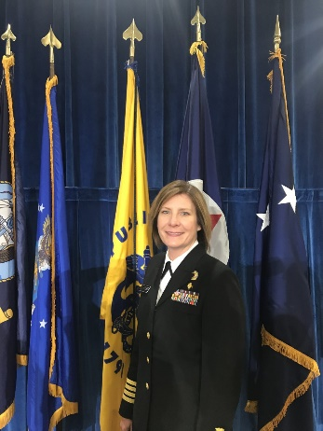
Jennifer Mosser is a Captain in the U.S. Public Health Service Commissioned Corps. CAPT Mosser received her Bachelor of Science degree in Chemical Engineering from West Virginia University and a Master of Science degree in Chemical Engineering from Virginia Tech. She is a registered Professional Engineer and a Certified Health Physicist.
CAPT Mosser is currently assigned to the U.S. Environmental Protection Agency where she works in the radiation protection program. CAPT Mosser serves as the Quality Assurance Manager and Science Advisor for the Office of Radiation and Indoor Air. One of her focus areas is ensuring that quality management principles are included in data collection and assessment activities during radiological emergency responses.
Prior to coming to the EPA, CAPT Mosser worked at the National Institute for Occupational Safety and Health. There she conducted workplace assessments to determine if workers were exposed to hazardous materials or harmful conditions and recommended ways to reduce hazards and prevent work-related illness.
When not working, Jen enjoys hiking with her dogs, practicing yoga, and keeping bees.
https://clemson.zoom.us/j/5783910968

Friday, October 23, 2020
2:30 PM
Online via Zoom
“Attendance is mandatory for graduate students enrolled in EES 8610, EES 9610, and GEOL 8510.”

