Environmental Engineering
and Earth Sciences

EEES Department Seminar

Chemical Destruction of Aqueous
Per- and Polyfluoroalkyl Substances (PFAS):
Are PFAS Truly “Forever Chemicals”?

Dr. Michael J. Bentel
Department of Environmental Engineering and Earth Sciences
Clemson University

Per- and polyfluoroalkyl substances (PFAS) comprise a large class of chemically stable compounds causing ubiquitous pollution. Their detrimental effects to humans and the environment are exacerbated by their mobility in aquatic systems. Effective and efficient methods are necessary to chemically destroy these aqueous contaminants. A photochemical system equipped with a 254 nm Hg lamp is used to irradiate an aqueous solution amended with a photosensitizer (i.e., sulfite, SO₃^{2–}), spontaneously generating reactive hydrated electrons (e_{aq}–) and sulfite radicals (SO₃•–), to probe the reactivity with PFAS. A systematic investigation using the UV/sulfite system reveal critical structure–reactivity relationships for legacy (e.g., carboxylates, sulfonates, and fluorotelomer carboxylates) and emerging (e.g., ether carboxylates) aqueous PFAS. Decay kinetics, transformation products, and defluorination results (i.e., percent C–F bond cleavage) highlight distinct reaction pathways. Quantum chemical calculations provide molecular-level interpretation of experimental results to elucidate destruction mechanisms. Increased reactivity and deeper defluorination achieves efficient treatment under increasingly basic conditions, where reaction pathways within the UV/sulfite system are thermodynamically mediated. Characterization of reaction solutions show chain-shortened and hydrogen-substituted (i.e., H/F exchange) transformation products. Subsequent oxidation (via heat-activated persulfate) of H/F exchange transformation products leads to complete mineralization, closing the fluorine mass balance. Thus, combined reduction-oxidation treatment scheme shows PFAS can be destroyed completely, demonstrating that PFAS are not forever chemicals.

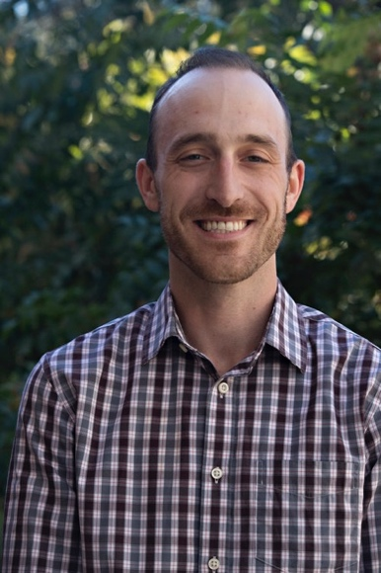
Bio: Michael J. Bentel received his B.S. in Chemical Engineering (2013) from the University of Illinois at Chicago, M.S. in Inorganic Chemistry (2019) and Ph.D. in Chemical & Environmental Engineering (2020) from the University of California, Riverside. Dr. Bentel joined the Environmental Engineering & Earth Sciences department at Clemson University as a postdoc in the Dr. Ezra Cates lab developing photocatalytic materials for water quality applications.

Dr. Bentel has published in leading academic journals including Environmental Science & Technology (ES&T) and ES&T Letters and has been recognized by professional organizations including the Association of Environmental Engineering and Science Professors (AEESP, 2021 Outstanding Doctoral Dissertation Award), the American Chemical Society (ACS, 2019 C. Ellen Gonter Environmental Chemistry Best Paper Award and the Committee on Environmental Improvement 2019 Film Award) and the American Water Works Association (AWWA, 2018 American Water Scholarship) for contributions and advancements towards environmental chemistry and water quality.

2:30 PM
Friday, October 8, 2021
Rich Lab Auditorium

Also available online via Zoom:
https://clemson.zoom.us/j/5783910968

Attendance is mandatory for graduate students enrolled in EES 8610, EES 9610, and GEOL 8510.

