Environmental Engineering
and Earth Sciences

EEES Department Seminar

Using Near-surface Geophysical Measurements to
Reveal Critical Zone Architecture

Dr. Brady Flinchum
Department of Environmental Engineering and Earth Sciences
Clemson University

The critical zone is the region near Earth’s surface where water, rock, and life interact. These interactions drive a variety of chemical, physical, and biological processes that, over geologic time, transform bedrock into soil. The transformation of rock to soil creates a unique critical zone architecture that can extend 10s to 100s of meters into the subsurface. This unique subsurface architecture contains clues about the chemical and physical processes that form and maintain it—yet it is difficult to quantify at depths greater than a few meters or over large spatial scales. Recently, the use of near-surface geophysical measurements to quantify critical zone architecture has been growing. However, understanding how geophysical properties and images are related to other properties of interest remains difficult. In addition, it is difficult to communicate and interpret the geophysical results to other disciplines who study the critical zone. This intertwining of geophysical data sets with other interdisciplinary measurements is important to have a wholistic view of critical zone processes. I will present a variety of geophysical data exploring CZ architecture across the continental US with a specific focus on crystalline rocks. I will also explore ways that we are trying to bridge the gap between geophysics and other disciplines through the virtual critical zone.

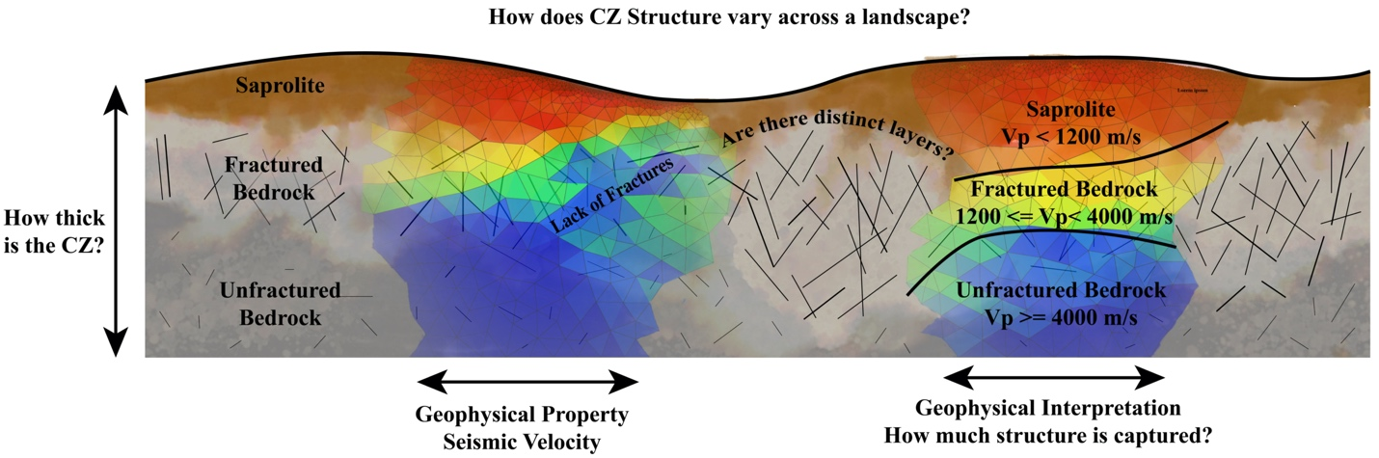

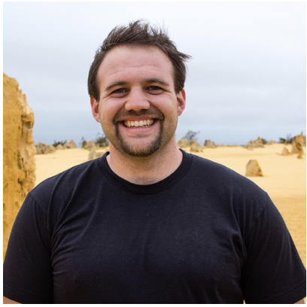
About Dr. Flinchum:
Dr. Flinchum is an Assistant Professor in the Department of Environmental Engineering and Erath Sciences at Clemson University. He has a B.S degree in Geophysics from the University of Nevada Reno and a Ph.D. in Geophysics from the University of Wyoming. Dr. Flinchum is focused on using near-surface geophysical techniques to uncover the deep CZ structure over large spatial scales and improving our understanding of relationships between geophysical, hydrological, and geochemical parameters.

2:30 PM
Friday, January 20, 2023
Brackett Hall 100
Attendance is mandatory for graduate students enrolled in EES 8610, EES 9610, and GEOL 8610.

