Environmental Engineering
and Earth Sciences

EEES Department Seminar

Algal C capture (and a History of Algae at Clemson)

Dr. Caye Drapcho
Department of Environmental Engineering and Earth Sciences
Clemson University

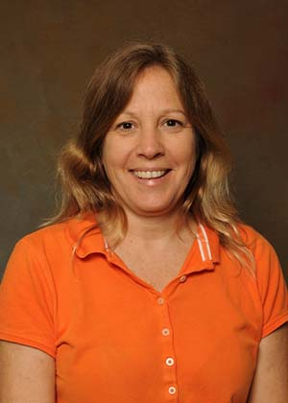
About Dr. Drapcho:

Dr. Drapcho is an Associate Professor in the Biosystems Engineering program in the Department of Environmental Engineering and Earth Sciences at Clemson University. Dr. Dpacho has a Ph.D. in Biosystems Engineering from Clemson, and a B.S. and M.S. in Environmental Management from the Pennsylvania State University. Dr. Drapcho’s professional interests focus on development of sustainable bioprocesses for renewable energy production, and on secondary and university STEM education.

2:30 PM
Friday, February 4, 2022

This seminar will be dual-mode (online and in-person).

For those attending in person, please go to BRACKETT 438

For those attending online, please join via:
https://clemson.zoom.us/j/5783910968

Attendance is mandatory for graduate students enrolled in EES 8610, EES 9610, and GEOL 8510.

