Environmental Engineering
and Earth Sciences

EEES Department Seminar

Following the Rivers: Long-term Drainage Basin Evolution in North America

Professor Andrew Leier

University of South Carolina

Abstract:

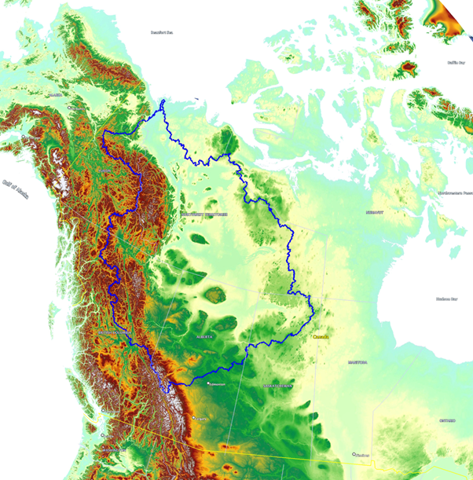
Drainage patterns in North America have changed dramatically over geologic time spans (tens of millions of years). Detrital zircon geochronology, which examines the uranium-lead ages of individual zircon grains, enables the reconstruction of past river systems by correlating sedimentary deposits with their original sediment source region. Between approximately 200 and 100 million years before present, west-flowing river systems transported Appalachian-derived sediment from eastern North America to the western United States and Canada. Today, extensive, and economically important sandstones exposed across western North America are composed of Appalachian sediment. Between approximately 100 and 60 million years ago mountain building in New Mexico, Colorado and Wyoming led to a reorganization of river drainages in the central United States, resulting in the development of a proto-Mississippi River drainage basin in the North American mid-continent. During roughly the same time, the massive Bell River system began to form in Canada. The Bell River included an east-flowing river that originated in the Canadian Rockies and emptied into the Labrador Sea, with a drainage basin that covered nearly half of North America. For at least 50 million years this river system discharged large volumes of sediment and freshwater into the Labrador Sea, impacting the density profile of marine waters in the basin and affecting regional ocean circulation patterns. Within the last 10 million years, likely in response to the growth of ice sheets in eastern Canada, the Bell River drainage was disrupted and surface runoff was redirected to other rivers. An increase in the sedimentation rate approximately 4 million years ago in the Mackenzie-Beaufort Basin near the Alaska-Canada border suggests that the Mackenzie River of northern Canada formed in response to the reorganization of the Bell River drainage. The influx of sediment and freshwater to the Arctic Ocean from the newly formed Mackenzie River impacted the freshwater budget of the Arctic Ocean, which plays an important role in cryosphere, atmosphere, and hydrosphere processes. These past river systems were important for redistributing crustal material across the continent and for delivering freshwater to high-latitude marine basins that serve as critical nodes in important global systems.

2:30 PM – 3:30 PM
Friday, February 23, 2024
Brackett Hall 100
Attendance is mandatory for graduate students enrolled in
EES 8610, EES 9610, and GEOL 8610.

Refreshments following seminar.

