All Faculty, Staff, and Students are invited to attend this seminar.

EEES Department Seminar

Climate and Wildfires in North America

Dr. Charles Ichoku
Professor of Earth and Environmental Sciences
Howard University, Washington, DC

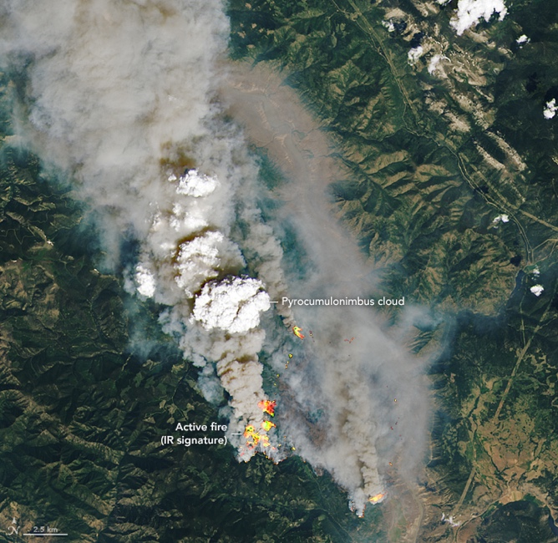
https://earthobservatory.nasa.gov/images/148630/a-summer-of-fire-breathing-smoke-storms
Wildfires and other types of biomass burning are a seasonal phenomenon in different land ecosystems around the world. These fires are estimated to consume biomass containing a total of 2-5 petagrams of carbon globally every year, generating heat energy and emitting smoke plumes that comprise different species of aerosols and trace gases. These emissions can have adverse effects on visibility, air quality, and climate. Specifically, although less than 5% of global fires occur in North America, recent studies have shown steady and significant increases in burned areas over the last few decades across the continent, especially in the western US.

In this presentation, we will discuss how we characterize fires and aerosols from satellite observations in conjunction with other data to continually improve our understanding of fire distribution in space and time, and how fire energetics are quantified and used to analyze emission source strengths and plume injection characteristics that in turn influence smoke dispersion, transport, and impacts. We will provide a brief survey of fire activities and smoke-aerosol emissions and their radiative forcing effects at global and regional scales, and focus on North American fires, to critically examine the impact of wildland fires and prescribed burns on the environment, air quality, and climate. We will explore the potential for fire and smoke forecasting, and show how synergism in coordinating satellite, airborne, and ground-based observations of fires and smoke can yield vital information for addressing current gaps in our knowledge of wildfires and their overall impacts.

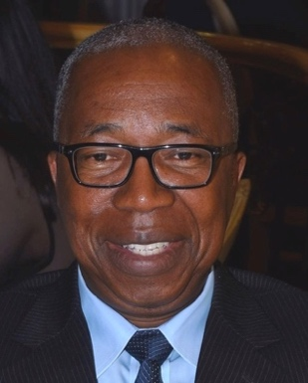
Brief Bio
Dr. Charles Ichoku is a Professor of Earth and Atmospheric Sciences in the Department of Interdisciplinary Studies within the College of Arts and Sciences (COAS) at Howard University, Washington, DC, USA. He is also the Distinguished Scientist of the NOAA Cooperative Science Center in Atmospheric Sciences and Meteorology (NCAS-M), a thirteen-member academic consortium constituted to diversify the student population trained in Atmospheric and Environmental Sciences, Meteorology, and other fields that are aligned with NOAA’s mission enterprise.

Dr. Ichoku received his Ph.D in Earth Sciences from the Pierre & Marie Curie University, Paris, France, and his M.Sc. and B.Sc. degrees in Remote Sensing and Surveying, respectively, from the University of Nigeria, Enugu Campus. Prior to joining Howard University in the fall of 2018, he was a Research Physical Scientist at NASA Goddard Space Flight Center, Greenbelt, Maryland, where he was involved in a variety of Earth Science research and related activities for 20 years (1998–2018).

2:30 PM
Friday, February 25, 2022
Brackett Hall 100

In-person attendance is mandatory for graduate students enrolled in EES 8610, EES 9610, and GEOL 8510. You can join online via Zoom only if you have tested positive for COVID-19 and requested an absence or have obtained prior approval for another valid reason.

For those attending online, please join via:
https://clemson.zoom.us/j/5783910968

