Environmental Engineering
and Earth Sciences

EEES Department Seminar

Cooling Tower Power from Visual Imagery, Optimization, and Physics Informed Machine Learning

Dr. Christopher A. Sobecki
Postdoctoral Research Scientist
Savannah River National Laboratory, Aiken, South Carolina

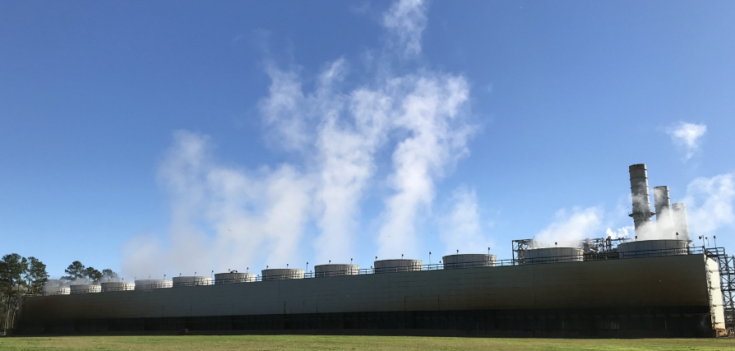
Mechanical draft cooling towers transfer heat from fossil fuel industrial cooling water to the atmosphere through forced convection and evaporation driven by large fans. The visible plumes exhausting out of multiple independent cells usually experience plume mergers as well as a transition from a forced jet to a buoyant jet, depending on fan speed at the operational facility. The amount of water usage and fans turned on is based on the energy demand from customers, especially in the southeastern United States. Consequentially, the energy demand is linked to the amount of natural gas consumed, thus contributing to CO₂ production via power output. Therefore, with a means to quantify the visible plume size and its relationship to the enthalpy discharge rate, plume images could be a possible way to monitor the accuracy of CO₂ emissions from multiple industrial sectors.

In this presentation, we will discuss how the power output of a twelve-cell mechanical draft cooling tower was estimated using plume volumes quantified by images from ground-based cameras using Mask R-CNN, image from motion, and space carving techniques. Along with weather and cooling tower operation data, 289 plume volumes were applied as inputs for a one-dimensional code that estimated the power output and was compared to the operational data gathered from a site-specific location. The comparison gave an $R^{2}$ of about 0.3616, which resulted from three possible uncertainties. We then attempted to improve the one-dimensional model by applying optimization schemes on the entrainment coefficients and compared the power outputs again, however, only minimal improvement was noticed. The results from the parameter optimization algorithms and the opinion of the subject matter expertise justified the application of physics-informed machine learning (PIML), a method that develops solutions for problems where physically based models alone cannot provide the accuracy needed for decision making. After screening through a plethora of commonly used machine learning approaches (to assess how they would respond to solving the problem), the PIML tool was trained followed by a validation of the unseen data. The results showed that $R^{2}$ increased to about 0.95, thus demonstrating a significant improvement to the physics-based model.

Brief Bio
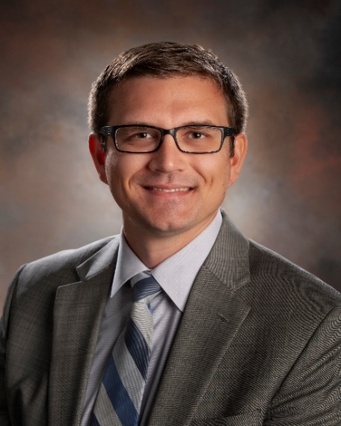
Dr. Christopher (Chris) A. Sobecki is a Postdoctoral Research Scientist at Savannah River National Laboratory (SRNL) where he is modeling plume dynamics from mechanical draft cooling towers and stacks using commercially available software. The efforts of these projects include external laboratory funding with the collaboration of faculty, staff, and students from Rochester Institute of Technology and other researchers at SRNL using funding awarded by the laboratory. Dr. Sobecki has also expressed interest in AI/ML/O applications for existing and developing physics-based codes with other individuals from diverse research backgrounds at the laboratory. He has presented and published six works at conferences such as the prestigious Cooling Technology Institute and has additional manuscripts currently under review.

Dr. Sobecki received his Ph.D. in Mechanical Engineering from Missouri University of Science and Technology (MS&T), Rolla, Missouri, where he researched theoretical, numerical, and experimental applications on microparticle dynamics in microfluidic and shear flows under uniform magnetic fields with the funding assistance from the Chancellor’s Distinguished Fellowship. His research was supported by three undergraduate students who he mentored how to manufacture microfluidic devices, fabricate non-spherical microparticles, and design Helmholtz coils. He additionally received his B.Sc. degree in Mathematics and a Minor in Dutch Language and Culture Studies from Indiana University Bloomington. Prior to joining SRNL in the summer of 2021, he was a year-round graduate intern at Sandia National Laboratory wherein he learned the Large-scale Atomic/Molecular Massively Parallel Simulator (LAMMPS) software, a classical molecular dynamics code, to study liquid-vapor phase changes for water molecules.

2:30 PM
Friday, March 17, 2023
Brackett Hall 100
In-person attendance is mandatory for graduate students enrolled in EES 8610, EES 9610, and GEOL 8610.
Refreshments following seminar.

