Environmental Engineering
and Earth Sciences

EEES Department Seminar

Expansion of Pendleton WWTP

Tony Reid and Will Nading
Goodwyn Mills Cawood
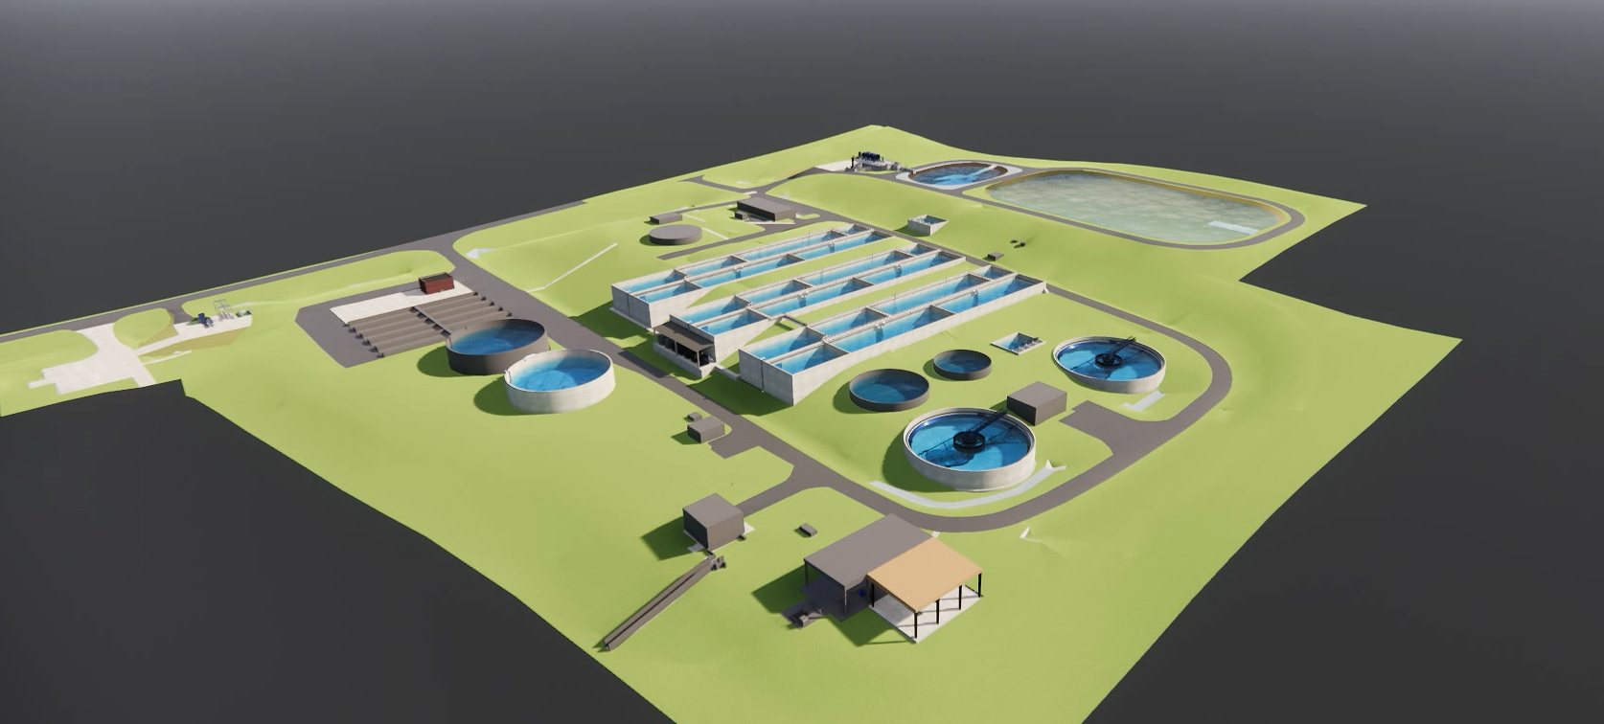

Abstract:

Goodwyn Mills Cawood (GMC) is providing engineering design services for the upgrade of the existing Pendleton-Clemson WWTP. The WWTP is jointly owned by the Town of Pendleton, City of Clemson, and Anderson County. This presentation will cover a variety of topics to provide an overview of a real-world design and construction project. Topics covered will include project need, project funding/cost, contractor selection, technical process design, and project scheduling.

Tony Reid and Will Nading are both 2010 MS graduates of the Clemson EEES department and are licensed professional engineers in the State of SC. Tony and Will work for Goodwyn Mills Cawood (GMC) in their Greenville, SC office. Tony leads GMC’s water and wastewater treatment design team that serves clients throughout the Southeast. Will is a project manager specializing in design and rehabilitation of wastewater collection systems and treatment facilities in South and North Carolina.

2:30 PM
Friday, April 14, 2023
Brackett Hall 100

Attendance is mandatory for graduate students enrolled in EES 8610, EES 9610, and GEOL 8610.

Refreshments after seminar.

