Environmental Engineering
and Earth Sciences

EEES Department Seminar

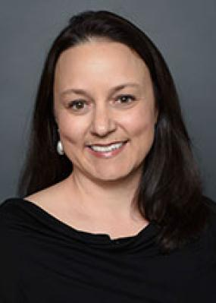

Research Overview and EEES Vision: Professor Belinda Sturm

Ross McKinney Faculty Fellow
Department of Civil, Environmental & Architectural Engineering
University of Kansas

Lawrence, KS

About Professor Sturm:
Professor Sturm is the Ross McKinney Faculty Fellow in the Department of Civil, Environmental & Architectural Engineering and the Interim Vice Chancellor for Research at the University of Kansas. Professor Sturm is also the Director of the Kansas National Science Foundation EPSCoR Program.

Professor Sturm has a BS in Environmental Science & Engineering, University of North Carolina – Chapel Hill; and a Ph.D. in Civil Engineering & Geological Sciences, University of Notre Dame. Following her Ph.D. and prior to the University of Kansas, Professor Sturm was a postdoctoral researcher in Civil and Environmental Engineering Department at the University of California, Davis.

Professor Sturm has served as the Principal Investigator on over $27.3 million in research and an additional $15 million as co-investigator. This research has resulted in more than 50 archival journal publications. Professor Sturm’s research was recognized by The Water Research Foundation in 2022 by awarding her with the Paul L. Busch Award. The Paul L. Busch Award recognizes an individual for innovative research in the field of water quality and the water environment, with a special focus on those who show promise and make significant contributions in bridging research and its practical application.

Professor Strum will present an overview of her research along with her vision for the EEES Department within the School of Civil and Environmental Engineering and Earth Sciences.

3:30 PM
Monday, April 15, 2024
Rich Lab Auditorium
https://clemson.zoom.us/j/5783910968
Attendance is strongly encouraged for graduate students enrolled in
EES 8610, EES 9610, and GEOL 8610.

