Environmental Engineering
and Earth Sciences

EEES Department Seminar

Bedrock composition and subsurface weathering control forest drought response in the southern Sierra Nevada, California

Dr. Russell P. Callahan
Postdoctoral Researcher
University of Wyoming, Laramie, Wyoming

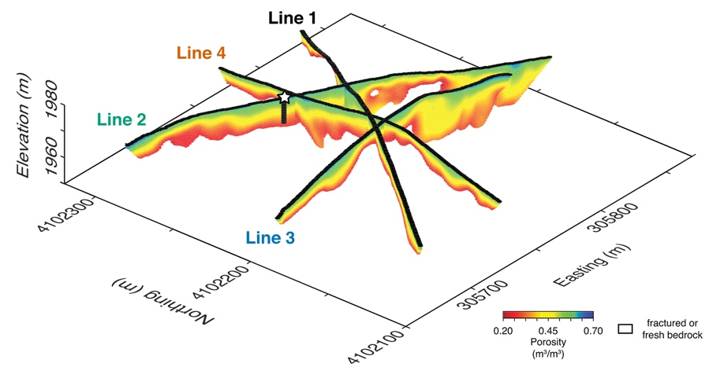
Inferred saprolite porosity reveals variations in weathering across each multiple geophysical transects. White space between saprolite and tomogram outlineis fractured or fresh bedrock, which are not represented in rock physics model. From: Subsurface weathering revealed in hillslope‐integrated porosity distributions.
https://doi. org/10.1029/2020GL088322
Forests are increasingly threatened by climate-change-fueled cycles of drought, dieback, and wildfires. However, for reasons that are incompletely understood, some forests are more vulnerable than others, leaving a patchwork of heterogeneous dieback and wildfire risk after drought. Here, I use a combination of surface geophysical and remote sensing techniques to demonstrate that spatial variability in forest dieback due to drought can be explained by differences in bedrock composition through its effects on subsurface weathering and nutrient supply, which regulate water storage and demand in mountain ecosystems. During the 2011–2017 drought in the Sierra Nevada, California, evapotranspiration declined in dense forest stands rooted in weathered, nutrient rich bedrock. In contrast, relatively unweathered, nutrient-poor bedrock supported thin forest stands that emerged from the drought unscathed. Hence, rather than enhancing forest resilience to drought by providing more water storage capacity, bedrock with more weatherable minerals induced greater vulnerability by enabling a boom-bust cycle in which higher ecosystem productivity during wet years drives excess plant water demand during droughts.

Brief Bio
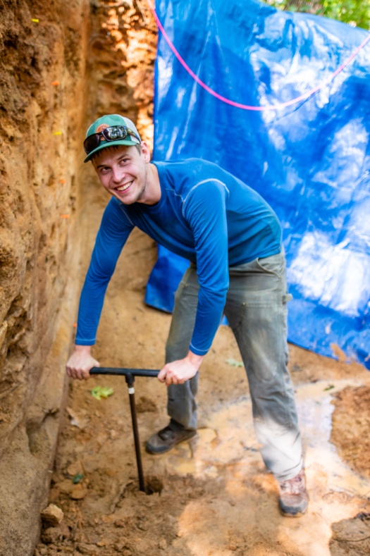
Russell studies geomorphology, weathering, and geophysics. He is interested in using a combination of geophysics and regolith geochemistry to understand landscape evolution and quantify regolith thickness across hillslope scales. Most of his work has been conducted in the Southern Sierra Critical Zone, where he studies lithologic, topographic, and climactic drivers of regolith thickness to understand how landscapes evolve over space and time. Russell received is B.S in Environmental Science from Montana State University and his PhD in Geology and Geophysics from the University of Wyoming. He has just finish a two year post-doctoral position at the University of Wyoming and starting a second post-doctoral position at UC Santa Cruise.

2:30 PM
Friday, April 26, 2022
Brackett Hall 100

In-person attendance is mandatory for graduate students enrolled in EES 8610, EES 9610, and GEOL 8510. You can join online via Zoom only if you have tested positive for COVID-19 and requested an absence or have obtained prior approval for another valid reason.

For those attending online, please join via:
https://clemson.zoom.us/j/5783910968

