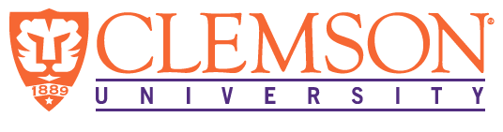
Environmental Engineering
and Earth Sciences

EEES Department Seminar

A Tale of Two Metals: Wetland Uranium & Iron Cycling

Connor Parker, Ph.D. Candidate
Environmental, Engineering, & Earth Sciences
Clemson University
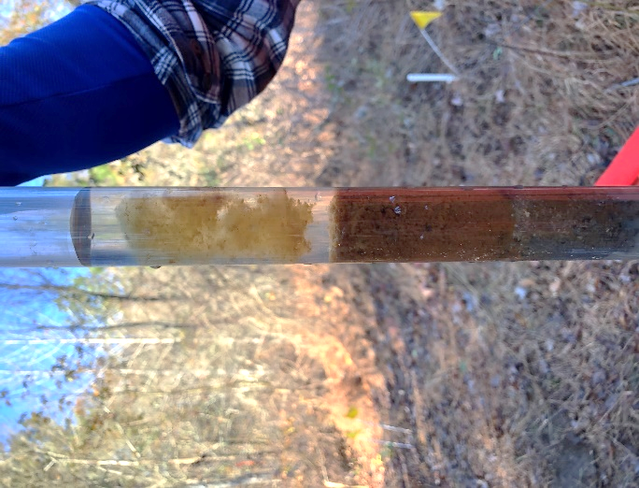

Wetlands are often described as the kidneys of the earth, referring to the ability of wetlands to filter and sequester heavy metals and other environmental contaminants. Uranium (U) releases from 1965 to 1988 resulted in contamination of the Tims Branch wetland at the United States Department of Energy Savannah River Site (SRS) near Aiken, South Carolina. Today, 94% of the 43,000 kg released remain sequestered in soils of two former ponds, Beaver Pond and Steed Pond. The objective of this work was to understand U partitioning from contaminated wetland sediments to aqueous and particulate iron-floc phases, with sampling guided by aerial and pedestrian gamma-mapping studies that identify U hotspots. Uranium releases to the stream are minimal at Beaver Pond, but U incorporation into Fe-OM colloids, or flocs, at Steed Pond results in appreciable fluxes of U from the wetland. This work expands upon studies conducted in the 1990’s and early 2000’s, improving our understanding of the geochemical controls of uranium migration through Tims Branch, particularly with respect to the changes over the last 30+ years. Current wetland conditions do not favor significant U movement, but long-term changes in local and regional hydrology may alter this delicate biogeochemical balance.

Connor J. Parker is a PhD Candidate in Clemson University’s EEES Department. Connor specializes in wetland heavy metal geochemistry and transport, working with Dr. Brian Powell studying uranium transport using geochemical and radiation detection methods. Specifically, he applies hydrologic fundamentals to field sites where targeted sampling is required to study key fluxes of contaminants at hydrologic and geochemical interfaces. Connor earned his B.S. in Environmental Engineering (2017) at the University of Notre Dame in South Bend, IN while researching uranium nanocluster formation and dissolution.

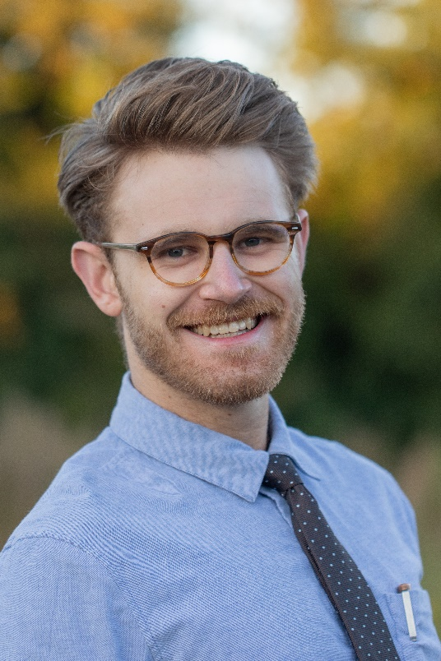

2:30 PM
Friday, November 5, 2021
Rich Lab Auditorium

Also available online via Zoom:
https://clemson.zoom.us/j/5783910968

Attendance is mandatory for graduate students enrolled in EES 8610, EES 9610, and GEOL 8510.

