Environmental Engineering
and Earth Sciences

EEES Department Seminar

“The role of polyfluoroalkyl substances in understanding perluoroalkyl acid contamination at aqueous fil,-forming foam impacted sites”
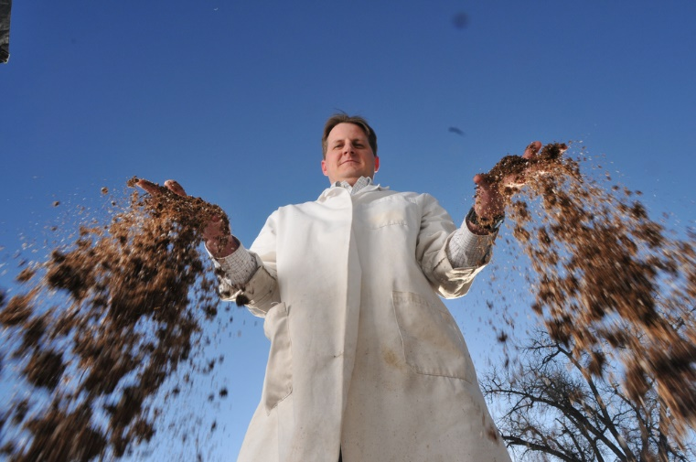
PRESENTED BY
Dr. Chris Higgins
Assistant Professor with Tenue
Colorado School of Mines

Abstract: Poly- and perfluoroalkyl substances (PFASs) are constituents in aqueous film-forming foam (AFFF) used to extinguish fires. Substantially elevated PFAS groundwater concentrations have been observed at firefighter protection training areas, where co-contaminants such as chlorinated solvents and fuel hydrocarbons are also commonly present. Though regulatory efforts are focused on perfluoroalkyl acids (PFAAs), polyfluorinated species (i.e., PFAA precursors), many of which behave differently than PFAAs, are potential sources of PFAAs at AFFF-impacted sites. A recent field investigation suggested significant conversion of polyfluoroalkyl chemicals to PFAAs in situ due to natural and enhanced remediation of petroleum hydrocarbons at an AFFF-impacted site. Bench-scale research into the fate and transport potential of PFASs at AFFF-impacted sites will also be presented, with a particular focus on the role of PFAA precursors. These bench-scale studies include examinations of the effects of various chemical oxidants, typically employed via in situ chemical oxidation (ISCO), on PFAA fate and transport. In addition, future challenges in addressing PFAS contamination at AFFF-impacted sites will be discussed.
Bio: Christopher P. Higgins is an environmental chemist examining the fate of environmental contaminants in aquatic and terrestrial systems. Dr. Higgins received his A.B. in Chemistry and Chemical Biology from Harvard University, and his M.S. and Ph.D. in Civil and Environmental Engineering from Stanford University. Prior to his graduate work, Dr. Higgins worked for the Cadmus Group, Inc., providing policy and regulatory support to the U.S. Environmental Protection Agency. Upon finishing his Ph. D. at Stanford in 2006, Dr. Higgins became a postdoctoral fellow at Johns Hopkins Bloomberg School of Public Health. He joined the faculty at the Colorado School of Mines as an Assistant professor in 2009, and was promoted to Associate professor with tenure in 2014. His research focuses on the movement of contaminants in the environment. In particular, he studies chemical fate and transport in natural and engineered systems as well as bioaccumulation in plants and animals. Contaminant under study in his laboratory include perfluorochemicals used in stain-repellent fabrics and fire-fighting foams, nanoparticles, wastewater-derived pharmaceuticals and personal care products, and trace metals. Dr. Higgins has authored more than 4 peer-reviewed publications to date and his research has been supported by the National Science Foundation, the National Institutes of Health, the U.S. Environmental Protection Agency, the U.S. Department of Agriculture, the U.S. Air Force, and the U.S. Department of Defense’s Strategic Environmental Research and Development Program.
2:30 PM

Friday, March 4, 2016 201 Kinard Hall
Refreshments following Seminar

