Environmental Engineering
and Earth Sciences

EEES Department Seminar

‟ The Chase for More Potent Bioremediation Groundwater Schemes: Synergistic Reductive Dechlorination of Trichloroethene Mediated by Zero-valent Iron and Microbial Chain Elongation”

Presented By

Dr. Anca G. Delgado
Assistant Professor of Environmental Engineering
Arizona State University
https://clemson.zoom.us/j/5783910968

Abstract
Anaerobic bioremediation of trichloroethene (TCE) through bioaugmentation with Dehalococcoides mccartyi-containing cultures has been utilized at many contaminated sites. The efficacy of in situ bioaugmentation is sometimes challenged by aerobic conditions in aquifers, limitations on the availability of H₂, the obligate electron donor for Dehalococcoides mccartyi, and toxicity of high TCE concentrations to reductively dechlorinating bacteria. In this seminar, I will highlight my lab’s efforts in alleviating some of these challenges through novel approaches towards the development of more effective groundwater treatment schemes. First, I will discuss our investigations on the effect of zero-valent iron (Fe⁰) and its oxidation product, Fe²⁺, at field-relevant concentrations, on microbial reductions of TCE and perchlorate (a co-contaminant). Fe⁰, a powerful chemical reductant, is often used during TCE bioremediation with Dehalococcoides mccartyi to establish anoxic conditions in the aquifer. However, the synergy between Fe⁰ abiotic reactions and microbiological TCE and ClO₄– reductions is poorly understood and seldomly addressed in the literature. Second, I will discuss our research on microbial chain elongation as an alternative to fermentation for producing the required H₂ for TCE reductive dechlorination of TCE in groundwater. Microbial chain elongation is a metabolism that combines simple substrates such as acetate and ethanol into the longer carboxylates, butyrate and hexanoate, while also producing H₂.

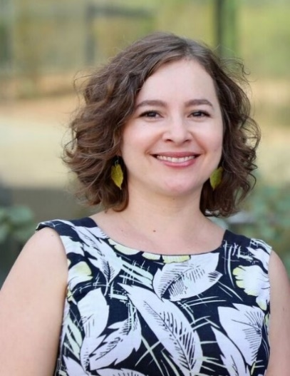
About Dr. Delgado
Dr. Anca Delgado received a Ph.D. in Microbiology from Arizona State University and is currently an Assistant Professor of Environmental Engineering in the School of Sustainable Engineering and the Built Environment and the Biodesign Swette Center for Environmental Biotechnology at ASU. She is a Principal Investigator in the National Science Foundation-sponsored Center for Bio-Mediated and Bio-Inspired Geotechnics (CBBG). Dr. Delgado’s expertise is in soil and groundwater microbial processes that transform or sequester carbon- and halogen-containing compounds to remediate contaminants and improve soil quality. Her research portfolio includes projects on bioremediation of chlorinated solvents, petroleum hydrocarbons, and heavy metals and on microbial chain elongation for biochemical production and oxidized contaminant reductions.

Friday, November 6, 2020
2:30 PM
Online via Zoom
“Attendance is mandatory for graduate students enrolled in EES 8610, EES 9610, and GEOL 8510.”

