Environmental Engineering
and Earth Sciences

EEES Department Seminar

The Sound of the Sea:
Seashells and the Fate of the Oceans

Cynthia Barnett
Environmental Journalist in Residence
College of Journalism and Communications, University of Florida

This week’s seminar is a special “Book Club” experience facilitated by the producers of The Outfall podcast, Robert Osborne, Amy Anderson, and David Ladner. The selected book is The Sound of the Sea: Seashells and the Fate of the Oceans, by Cynthia Barnett who will join the discussion remotely. Barnett blends cultural history and science to trace our long love affair with seashells and the hidden lives of the mollusks that make them. Spiraling out from the great cities of shell that once rose in North America to the warming waters of the Maldives and the slave castles of Ghana, Barnett has created an unforgettable account of the world’s most iconic seashells. She begins with their childhood wonder, unwinds surprising histories like the origin of Shell Oil as a family business importing exotic shells, and charts what shells and the soft animals that build them are telling scientists about our warming, acidifying seas. From the eerie calls of early shell trumpets to the evolutionary miracle of spines and spires and the modern science of carbon capture inspired by shell, Barnett circles to her central point of listening to nature’s wisdom—and acting on what seashells have to say about taking care of each other and our world. The audience is encouraged to join the discussion, which will be recorded and turned into a future episode of The Outfall.

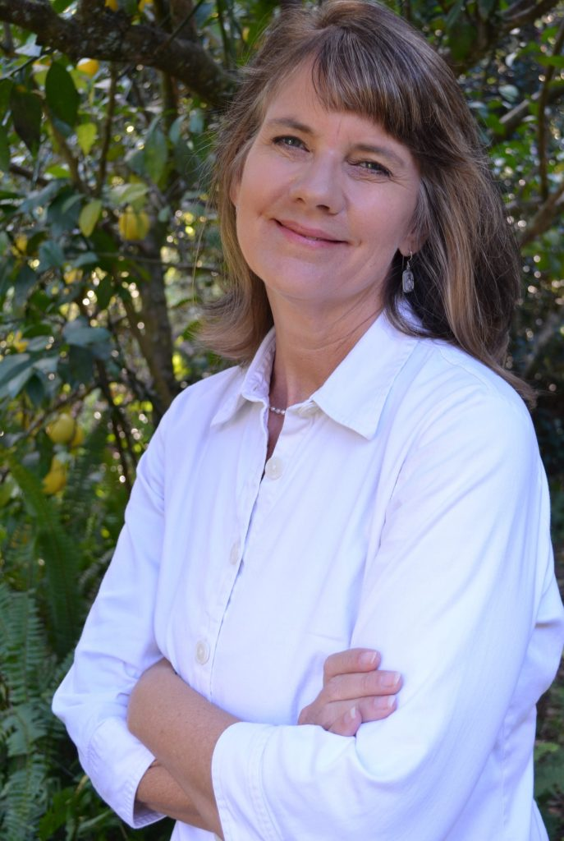
Bio: Cynthia Barnett is an environmental journalist who has covered water and climate stories worldwide, from the decline in Florida’s signature springs, to epic drought in California and Australia, to the rainiest place on Earth in Cherrapunji, India. She is the author of three books on water, including her latest Rain: A Natural and Cultural History, longlisted for the National Book Award, a finalist for the PEN/E.O. Wilson Award for Literary Science Writing, and named among the best nonfiction books of 2015 by NPR’s Science Friday, the Boston Globe, the Tampa Bay Times, the Miami Herald and others. Barnett has also written for National Geographic, the New York Times, Los Angeles Times, the Wall Street Journal, the Atlantic, Discover magazine, Salon, Politico, Orion, and many other publications. As CJC’s Environmental Journalist in Residence, she teaches Environmental Journalism and teams across disciplines with UF faculty and students who are working to improve public understanding of complex environmental issues such as climate change.

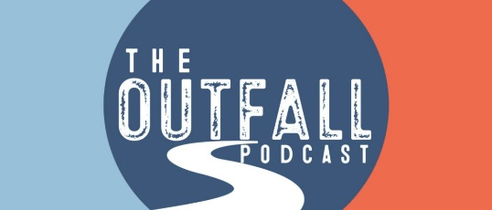
2:30 PM
Friday, October 22, 2021
Rich Lab Auditorium

Also available online via Zoom:
https://clemson.zoom.us/j/5783910968

