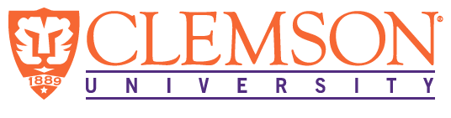

**Environmental Engineering**

**and Earth Sciences**

**EEES Department Seminar**

**“EEES Laboratory Safety Training”**

PRESENTED BY



**Laura He, MS**

Health and Safety Specialist

Occupational and Environmental Safety

Dear EEES Faculty, and Students,

All are required to attend the Laboratory Safety Seminar which will be held on Friday, September 23 at 2:30 PM to 3:30 PM at the Rich Lab Auditorium. The training will be held by Laura He. She will cover topics of general laboratory safety such as PPE selection, emergency response, proper waste disposals, chemical storage, exposure control, hazard communication. We look forward to your attendance!

**2:30 PM**

**Friday, September 23, 2022**

***“Attendance is mandatory for graduate students enrolled in EES 8610, EES 9610, and GEOL 8610”***

