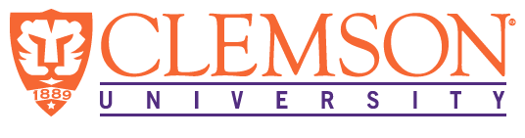
Environmental Engineering
and Earth Sciences

EEES Department Seminar

Electrochemical Oxidation of PFAS Using
Boron-Doped Diamond Electrodes

Dr. Suzanne E. Witt
Scientist, Fraunhofer USA Center Midwest
Email: switt@fraunhofer.org
Phone: 517-884-8694

Per and polyfluorinated alkyl substances (PFAS) are highly stable and toxic chemicals used in a wide variety of consumer goods and industrial processes. Their widespread use and recalcitrant nature have led to their accumulation in the environment, resulting in extensive water and soil contamination. Contamination of PFAS is typically addressed through removal by adsorption or filtration technologies, however this results in a concentrated waste stream that requires further treatment to permanently destroy PFAS. Electrochemical oxidation (EO) is a promising strategy for destroying PFAS in a variety of impacted water sources. This technology utilizes high current densities to oxidize the strong carbon-fluorine bonds of PFAS chains, ideally resulting in carbon dioxide and fluoride (mineralization) through both direct and indirect oxidation processes. Though it has been successfully demonstrated on a fundamental level, the application of EO in real world solutions presents new and unique challenges. Real wastewater solutions contain multiple co-contaminants in addition to PFAS, which adds complexity to the treatment. Furthermore, the harsh treatment conditions and high potential for fouling limits the number of viable electrode materials for this application. Boron-doped diamond (BDD) is an excellent electrode material for this purpose due to its robustness under EO operating conditions, among other key properties. This talk will cover Fraunhofer USA Center Midwest’s research on the electrochemical treatment of PFAS in real wastewater solutions using home-built batch recirculation systems equipped with BDD cells. The fundamentals of EO will be introduced, followed by the results of treating PFAS in two different wastewater matrices: ion exchange still bottom solutions and landfill leachates.

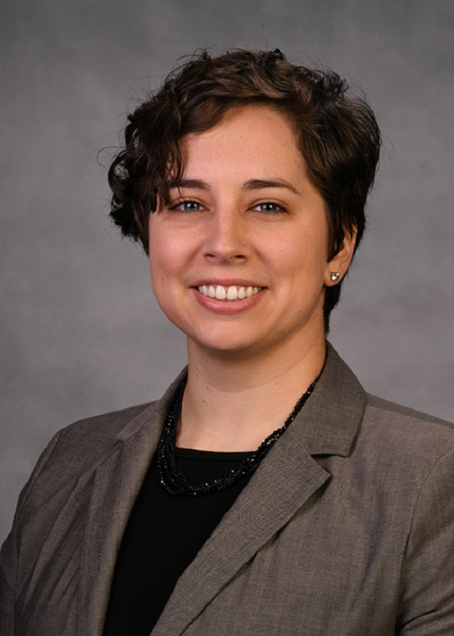
Dr. Suzanne E. Witt received her PhD in Chemistry from The Ohio State University in 2017. Her graduate research centered around the investigation of dirhodium catalysts for electrochemical water splitting and/or carbon dioxide reduction. Prior to joining Fraunhofer USA, she was awarded a National Research Council Postdoctoral Associateship at the National Institute of Standards and Technology (NIST), where she researched microstructure-performance relationships of solid oxide fuel cell materials. At Fraunhofer USA, she is the technical lead on projects related to the electrochemical application of diamond and diamond-related materials, including the use of boron doped diamond in wastewater treatment.

2:30 PM
Friday, April 8, 2022
Brackett Hall 100

Also available online via Zoom:
https://clemson.zoom.us/j/5783910968

In-person attendance is mandatory for graduate students enrolled in EES 8610, EES 9610, and GEOL 8510.
You can join online via Zoom only if you have tested positive for COVID-19 and requested an absence or have obtained prior approval for another valid reason.

