Environmental Engineering
and Earth Sciences
EEES Department Seminar

“welcome seminar”

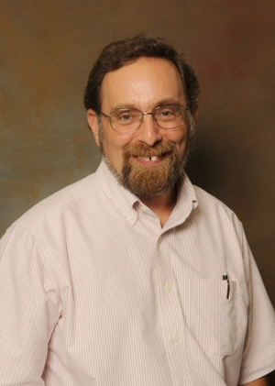

Presented By
Dr. David L. Freedman
Chair and Professor
Biological Process Engineering/Bioremediation

2:30 PM

Friday, August 19, 2016

Rich Lab Auditorium
Refreshments following Seminar

