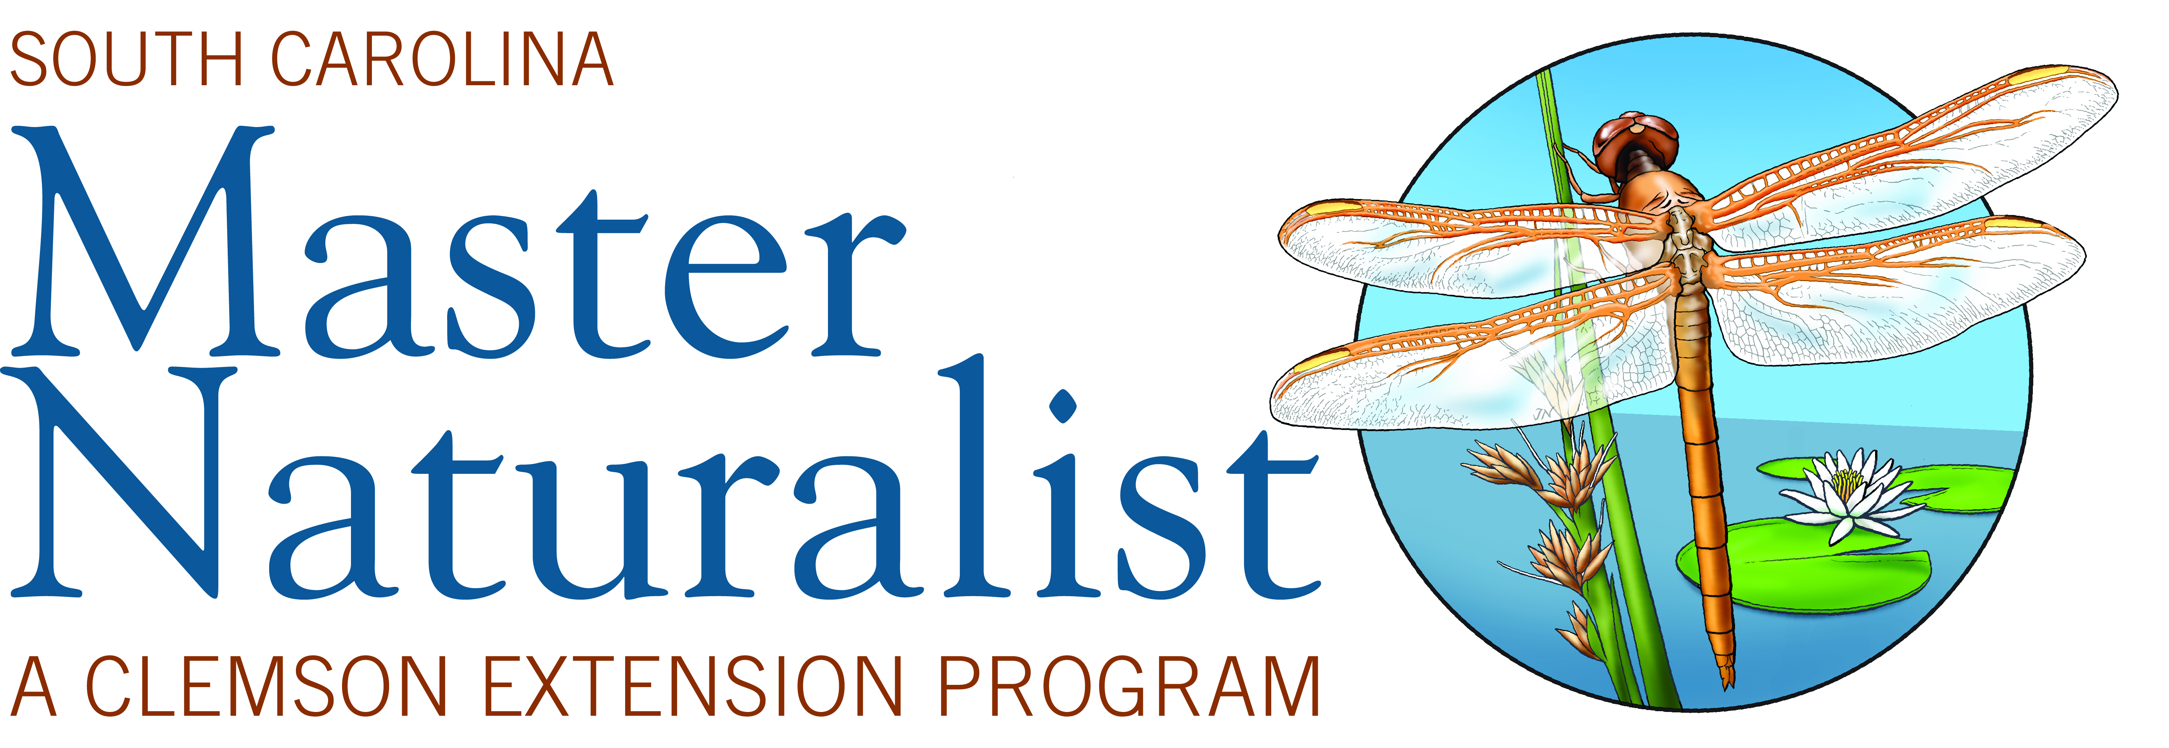

South Carolina Master Naturalist Program
Volunteer Hour Tracking Form

I. VOLUNTEER HOURS - count travel (>30 minutes, no more than 1 hour for each activity) and preparation time.
 | A. SCMN program service
Date | Activity & Location | Hrs
 | B. Ecological Services: Enhancement/Development
Date | Activity & Location | Hrs
 | C. Citizen Science: Field/ Research/Surveys
Date | Activity & Location | Hrs
 | D. Education/Interpretation
Date | Activity & Location | Hrs
II. ADVANCED TRAINING – do NOT count travel time.
Date | Activity & Location, Sponsor/Instructor |  | Hrs

Volunteer projects should fit into one of the four categories (A-D) listed above. The State Office retains the right of refusal of certain projects if they are deemed exploitative or inappropriate. If you’re unsure of whether your project fits into one of these categories, please see the volunteer service and incentives download on the website www.clemson.edu/masternaturalist. See the Advanced Training guidelines form for training that qualifies.

NOTE: Please do not mail any forms to Clemson University.

Hours should be reported by the Master Naturalist using the Master Naturalist Online Volunteer Hour Reporting System. A username and password were assigned and given to you at your graduation. If you cannot find that information or cannot remember your password, please contact Dr. Blake (jblake@clemson.edu).

You can keep track of your volunteer hours using this form so you can easily input them once you have access to the system.

The Clemson University Cooperative Extension Service
offers its programs to people of all ages, regardless of race, color, sex, religion, national origin, disability, political beliefs, sexual orientation, marital or family status and is an equal opportunity employer.
Clemson University Cooperating with U.S. Department of Agriculture, South Carolina Counties, Extension Service, Clemson, South Carolina. Issued in Furtherance of Cooperative Extension Work in Agriculture and Home Economics, Acts of May 8 and June 30, 1914
Public Service Activities

