CLEMSON UNIVERSITY

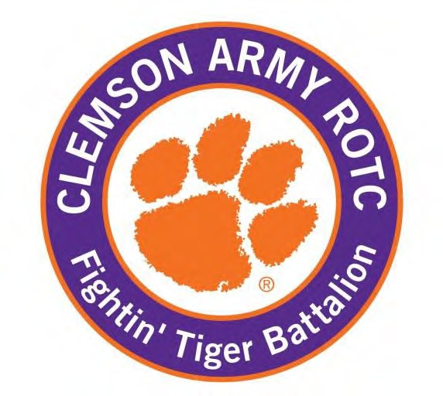

THE FIGHTIN’ TIGER BATTALION ORANGE BOOK

Contents

CLEMSON UNIVERSITY 1
THE FIGHTIN’ TIGER BATTALION 1
ORANGE BOOK 1
INTRODUCTION 4
Introduction to ROTC and the Army 5
MILITARY TIME 6
Phonetic Alphabet 7
Army Officer Branches 7
Chain of Command 8
Army Rank Structure 10
Cadet Duties and Responsibilities 11
Leadership Development Program 15
LEADERSHIP REQUIREMENTS MODEL 16
Clemson ML Year Line of Effort / Activity 19
Military Courtesies and Appearance 20
Military Appearance 22
Army Service Uniform (ASU) 28
ROTC Class B Uniform 34
ROTC Class C Uniform (ACU) 36
Occupational Physical Assessment Test (OPAT) 39
Physical Fitness 40
ANNEX A - Army Values and Leadership Dimensions 46
CORE LEADER COMPETENCIES – What an Army Leader does 48
ANNEX B- The Army as a Profession 50
ANNEX C – Soldier’s Creed, Cadet Creed, Alma Mater 52
ANNEX D – Cadet Song and Army Song 54
ANNEX E – General Rules of Conduct 56
ANNEX F - Unit Crest and Command Patch History 57
ANNEX G – History and Traditions of the Clemson Corps of Cadets 58
ANNEX H - Cadet of the Month Boards 60
ANNEX I – Army ROTC Accessions Process (changes yearly, PML to brief) 62
ANNEX J - Simultaneous Membership Program (SMP) 64
ANNEX K – Oath 65
ANNEX L – Code of Conduct 66
ANNEX M – Uniform/TA-50/MOLLE Information 67
ANNEX N – Summer Training 70
ANNEX O – ROTC affiliated clubs 75
ANNEX P –MEDEVAC REQUEST 77
ORDERS PROCESS 81

INTRODUCTION
Welcome to Army ROTC. We are proud to have you in the Fightin’ Tiger Battalion. Army ROTC educates, trains, and commissions college students to be officers and leaders of character in the United States Army. You have already distinguished yourselves from the pack by taking on this challenge. There is no better opportunity available to college students today to learn the leadership and life skills needed to be successful in any career than Army ROTC. Whether you stay for one semester or continue to pursue a commission, you have already taken the first step on a journey that I’m confident will change your life forever. If you do choose commission and join our Army as a second lieutenant, you will be joining an organization that's the best in the world at what it does. It's comprised of selfless men and women who are out there every day making a difference in an increasingly complex world.

You will be challenged in Army ROTC. You will learn about and be expected to live a set of values that transcend the Army. The Army values of loyalty, duty, respect, selfless service, honor, integrity and personal courage are more than mere words that we recite. Taken together and integrated through an understanding and appreciation of the sacrifices made by the generations of citizen-soldiers who previously answered the call to defend America's freedoms…those values become part of who we are and form the moral and ethical identity that inspire us and form the basis of our professional ethic. It is no accident that companies all over the country seek out those with military experience – for it is our ability to lead and our adherence to these values that make us one of the most respected professions in the Nation.
During your time in Army ROTC, you will learn what it means to be an Army officer. You will apply leadership fundamentals not just in the classroom, but through a variety of exciting and challenging training events. You will lead small units through team-building, critical thinking, and tactical scenarios while planning and executing training events for your peers. You will learn about comprehensive fitness and get in the best shape of your life. You will learn about and help instill in all students the military heritage that Clemson University was founded on and that continues to thrive today.
The “Tiger Orange Book” will help you learn the foundations of our program and set you on your way to tremendous success. Enjoy the journey. Be proud of Clemson, the Fightin’ Tiger Battalion, and yourself for volunteering for what most others cannot or will not do. I am confident you are up to the challenge.

GO TIGERS!

Shane A. Werst K. Todd Crawford
Shane A. Werst K. Todd Crawford
Master Sergeant, U.S. Army Lieutenant Colonel, Aviation
Senior Military Instructor Professor of Military Leadership

Introduction to ROTC and the Army

The Cadet Battalion. Cadets in the Army Reserve Officers Training Corps at Clemson University are organized into a cadet battalion modeled after an Army light infantry battalion. In addition to the cadet battalion staff, there are three companies each consisting of two platoons with a cadet chain of command. This structure provides opportunities for leadership and practical experience in problem solving. The cadet battalion staff plans, organizes, and conducts much of the training and other activities.
Generally, Military Leadership (ML) level 1 and 2 Cadets act as squad members. In the fall semester, ML 3 Cadets hold positions in the NCO support channel. These positions include Squad Leader, Platoon Sergeant, and First Sergeant. In the spring semester, ML 3 Cadets hold all leadership positions in the Company and the Battalion CSM. ML 4 Cadets are assigned to staff officer or command positions at the battalion and company level. The Battalion Staff consist of the BN XO, S-1, S-2, S-3, S-4, S-6, Recruiting Officer and Academic Mentorship Officer. In the fall semester, ML 4’s will hold positions of Company Commander, Company Executive Officer and Platoon Leader. In the spring semester, the ML 4’s in company leadership positions will transition into Company and Platoon Training Officers responsible for training, assessing, and counseling ML 3’s in various leadership positions. As Cadets move into higher ranks and positions, they are charged with additional duties and responsibilities.
Insignia of grade (rank) will be worn in accordance with the guidelines established in chapter 3, LDP
The following descriptions cover the range of positions that are possible within the cadet command structure. The actual positions for the current year are depicted in the diagram in paragraph 3-2 and are based on the number of Cadets available in the various ML levels for the given year.
- Fire Team Level. Up to 4 Cadets form a team with the team led by a cadet (c)/CPL (MSII).
Team Member (MLI and II). This is an entry-level position providing the opportunity for learning and mastery of basic military skills. MLIs: Cadet Private (c/PVT) to Cadet Corporal (c/CPL). MLIIs: c/CPL or Cadet Sergeant (c/SGT).
Fire Team Leader (TL) (MLII and MLIII). A team leader is an assistant to the squad leader and a mentor and example for the squad members. MLIII: Cadet Sergeant (C/SGT).
- Squad Level. There are two fire teams per squad, A (alpha) and B (bravo). Nine Cadets form a regular squad but the size can range from five to nine, depending on unit strength. The squad is led by a squad leader (SL).
Squad Leader (SL). Squad Leaders are responsible for the attendance, accountability, and mission readiness of their squad. ML III: Cadet Staff Sergeant (c/SSG).
- Platoon Level. Two to four squads form a platoon. There are 20 to 38 Cadets in a platoon. The platoon is led by a platoon leader (PL) and run by a platoon sergeant (PSG).
Platoon Leader (PL). The platoon leader is in charge of the platoon and responsible for its actions and mission accomplishment. MLIII: Cadet Second Lieutenant (c/2LT).

Platoon Sergeant (PSG). Platoon Sergeants are responsible for the welfare, training, and morale of the platoon. MSIII: Cadet Sergeant First Class (c/SFC).
- Company Level. The company is comprised of 2 – 4 platoons and is led by a company commander or commander officer (CO) and run by the first sergeant (1SG).
Company Commander (CO). The Company Commander is responsible for planning and executing orders and mission accomplishment. MSIII: Cadet Captain (c/CPT)
Company Executive Officer (XO). The company executive officer (XO) assists the company commander in planning company training and performs such administrative duties as designated by the commander.
MSIII: Cadet 1st Lieutenant (c/1LT).
Company First Sergeant (1SG). First Sergeants are responsible for the welfare, training, and morale of the company. MLIII: Cadet First Sergeant (C/1SG).
- Battalion Level. The battalion is comprised of 2 – 3 companies, is commanded by a battalion commander (BC), and run by the command sergeant major (CSM). The battalion command and the battalion staff plan and coordinate all battalion activities that take place within the battalion’s three campuses. The positions of staff include the Executive Officer (XO; c/Major), Battalion Adjutant (S1; c/Captain), Battalion Intelligence Officer (S2; c/Captain), Battalion Operations Officer (S3; c/Major), Battalion Logistics Officer (S4; c/Captain), Battalion Recruiting Officer (CRO; c/Captain), and the Battalion Signal Officer (S6; c/Captain). All of these positions are filled by MLIVs. The staff receives guidance from the Cadre staff.

MILITARY TIME
The military operates off a 24-hour clock, beginning at midnight (which is 0000 hours). So, 1:00 AM is 0100 hours, 2:00 AM is 0200 hours and so-on up until 11:00 PM which is 2300 hours.
The below table is a quick reference.
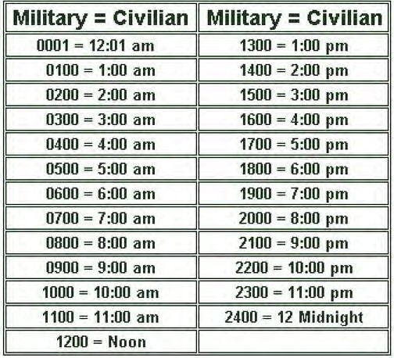
Minutes are listed in the third and 4th number position. So, 5:15 AM is 0515 hrs. 12:17 AM is 0017 hrs. 10:30 PM is 2230 hrs.

Phonetic Alphabet
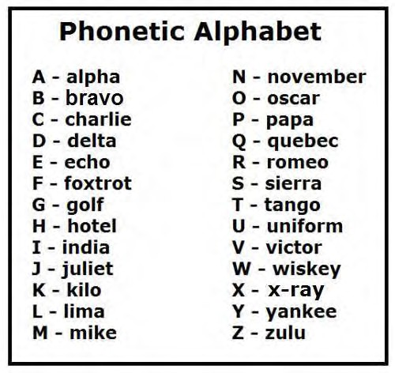

Army Officer Branches
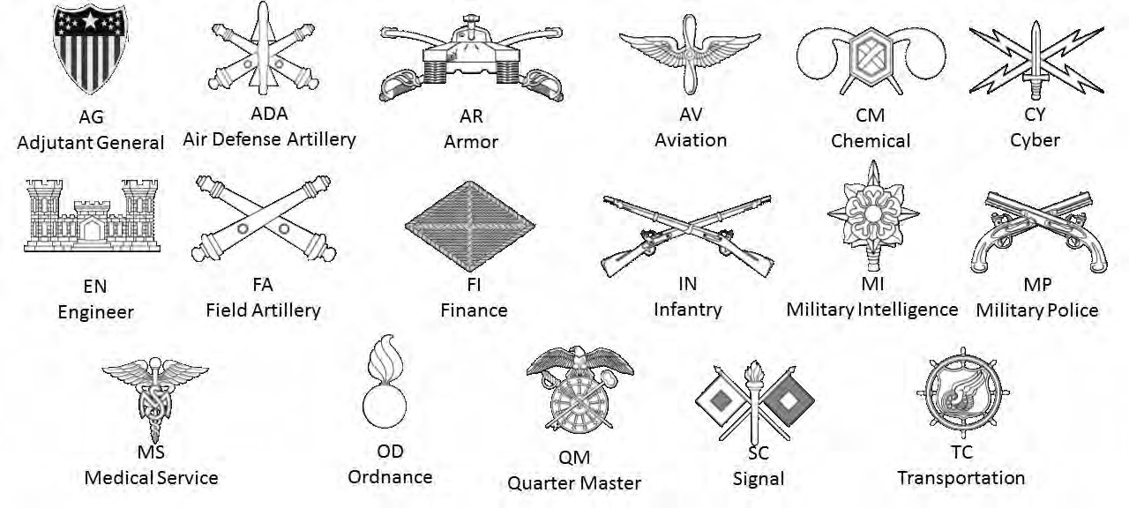

Chain of Command
- Army Chain of Command: One of the most basic concepts in the military is the Chain of Command. The Chain of Command is a succession of commander’s senior to subordinate in which command is exercised. You will receive instruction on how the chain of command works in your Military Science class. Official communications flow through this chain. Most importantly, all individuals must take the responsibility of informing those above and below you of anything that may be of concern.

- The NCO Support Channel: is subordinate to and supportive of the chain of command. The NCO support channel is not an independent channel. It is incumbent on the users of this channel to ensure that the chain of command is kept informed of actions implemented through the NCO support channel and to eliminate the possibility of the NCO support channel operating outside of command policy and directives. Problems should be brought to the attention of the chain of command and resolved through a coordinated effort. Since the NCO support channel should be operating in accordance with established command policy and directives, conflicts should be minimal and easily resolved.
The connection between the chain of command and the NCO support channel is the senior NCO. Commanders issue orders through the chain of command, but senior NCOs must know and understand the orders to issue effective implementing instructions through the NCO support channel. Although the first sergeant and command sergeants major are not part of the formal chain of command, leaders should consult them on individual Soldier matters. In units at the battalion level and higher, the NCO support channel is the communication and supervision that begins with the command sergeant major (CSM), extends through first sergeants and platoon sergeants and ends with section chiefs, squad leaders, or team leaders. In addition to passing information, this channel is used for executing the commander’s orders and getting routine, but important, jobs done. Most often it is used to put into effect policies and procedures and to enforce standards of performance, training, appearance and conduct.

Chain of Command | NCO Support Channel
Commander-in-Chief | N/A
Secretary of Defense | N/A
Secretary of the Army | N/A
Chief of Staff of the Army | Sergeant Major of the Army
TRADOC Commander | TRADOC CSM
Cadet Command Commander | Cadet Command CSM
Brigade Commander | Brigade CSM
Battalion Commander (PMS) | Battalion CSM (SMI)
Cadet Battalion Commander |  | Cadet Battalion CSM
Company Commander |  | Company 1SG
Platoon Leader | Platoon Sergeant
**Squad/Section Leader | **Squad/Section Leader

**The Squad/Section Leader is the only individual that is in both the Chain of Command and the NCO Support Channel.

Successful officers have a good leader and NCO relationship with their first sergeants and command sergeants major. This leaves the commander free to plan, make decisions and program future training and operations. The need for such a relationship applies to platoon leaders and platoon sergeants as well as to staff officers and NCOs. Senior NCOs have extensive experience in successfully completing missions and dealing with enlisted Soldier issues. Also, senior NCOs can monitor organizational activities at all levels, take corrective action to keep the organization within the boundaries of the commander’s intent, or report situations that require the attention of the officer leadership. Regardless of where the information or task begins – in the chain of command or in the NCO support channel – keep the counterpart informed. A positive relationship between officers and NCOs creates conditions for success. Cadets will wear rank in accordance with the promotion criteria.

Army Rank Structure Enlisted Rank
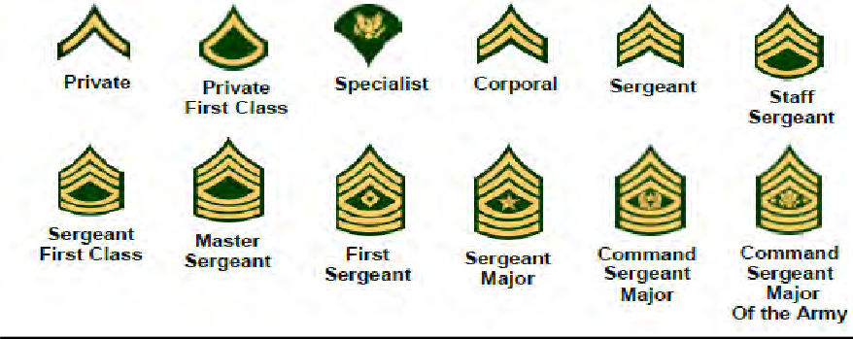

Warrant Officer Rank
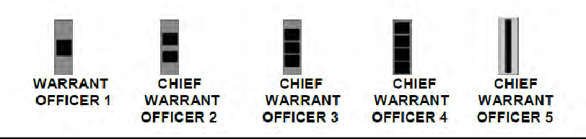
Officer Rank
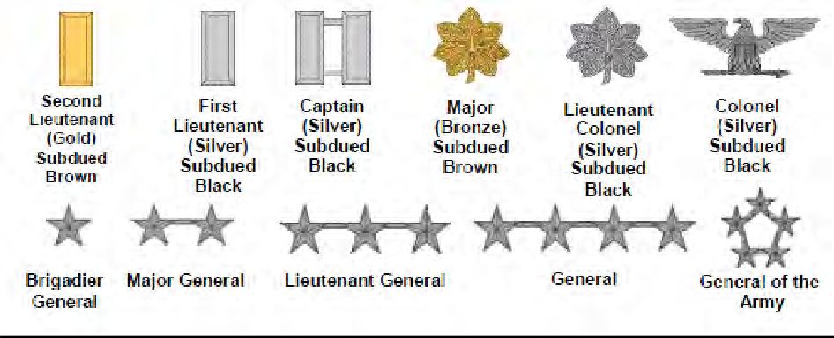
Cadet Enlisted Rank
 |  |  |  | 
CADET PRIVATE (c/PVT/PV2) | CADET PRIVATE FIRST CLASS  (c/PFC) | CADET CORPORAL  (c/CPL) | CADET SERGEANT  (C/SGT) | CADET STAFF SERGEANT  (C/SSG)
 |  |  | 
CADET SERGEANT FIRST CLASS  (C/SFC) | CADET MASTER SERGEANT  (C/MSG) | CADET FIRST SERGEANT  (C/1SG) | CADET SERGEANT  MAJOR (C/SGM)

Cadet Officer Rank
 |  |  |  |  | 
CADET SECOND | CADET FIRST | CADET | CADET MAJOR | CADET | CADET
LIEUTENANT | LIEUTENANT | CAPTAIN | (c/MAJ) | LIEUTENANT | COLONEL
(c/2LT) | (c/1LT) | (c/CPT) |  | COLONEL | (c/COL)
 |  |  |  | (c/LTC)

Cadet Duties and Responsibilities
- BATTALION COMMANDER (BC)
  - Exercises authority over the battalion by virtue of rank and assignment. The c/BC uses available resources and is responsible for planning organizing, directing, coordinating, and controlling the battalion for the accomplishment of assigned missions. Gives guidance on battalion training and sets and approves all cadet plans and policies. Sets the example of cadet leadership and the tone for professional performance of the battalion as a whole.
- BATTALION COMMAND SERGEANT MAJOR (CSM)
  - The CSM is the senior enlisted Soldier in the battalion and principle adviser to the BC
  - The CSM is responsible for the battalion’s welfare, morale, and training.
  - Responsible for coaching and mentoring the junior NCOs in the leadership development.
- BATTALION EXECUTIVE OFFICER (XO)
  - The XO is second in command. As the battalion’s “chief of staff”, and 2nd in charge (2IC), he or she must be prepared to assume the duties of the battalion commander at any time.
  - The commander may use the XO to operate the unit’s main CP, the alternate CP, or supervise overall logistical support depending on mission requirements and METT-T.
  - Coordinating staff actions (S1, S2, S3, S4, S5, and AMA) are the responsibility of the XO.
  - The XO has primary responsibility for the following areas:
  - Establishing staff operating procedures (MDMP)
  - Ensuring the commander and the staff are informed on matters affecting the command
  - Assembling and supervising the staff during the decision-making process
  - Ensuring information flow between the staff and commander on the staff’s recommendations and the commander’s decisions
  - Representing the commander (as required) and supervising main CP and its operations
  - Supervising unit status reporting and all tasking’s.
  - Coordinating all logistical and budgetary actions.
- BATTALION ADJUTANT (S1)
  - The S1 is responsible for all personnel and administrative actions.
  - Publishes orders announcing promotions, reductions, and awards.
  - Prepares alert and attendance rosters, training attendance records, and maintains these records on the battalion computer network.
- BATTALION OPERATIONS OFFICER (S3)
  - The S3 plans all operations and works closely with the Cadre S3, the Cadet Training Officers, Company Commanders and 1SGs, and Lab Instructors.
  - Prepares the annual training calendar, coordinates the use of all training aids, ensures rehearsals are being performed prior to all training, supervises training, prepares the FTX operations order and publishes all garrison orders.

  - Overall responsible for the Battalion PT Program; executes all monthly Army Physical Fitness Tests (APFTs) and maintains APFT records.
- BATTALION SUPPLY OFFICER (S4)
  - Processes requests for supplies from the Cadets and ensures all Cadets are supplied with all necessary clothing and equipment.
  - Coordinates transportation for all training events and arranges the acquisition, storage, transportation, and accountability of all weapons, ammunition and communication equipment.
- BATTALION RECRUITING AND RETENTION OFFICER (CRO)
  - Coordinates all recruiting efforts during the school year and assists the Recruiting Operations Officer (ROO) and Gold Bar Recruiter (GBR).
  - Serves as Social and Financial Committee Chairperson and maintains cadet fund.
  - Plan and execute all retention, alumni, and morale activities including the Military Ball, Dining In, and fundraising activities.
- BATTALION SIGNAL OFFICER (S6)
  - Responsible for maintaining and updating the school’s Army ROTC Website and Facebook page.
  - Responsible for publicizing unit events and for publishing a monthly newsletter.
  - Coordinates Alumni Activities and publishing an Alumni Newsletter each semester.
- BATTALION ACADEMIC MENTORSHIP OFFICER
  - Responsible for the Academic Mentor Program.
  - Research and publish list of available tutors within each school of study.
  - Recruit mentors from within the Battalion for Cadets needing assistance.
  - Track progress of mentor program and mentored Cadets. Keep cadre informed.
- COMPANY COMMANDERS (CO)
  - Commands the company. Responsible for everything the company does or fails to do.
  - Receives missions from Battalion and plans and executes those missions and tasking’s.
  - Rehearsals are critical. Make sure Platoon Leaders, Platoon Sergeants, and Guidon Bearers know their positions and their jobs.
  - The plan is yours. Ensure you know what is expected of your unit. Your briefing must be complete and detailed. After briefed – no one should be in doubt of what to do. Pay attention to details; try to find and fix problems in your plan; have back-up plans.
  - Recon the training site. Look for where to have formations, where to ground gear, etc. Ask to be taken there in order to recon.
  - Use your XO. Assign specific supervisory jobs. Then follow up to ensure completion.
  - Keep your meetings brief. Time is critical.
  - Make sure your people carry only the minimum essential equipment.
  - If marching, keep control of the lead platoon; the others will follow.

  - If moving by vehicle, ensure you know how many actually got on the trucks. It takes 10 minutes or better to board vehicles and get a head count. Don’t under plan or you’ll be late.
  - Weapons security/sensitive items are very important. Personnel and equipment counts should occur a minimum of twice a day.
  - Formations at training sites are very important. The XO should place the Guidon bearer properly after receiving guidance from the site’s cadre.
  - Don’t allow your unit to just “mob” into training areas. Have platoons march! Have them file into the bleachers.
  - Know the company’s status report all day. Ensure you are informed of changes. Inform cadre.
  - At the end of the day, don’t leave the training site until all equipment is accounted for. Weapons accountability is critical.
  - Be polite and show interest in your debriefing by the cadre. Be open to improvement.
  - Be a professional.
- PLATOON LEADER (PL)
  - PLs command platoons and are responsible for everything your platoon does or fails to do. You are in charge. Success will come only from maximum effort in planning and execution.
  - Receives missions from Company and plans and executes those missions and tasking’s.
  - Keep your NCO’s informed; you need active assistance of your platoon NCOs.
  - Talk to the individual who was in the same leadership position before; gain lessons learned.
  - DON’T TRY TO DO IT ALONE.
  - Be prepared for FRAGOs. It’s a test to see how you react.
  - While your PSG conducts formation, you can check each person’s gear.
  - Make on the spot corrections.
  - Practice your D&C commands. Know your D&C. -When you are conducting formation, be careful about your posture and your commands; Give commands only from the Position of Attention.
  - If you have to do something unusual like stacking rifles – add rehearsal time before formation. Be professional, but don’t waste people’s free time. Remember, you are responsible for the morale of your unit.
  - Write up a timeline for yourself and your PSG. It should detail actions and responsibilities.
  - Make sure everyone understands your orders and plans. Be specific. Don’t assume anything.
  - Be confident. If you give the wrong command, just regain control and continue. (No one expects perfection.)
  - Use a WARNING ORDER for upcoming events and a tentative timeline. The platoon will be scattered by the time you get back from your company meeting.
  - If your platoon is divided up, you go with one section, your platoon sergeant with the other.
  - Make sure you know everything in the platoon. You are expected to know statuses, equipment issued, personnel locations, and issues.

  - PLAN AHEAD! Anticipate problems. Meet time hacks.
  - In the field, leaders eat last. Look out for the welfare of your people.
  - Avoid surprises. You will only be surprised if you are not supervising.
  - Be professional in everything. Be aggressive but maintain poise.
  - Don’t keep your unit at attention or parade rest. Give them at ease or rest while waiting around.
  - After training, you are not finished until the last person in your platoon is finished.
  - Keep cadre informed. Don’t wait for them to ask for your problems or status.
  - You can call cadences when marching, but this is usually the platoon sergeant’s duty.
- PLATOON SERGEANT (PSG)
  - You are the senior NCO in the platoon and second in succession of command. You help and advise the platoon leader, and lead the platoon in the platoon leader’s absence.
  - Know the training Task, Conditions, and Standards. You will be spot checking.
  - Know how to conduct a formation.
  - You are responsible for weapons and equipment accountability, leave a guard. Be sure they get relieved. Assign one of your squads the responsibility.
  - Always know where your platoon members are. Count your people as they load the vehicles.
  - After the squad leaders brief their people, spot check various individuals to ensure the people are getting the right information.
  - Ensure you are always on time, leaders must be there first.
  - Constantly anticipate problems in order to mitigate them.
- SQUAD LEADER (SL)
  - This person is the doer – you will be directly responsible to accomplish the various objectives assigned. The squad members will look to you for example and direction. Know your squad members – the quicker you learn names, the better.
  - Keep informed – know the schedule, know what is required of your squad and to what standards; ensure they know everything you know.
  - Maintain accountability of people and equipment. Constantly check gear – you’ll be surprised how many times squad members will lose or misplace sensitive items. There is a certain way to wear your gear, check it at every formation.
  - Make sure every person knows their duties and what is expected of them all day. Don’t run a “hey-you” roster. Brief your people thoroughly.
  - Inspect equipment before training—pre-combat checks (PCC). Give yourself time to fix issues. You even have to check to make sure people wear their Kevlar properly. CHECK EVERYTHING!
  - Know each member’s health status; ensure they drink enough water to avoid heat injuries.
  - Don’t let others run your squad. If it is your time to lead, accept advice – but YOU make the decisions.
  - Set clear standards. Use visual aids. If you are having a field gear layout, lay your equipment out before your meeting. That way everyone sees how to do it.
  - You are responsible for motivation. SET THE EXAMPLE. Don’t fall asleep at training. Help keep others awake.

  - Upon returning to the unit area, you are not finished until all of your people have cleaned and turned in any equipment necessary.
k. Team Leaders should assist you. Don’t plan on always being with your squad. Something always comes up that will take you away from them for a while.
- TEAM LEADER (TL)
  - The NCO Corps is known as the backbone of the Army, corporal is the backbone of the NCO Corps. Team Leaders normally wear the rank of corporal. This rank was established in 1775 with the birth of the Army and the NCO Corps.
  - The Team Leader is a leader who leads by personal example and helps the squad leader as required.
  - He controls the movement of the fire team and the rate and placement of fire by leading from the front and using the proper commands and signals.
  - Like the squad leaders, team leaders are responsible for individual training, personal appearance and cleanliness of their Soldiers.
  - Team leaders maintain accountability of his Soldiers and equipment. He ensures the Soldiers maintain the unit standards in all areas.
- TEAM MEMBER
  - Team members are responsible for themselves, their uniform, appearance, bearing, and knowledge of required military and academic material.
  - Team members should actively participate in unit activities and be a positive part of the team.

Leadership Development Program
The Leadership Development Program (LDP) is an individual focused training process design to develop leadership skills in a variety of training environments. It is administered on campus by a primary assessor, either Military Science Instructor or ML IV, and at Advanced Camp by Platoon and Company level OTMs. The LDP uses an integrated system of structured leadership opportunities to maximize leadership potential and predict success as a lieutenant. Periodically, Cadet progress is determined and individual potential to lead Soldiers gauged. The LDP seeks to develop Cadets into officers using the Leadership Requirement Model.

LEADERSHIP REQUIREMENTS MODEL
The Leadership Requirements Model conveys the expectations that the Army wants leaders to meet. A common model of leadership shows how different types of leaders work together and is useful for aligning leader development activities and personnel management practices and systems. One set of requirements consists of attributes of what leaders should be and know and the second is a set of competencies that the Army requires leaders to do. The single model organizes the disparate requirements and expectations of leaders at all levels of leadership.

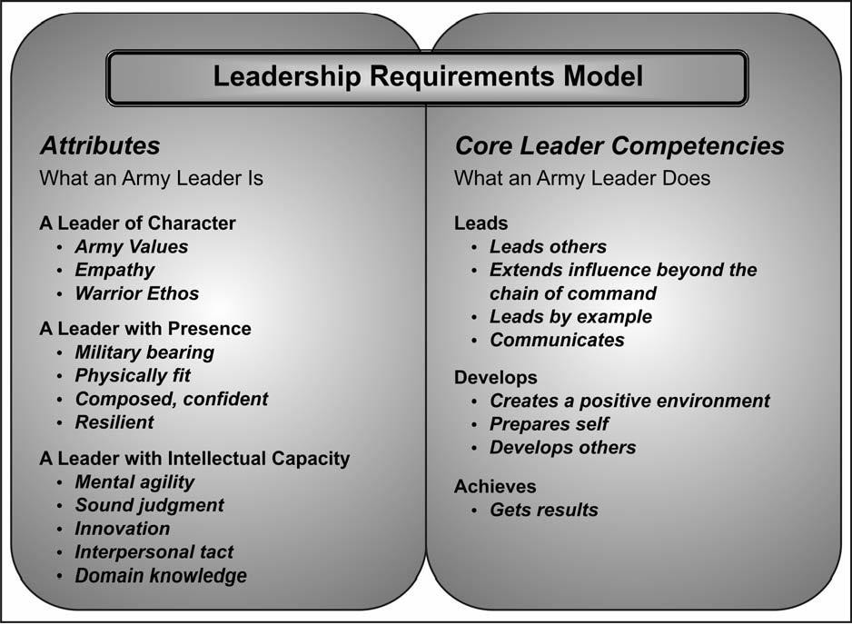

Leadership attributes are characteristics internal to a leader. Character is the essence of who a person is, what a person believes, how a person acts. The internalization of Army Values is one type of character attribute. Empathy is identifying and understanding what others think, feel and believe. Leaders of character who embrace the Army leader attributes and competencies will be authentic, positive leaders. While character relates to the internal identity of the leader, presence attributes relate how others see the leader and intellect relates to what abilities and knowledge the leader possesses to think and interact with others.

Leadership competencies are groups of related actions that the Army expects leaders to do—lead, develop and achieve. Core competencies are those groups of actions universal to leaders, across cohorts and throughout organizations.
The ROTC Leadership Development Program (LDP) at Clemson University Army ROTC will focus on the following key elements:
- Develop leaders of character
- Systematic problem-solving and self-analysis skills
- Complements skills lieutenants are expected to possess
- Enhances self-sufficiency and ability to lead in unfamiliar situations
- Provides valuable insight to leadership potential
- Evaluate Cadets in the 19 leadership dimensions, the 7 Army Values, Empathy and the Warrior Ethos listed above, throughout their academic and ROTC career.
- Allow for early exposure of Cadets to the LDP process.
- Provide cadre with a standardized measurement tool.
- Provide a vehicle for constructive feedback to Cadets concerning their performance and leadership development.
ii. ML III Cadets will rotate through a variety of leadership opportunities from Squad Leader up to CSM.
iv. MLIVs will mentor and teach their respective ML III's during the first Battalion and Advanced Labs. TACs will utilize these opportunities to assess strengths and weaknesses, provide good feedback, and relate CLC experience to that Cadet. MLIVs will informally counsel their respective ML III using abbreviated counseling’s identifying two strengths and two weaknesses for the first two weeks of performance. The ML III will take what he/she has learned and apply it to their formal leadership opportunities mentioned above. A fair, objective evaluation is the culminating point of the LDP.
v. All leadership evaluations will require a verbal counseling and a written DA 4856 if time permits.
- Counseling Assignments: Evaluated Position Evaluator
  - CO CDR CTO (after Fall Break)
  - CO XO CEO (after Fall Break)
  - CO 1SG CTO
  - PL PTO (after Fall Break)
  - PSG PTO
  - SL CEO/PL
  - PT Instructor Cadre/Cadet Staff
  - Adv. Lab PL/PSG Cadre/Cadet Staff
  - Tactical Lab Leadership positions Cadre/Cadet Staff

The Cadet’s leadership position is based on his/her year in the program. As the Cadet progresses, he/she will become exposed to more and more LDP. The bulk of the Cadet’s evaluation occurs during the MLIII year. The below schedule depicts the LDP activities by ML year.
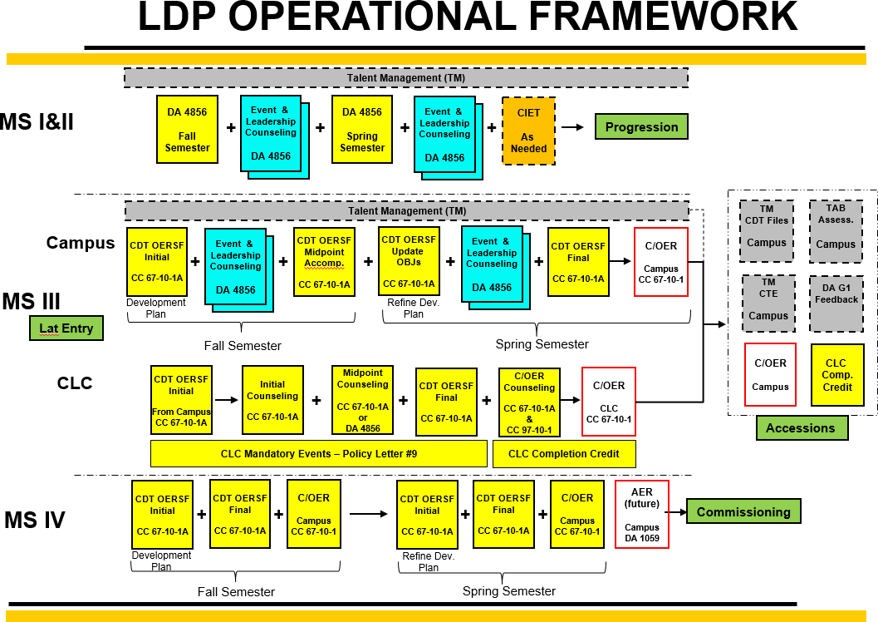
ROTC Cadet Responsibilities:
- Effort
  - Display reasonable effort toward achieving training objectives to include physical fitness
  - Requires knowledge of Cadet’s history, capabilities, limitations
  - Effort does not guarantee success; Recognize effort separately and consider it accordingly
- Trend toward Growth
  - Show a trend of growth over time
  - Rate of expected growth varies with situation
- Contribution to the Team
  - Expected to work as a member of a coordinated effort
  - Individual strengths must be selflessly directed to benefit the unit
- Enthusiasm
  - Display sincere enthusiasm and commitment to duties at hand

Clemson ML Year Line of Effort / Activity
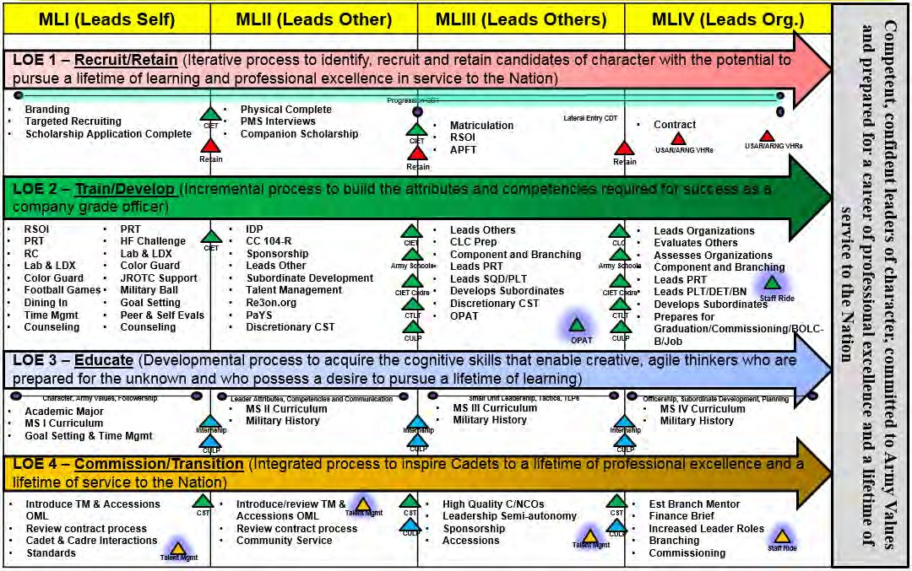
MLI. Leads Self. Introduction to LDP in the Fall Semester. Select personnel will be assigned to team leader positions during the spring semester
MLII. Leads Others. In-depth instruction on the 19 Leadership dimensions, LDP process and leadership assessment management (counseling’s, etc.). Will serve as team leaders during the fall semester and squad leaders during the spring semester. Some ML II’s will also be given the opportunity to conduct PRT.
MLIII. Leads Others. Evaluation of multiple leadership opportunities per Cadet in various leadership roles (70% Garrison / 30% Tactical). During the fall semester, ML III’s will serve in all the NCO positions (1SG, PSG and SL). During the spring semester, ML III’s will serve in all company leadership positions (platoon sergeant to company commander).
MLIV. Leads Organization. MLIV Cadets lead the battalion in aspects of the operations – plan, prepare, execute, and asses – with direct cadre oversight. The focus is to prepare MLIV Cadets to commission and serve as competent leaders of character for the United States Army and the Nation.

Military Courtesies and Appearance
Military Courtesies: Cadets must at all times practice conventional politeness and render all military courtesies because their actions reflect on the highest traditions of Clemson University, Army ROTC, and the US Army.
Salutes: Saluting is one of the oldest military customs, and is rendered as a sign of respect. A mechanical or sloppy salute is discourteous. As part of your initial training you will be taught to master a "sharp" salute and to render it with respect and recognition. Look at the person you salute. When encountering or reporting to a superior officer, all Tiger Battalion Cadets will render the salute and greet with “This We’ll Defend, Sir/Ma’am!” Hold the salute until it is returned with the response of “Go Tigers!” Learn the greeting well; deliver it with pride. As a junior officer, you can expect the same.
  - Salutes are exchanged when outdoors upon recognition (usually within 6-12 paces) of commissioned officers of all services. The same applies to cadet officers and basic and advanced Cadets, with the junior member saluting first. Saluting applies outdoors only when in uniform (to include PT uniform).
  - Salutes are not required indoors, except for formal reporting procedures and when entering or exiting the commander’s office.
  - Individuals in formation do not salute or return salutes, except at the command of "Present Arms". The individual in charge of a formation salutes and acknowledges salutes for the whole formation. Platoon Leaders of platoons that are not part of the formation salute officers of higher grade by bringing the platoon to attention before saluting.
  - Individuals in a group, but not in formation, are called to attention by the first person that sees a senior officer approaching. All come to attention, face the officer and render the hand salute. The salute is rendered only once if the officer remains in the immediate vicinity and no conversation takes place. If conversation occurs, the senior officer is saluted upon departing.
  - In the academic classroom, the normal military courtesy is to call the class or those in the room to attention when the officer instructor or other senior official enters.
  - Do NOT salute when carrying articles in both hands. Do NOT shift articles to both hands to avoid rendering a salute. Verbally greet an officer if you are unable to return or render a salute.
  - In public gatherings, such as sports events or meetings, or when a salute would be inappropriate or impractical, salutes among individuals need not be rendered, although the appropriate greeting or acknowledgement should be rendered.
Reporting and Office Calls: When entering the office to speak to cadre personnel, knock and request permission to enter. After obtaining permission to enter the office of a commissioned officer, walk to a position two steps in front of the desk and come to attention. If reporting (after being summoned), salute, and report “sir/ma’am, Cadet reports.”
Addressing Officers, NCOs, and other Soldiers: When speaking to a commissioned officer, stand at the position of attention, and make proper use of their title. E.g. “Captain Smith,” “Lieutenant Jones,” “Sir,” or “Ma’am.” Remain at attention until told otherwise. When addressing multiple officers, address the senior officer as appropriate. When addressing an officer in a group of officers where that officer is not the senior officer, acknowledge the senior

officer before conducting other business. When speaking to a senior non-commissioned officer, stand at parade rest and address them with their proper title. Address individuals in the grades of Sergeant thru Master Sergeant as “Sergeant”, address a First Sergeant as “First Sergeant” and address a Sergeant Major (SGM or CSM) as “Sergeant Major.” Cadets are addressed as “cadet” followed by the Cadet’s last name. Soldiers are addressed as simply “Private ,” “PFC
,” or “Soldier” (if one does not know him or her). Cadets will always follow instructions of NCOs without question and afford them the proper respect described above.
Calling a Room to Attention: When indoors, even in the lounge, and an officer enters the room, the first cadet to see the entering officer will call the room to attention. For NCOs, Cadets call the room to “at ease” and stand up at attention or at ease until directed otherwise by the officer or NCO.
National Anthem or To the Colors: The US flag is symbolic of the United States and the principles for which it stands. The National Anthem is the declaration of reverence and loyalty to the US with the flag as an emblem. On certain occasions, such as during inclement weather or when no band is present for the retreat ceremony, “To The Colors” is played instead of the National Anthem. “To The Colors” is a bugle call sounded as a salute to the flag, as is the National Anthem. The Flag and the United States are thought of as being one and the same therefore, anytime the National Anthem or “To The Colors” is played, the proper courtesy must be rendered as prescribed in the following paragraphs:
  - When in formation, but not part of a ceremony: The unit should be faced toward the flag or (if no flag is present) toward the music. The unit commander commands “Present Arms" when the National Anthem or To the Colors is playing.
  - When outdoors in uniform (to include PT uniform), but not in formation: Face the flag or (if no flag is present) the music and salute. At sporting events, if no flag is visible and the music is recorded, face front and salute. At the end of the duty day when Retreat and “To The Colors” is played, unit commanders will command their units to “Parade Rest” for the playing of Retreat. At the conclusion of Retreat, unit commanders will command their units to “Attention” and “Present Arms”. Individuals not in formation will stand at the position of Attention for Retreat and render the hand salute for “To The Colors”.
  - When indoors in uniform (to include PT uniform), but not in formation: Take the position of attention facing the flag or (if no flag is present) the music. Do NOT salute unless under arms. Playing of the National Anthem or “To The Colors” on radio or TV does not require any action.
  - When in civilian clothing: Take the same action as when in uniform, except the manner of rendering honors is different. Stand at attention, remove any headgear, and place your right hand over your heart.
  - When in a vehicle: The driver brings a moving vehicle to a stop at the first note of the National Anthem or “To The Colors” and all dismount, face the flag or (if no flag is present) the music, and render the appropriate salute or honor.
The Army Song. The official song of the Army is “The Army Goes Rolling Along.” It is customary for all members of the Army, in or out of uniform, to stand at attention and face the music during the play of the Army song.

Wear of the Uniform (See pages at end of this section for illustrations). The US Army uniform represents a proud tradition predating the beginning of the United States as a sovereign nation.
The ROTC uniform is a descendant of the original and should be worn correctly and proudly. A Cadet in uniform attracts attention and identifies the Cadet as a member of Army ROTC at Clemson University. Your appearance reflects not only on you, but also on the Tiger Battalion and US Army. The information in this section will help you wear the uniform correctly. You will receive additional assistance from your Squad Leader. Your Cadet Chain of Command will also be checking for proper fit and wearing of your uniform. The exact manner for wear and appearance of the uniform is prescribed by AR 670-1, AR 145-1, and CC Reg 670-1. Cadets must conform to these regulations at all times when in uniform. Unserviceable or ill-fitting uniform items may be exchanged with the Supply Technician for a properly fitting replacement. The important maxim to remember is: wear the uniform properly or don't wear it at all.
  - The ACU uniform is authorized for wear on campus on Wednesday and Thursday during the school year. The following are general guidelines for wear:
  - Uniforms must be properly fitted, clean, serviceable, and pressed, as necessary. Uniforms must be worn buttoned, zipped, or snapped. Metallic uniform items must be highly shined. Footgear must be clean and/or highly shined if required.
  - Uniforms must be complete and unmixed. Never mix uniform items with civilian clothing, except for footgear and all-weather coat worn without insignia.
  - Alternations and tailoring, as required, must be arranged through the Supply Technician. Cadets may make only minor repairs such as sewing-on a button.
  - Appropriate headgear must be worn outdoors and removed when indoors.
  - A conservative personal wristwatch, identification wrist bracelet, and not more than two rings are authorized if in good taste.
  - While in uniform, personnel will not place their hands in their pockets except to retrieve or place objects.
  - Religious medals on a chain may be worn if neither medal nor chain is exposed.
A complete Army Service Uniform (ASU) will be issued to all MLII/III/III Cadets and as available to ML1 Cadets. Only prior service Cadets will be authorized the wear of CSIB, Service Stripes, Overseas Service Bars, Awards, Special skill badges and Ribbons.

Military Appearance
Fightin’ Tiger Battalion Cadets wear the United States Army ROTC uniform. According to Cadet Command Regulation 670-1, this uniform is indistinguishable from the US Army enlisted Soldier uniform, other than by insignia. While wearing the uniform Cadets must meet prescribed Army standards of bearing and appearance in accordance with Army Regulation 670-1. You will receive an in-depth briefing concerning these standards early in the semester, but the following will get you started.

What the Army uniform represents
For Soldiers it means that they are part of something far bigger than themselves…it is an opportunity to serve this great country and to make a difference in this world. For Army families, the uniform is a source of both pride and anxiety, knowing the sacrifices ahead. For our veterans, it represents one of the most important periods of their lives…pride in service, accomplishments, and a life-long connection to the comrades that they served with and in some cases lost during

their time in uniform. Our Veterans are Soldiers for Life. For the American citizen, Soldiers are their sons, daughters, relatives, neighbors, and during disaster, their lifeline. They see in us patriotism and selfless service—men and women in whom the Nation takes collective pride and who they see as heroes. And as heroes, they become disappointed and disillusioned when we do not live up to their expectations. People around the world recognize the American Soldier as a symbol of the United States…Soldiers represent freedom, democracy, and stability. To our allies, Soldiers presence signals an American commitment during a crisis. To our enemies, the American Soldier represents strength and resolve, and a commitment to defend the Values that we hold dear as a Nation and as a people.

Hair and fingernail standards and grooming policies.
General - There are many hairstyles that are acceptable in the Army. So long as the cadet's hair is kept in a neat, clean manner, the acceptability of the style will be judged solely by the criteria described below. Extreme or fad style haircuts or hairstyles are not authorized. If dyes, tints, or bleaches are used, colors used must be natural to human hair and not present an extreme appearance. Lines or designs will not be cut into the hair or scalp. Styles of hair and texture differ among the different ethnic groups and these differences affect the length and bulk of hair as well as the style worn by each cadet. Haircuts, without reference to style, will conform to the following standards.

Male Hair.
  - The hair on top of the head must be neatly groomed. The length and bulk of the hair may not be excessive or present a ragged, unkempt, or extreme appearance. The hair must present a tapered appearance. A tapered appearance is one where the outline of the Soldier’s hair conforms to the shape of the head curving inward to the natural termination point at the base of the neck. When the hair is combed, it will not fall over the ears or eyebrows, or touch the collar, except for the closely cut hair at the back of the neck. The block-cut fullness in the back is permitted to a moderate degree, as long as the tapered look is maintained. Males are not authorized to wear braids, cornrows, or dreadlocks (unkempt, twisted, matted, individual parts of hair) while in uniform, or in civilian clothes on duty. Haircuts with a single, untapered patch of hair on the top of the head (not consistent with natural hair loss) are considered eccentric and are not authorized. Examples include, but are not limited to, when the head is shaved around a strip of hair down the center of the head (mohawk), around a u-shaped hair area (horseshoe), or around a patch of hair on the front top of the head (tear drop). Hair that is completely shaved or trimmed closely to the scalp is authorized.
Sideburns. Sideburns are hair grown in front of the ear and below the point where the top portion of the ear attaches to the head. Sideburns will not extend below the bottom of the opening of the ear.
  - Sideburns will not be styled to taper, flair, or come to a point. The length of an individual hair of the sideburn will not exceed 1/8 inch when fully extended.
Facial hair. Males will keep their face clean-shaven when in uniform, or in civilian clothes on duty. Mustaches are permitted. If worn, males will keep mustaches neatly trimmed, tapered, and

tidy. Mustaches will not present a chopped off or bushy appearance, and no portion of the mustache will cover the upper lip line, extend sideways beyond a vertical line drawn upward from the corners of the mouth or extend above a parallel line at the lowest portion of the nose Handlebar mustaches, goatees, and beards are not authorized. If appropriate medical authority allows beard growth, the maximum length authorized for medical treatment must be specific. For example, “The length of the beard cannot exceed 1/4 inch” (see Training Bulletin Medical (TB Med) 287). Cadets will keep the growth trimmed to the level specified by the appropriate medical authority, but are not authorized to shape the hair growth (examples include, but are not limited to goatees, “FuManchu,” or handlebar mustaches).
  - Wigs and hairpieces. Males are prohibited from wearing wigs or hairpieces while in uniform, or in civilian clothes on duty, except to cover natural baldness or physical disfiguration caused by accident or medical procedure. When worn, wigs or hairpieces will conform to the standard haircut criteria, as stated within this regulation.
Female haircuts and hairstyles. The requirements for hair regulations are to maintain uniformity within a military population for female Soldiers while in uniform, or in civilian clothes on duty, unless otherwise specified. Female hairstyles may not be eccentric or faddish and will present a conservative, professional appearance. For the purpose of these regulations, female hairstyles are organized into three basic categories: short length, medium length, and long length hair.
  - Short length. Short hair is defined as hair length that extends no more than 1 inch from the scalp (excluding bangs). Hair may be no shorter than 1/4 inch from the scalp (unless due to medical condition or injury), but may be evenly tapered to the scalp within 2 inches of the hair line edges. Bangs, if worn, may not fall below the eyebrows, may not interfere with the wear of all headgear, must lie neatly against the head, and not be visible underneath the front of the headgear. The width of the bangs may extend to the hairline at the temple.
  - Medium length. Medium hair is defined as hair length that does not extend beyond the lower edge of the collar (in all uniforms), and extends more than 1 inch from the scalp. Medium hair may fall naturally in uniform, and is not required to be secured. When worn loose, graduated hair styles are acceptable, but the length, as measured from the end of the total hair length to the base of the collar, may not exceed 1 inch difference in length, from the front to the back. Layered hairstyles are also authorized, so long as each hair’s length, as measured from the scalp to the hair’s end, is generally the same length giving a tapered appearance. The regulations for the wear of bangs detailed in paragraph (a), above, apply. No portion of the bulk of the hair, as measured from the scalp, will exceed 2 inches.
  - Long length. Long hair is defined as hair length that extends beyond the lower edge of the collar. Long hair will be neatly and inconspicuously fastened or pinned, except that bangs may be worn. The regulations for the wear of bangs detailed in paragraph (a), apply. No portion of the bulk of the hair, as measured from the scalp, will exceed 2 inches (except a bun, which may extend a maximum of 3 inches from the scalp) and be no wider than the width of the head.
  - Additional hairstyle guidelines. Faddish and exaggerated styles, to include shaved portions of the scalp other than the neckline, designs cut in the hair, unsecured ponytails (except during physical training), and unbalanced or lopsided hairstyles are prohibited.

Hair will be styled so as not to interfere with the proper wear of all uniform headgear. All headgear will fit snugly and comfortably around the largest part of the head without bulging or distortion from the intended shape of the headgear and without excessive gaps. When headgear is worn, hair should not protrude at distinct angles from under the edges. Hairstyles that do not allow the headgear to be worn in this manner are prohibited.
Examples of hairstyles considered to be faddish or exaggerated and thus not authorized for wear while in uniform, or in civilian clothes on duty, include, but are not limited to, locks and twists (not including French rolls/twists or corn rows); hair sculpting (eccentric directional flow, twists, texture, or spiking); buns or braids with loose hair extending at the end; multiple braids not braided in a straight line; hair styles with severe angles; and loose unsecured hair (not to include bangs) when medium and long hair are worn up.

Devices. `
Soldiers will not place hair holding devices in the hair for decorative purposes. All hair holding devices must be plain and of a color as close to the Soldier’s hair as is possible or clear. Authorized devices include, but are not limited to, small plain scrunchies (elastic hair bands covered with material), barrettes, combs, pins, clips, rubber bands, and hair/head bands. Such devices should conform to the natural shape of the head. Devices that are conspicuous, excessive, or decorative are prohibited. Some examples of prohibited devices include, but are not limited to: large, lacy scrunchies; beads, bows, or claw or alligator clips; clips, pins, or barrettes with butterflies, flowers, sparkles, gems, or scalloped edges; and bows made from hairpieces. Soldiers may not wear hairnets unless they are required for health or safety reasons, or in the performance of duties (such as those in a dining facility). No other type of hair covering is authorized in lieu of the hairnet. The commander will provide the hairnet to the Soldier at no cost to the Soldier.
  - Braids. Medium and long hair may be braided. Multiple braiding (defined as more than two braids) is authorized. When worn, multiple braids will be of uniform dimension, small in diameter (approximately 1⁄4 inch), show no more than 1/8 of an inch of scalp between the braids and must be tightly interwoven to present a neat, professional, well-groomed appearance. Foreign material (for example, beads and decorative items) will not be braided into the hair. Braids must continue to the end of the hair in one direction, in a straight line, and can be worn loose per medium hair length guidelines or secured to the head in the same manner as described for medium or long length hair styles. Ends will be secured only with inconspicuous rubber bands. If multiple braids are worn, they must encompass the whole head. When braids are not worn loosely and braided close to the scalp, the braids must start at the front of the head.
  - Twists. Twists are defined as twisting two distinct strands of hair around one another to create a twisted ropelike appearance. Although some twists may be temporary, and can be easily untwisted, they are unauthorized (except for French twists). This includes twists formed against the scalp or worn in a free-hanging style.
  - Dreadlocks. Dreadlocks are defined as any matted, twisted, or locked coils or ropes of hair (or extensions). Any style of dreadlock (against the scalp or free-hanging) is not authorized. Braids or cornrows that are unkempt or matted are considered dreadlocks and are not authorized.
  - Cornrows: Cornrows are defined as hair rolled (not twisted using two strands) or braided closely to the scalp producing a continuous, raised row of hair. When worn, cornrows must be of uniform dimension, small in diameter (approximately 1⁄4 inch), show no more

than 1/8 inch of scalp between the cornrows and must be tightly rolled or braided to present a neat, professional, well-groomed appearance. Cornrows must start at the front of the head and continue in one direction in a straight line and end at a consistent location of the head. Only one cornrow style (braided or rolled) may be worn at one time.
  - Hair extensions. Hair extensions are authorized. Extensions must have the same general appearance as the individual’s natural hair and otherwise conform to this regulation.
  - Wigs. Wigs, if worn in uniform, must look natural and conform to this regulation.
  - Physical training. Long length hair, as defined in paragraph 3–2a(3)(c), may be worn in a ponytail during physical training. A single pony tail centered on the back of the head is authorized in physical fitness uniforms, except when considered a safety hazard. The pony tail is not required to be worn above the collar. When hair securing devices are worn, they will comply with the guidelines set in paragraph 3–2a(3)(e). Examples of hair accessories not authorized for securing hair during physical fitness are bows, ribbons, and claw or alligator clips.
  - Physical training in utility uniforms. Pony tails are authorized using guidelines set forth in paragraph 3– 2a(3)(l), above, while conducting physical training in utility uniforms. However, if the helmet is worn during physical training, hair must be secured

Fingernails. All personnel will keep fingernails clean and neatly trimmed. Males will keep nails trimmed so as not to extend beyond the fingertip unless medically required and are not authorized to wear nail polish. Females will not exceed a nail length of ¼ inch as measured from the tip of the finger. Females will trim nails shorter if the commander determines that the longer length detracts from a professional appearance, presents a safety concern, or interferes with the performance of duties. Females may only wear clear polish when in uniform or while in civilian clothes on duty. Females may wear clear acrylic nails provide the have a natural appearance an conform to Army Standards.
Cosmetics. Female Soldiers are authorized to wear cosmetics applied conservatively (as determined by the PMS) and in good taste. Exaggerated or faddish cosmetic styles are inappropriate with the uniform and will not be worn. Lipstick and nail polish may be worn with all uniforms as long as the color is conservative and complements the uniform. Extreme shades of lipstick and nail polish such as purple, gold, blue, and white will not be worn.

Wearing of Jewelry.
  - The wearing of a wrist watch, wrist identification bracelet, including a conservative style MIA/POW identification bracelet (only one item per wrist), and no more than two rings, one per hand, is authorized with cadet uniforms unless prohibited for safety or health reasons as long as the style is conservative and in good taste.
  - Female Cadets are authorized optional wear of screw-on, clip-on, or post-type earrings with cadet uniforms. Earrings will not be worn with the Class C uniform (utility, field, or physical fitness uniforms). Earrings will not exceed 6mm or ¼ inch in diameter. They will be of gold, silver, and white pearl, or diamond; unadorned and spherical. When worn, earrings will fit snugly against the ear and will be worn as a matched pair with only one earring per ear lobe. Male Cadets are not authorized to wear any type of earrings when in uniform or when wearing civilian clothing on duty.

  - Fad devices, vogue medallions, personal talismans, or amulets are not authorized for wear in uniform or on duty.

Eyeglasses, sunglasses, and contact lenses Eyeglasses and sunglasses.
  - Conservative civilian prescription eyeglasses are authorized for wear with all uniforms.
  - Conservative prescription and nonprescription sunglasses are authorized for wear when in a garrison environment, except while indoors. Individuals who are required by medical authority to wear sunglasses for medical reasons,
  - AR 670–1 • 31 March 2015 other than refractive error, may wear them, except when health or safety considerations apply. Commanders may authorize sunglasses in formations or field environments, as appropriate.
  - Eyeglasses or sunglasses that are trendy or have lenses or frames with conspicuous initials, designs, or other adornments are not authorized for wear. Cadets may not wear lenses with extreme or trendy colors, which include, but are not limited to, red, yellow, blue, purple, bright green, or orange. Lens colors must be traditional gray, brown, or dark green shades. Personnel will not wear lenses or frames that are so large or so small that they detract from the appearance of the uniform. Personnel will not attach chains or ribbons to eyeglasses. Eyeglass restraints (to include bands) are authorized when required for safety purposes. Personnel will not hang eyeglasses or eyeglass cases on the uniform and may not let glasses hang from eyeglass restraints down the front of the uniform. Glasses may not be worn on top of the head at any time.
  - Cadets are authorized to wear ballistic spectacle eye protection issued by the Army, Clear Lens are the only authorized lens to be worn in field environments.
Restrictions on contact lenses. Tinted or colored contact lenses are not authorized for wear with the uniform. The only exception is for opaque lenses that are prescribed medically for eye injuries. Clear lenses that have designs on them that change the contour of the iris are not authorized for wear with the uniform. Contact lenses may be restricted by the PMS for safety or mission requirements.

Identification tags and security identification badges
Identification tags. Wearing identification tags is governed by AR 600–8–14.
  - MLIII and above Cadets will wear identification tags at all times while on duty in uniform unless otherwise directed by the PMS.
  - Personnel will wear identification tags around the neck, except when safety considerations apply (such as during physical training).
Tattoo, Branding, and Body Mutilation Policy
  - Commanders must validate Soldiers’ existing tattoos or brands located in unauthorized locations in accordance with AR 670–1, paragraph 3–3, using an official memorandum with full-page photos of tattooed areas as enclosures.
  - The memorandum will include current tattoos in unauthorized locations with a description (shape, color, and size) of each tattoo above the neck on an official

memorandum. This only includes tattoos above the neckline, below the elbows, or below the knees.
  - The memorandum will be posted in the Soldier’s Army Military Human Resource Record by the prescribed records manager. Files must be in multi-page black and white tagged image file format (TIFF) in 300 dpi for upload, which is the same requirement for other service documents. There are no special requirements for specific camera settings. Photos must be clear and visible. Commanders should use a nylon black and white ruler (available in supply system) in each photo to help identify tattoo sizes. Commanders must photograph the entire area (above the T-shirt neckline, below the elbows, and below the knees) on locations where tattoos or brands exist to help identify location and size. A shell memorandum and additional training is available at http://www.armyg1.army.mil/hr/uniform.
  - Commanders will keep a permanent copy of the memorandum and attachments until he or she verifies they are posted in the Soldier’s Army Military Human Resource Record and the photos are of functional quality.
  - Soldiers will be given a copy of the memorandum and attachments for his or her records.
  - Commanders will perform an annual check for new tattoos or brands in prohibited locations. If any new tattoos are found not in compliance with current standards, the Soldier must be processed in accordance with AR 670–1, paragraph 3–3h.

Army Service Uniform (ASU)

Beret:
General. The beret is the basic headgear for ASU. The beret is not worn in the field, in training environments, or in environments where the wear of the beret is impractical, as determined by the commander.
Wear. The beret is worn so that the headband (edge binding) is straight across the forehead, 1 inch above the eyebrows. The flash is positioned over the left eye, and the excess material is draped over to the right ear, extending to at least the top of the ear, and no lowers than the middle of the ear. Personnel will cut off the ends of the adjusting ribbon and secure the ribbon knot inside the edge binding at the back of the beret. When worn properly, the beret is formed to the shape of the head; therefore, soldiers may not wear hairstyles that cause distortion of the beret.
The Army flash is the only flash authorized for wear on the black beret, unless authorization for another flash was granted before the implementation of the black beret as the standard Army headgear.

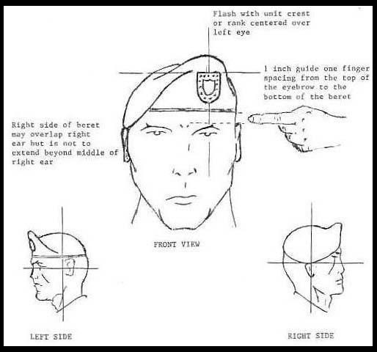
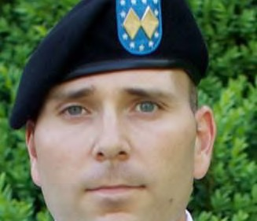
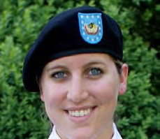

Cadet Officer
Rank, Beret

Cadet Enlisted DUI, Beret

ASU Coat
  - Insignia of rank. Non-subdued insignia will be worn centered on both shoulder loops of the coat, 5/8 inch from the outside shoulder seam. The top of enlisted insignia will point toward the neck.
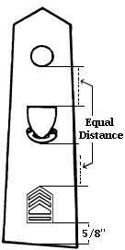
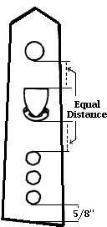
  - Distinctive Unit Insignia (DUI). The DUI is worn on the shoulder loops of the coat and centered between the insignia of grade and the outer edge of the button.

F

Torch of Knowledge. This insignia is worn by Basic Course Cadets centered on both collars parallel to the inside edge of each lapel with the outside edge of the insignia positioned 1 inch above the notch of the lapel.
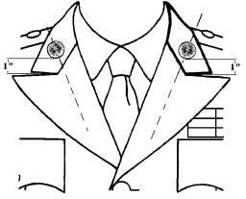

ASU- Torch of Knowledge (Enlisted)

R.O.T.C. Initials. This insignia is worn by Advanced Course Cadets centered on both lapels of the coat, parallel to the inside edge of each lapel. The lower edge of the insignia is positioned 5/8 inch above the notch of the lapel.
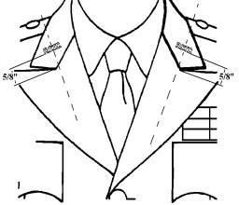
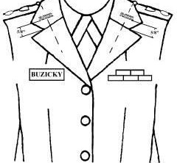

ASU- ROTC Insignia Male (Officer)

ASU- ROTC Insignia Female (Officer)

Branch Insignia. Second semester MS IV's may wear branch insignia centered on both lapels, 1 1/4 inches below the ROTC initials, with the insignia bisecting the ROTC initials and parallel to the inside edge of the lapel.

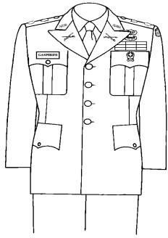
ASU - Branch Insignia

Name plate.
- Male Cadets. The nameplate will be worn on the flap of the right breast pocket, centered from left to right and between the top of the button and the top of the pocket on the ASU.
- Female Cadets. On the ASU, the nameplate will be worn between 1 to 2 inches above the top button, centered horizontally on the wearer's right side. Placement of the nameplate may be adjusted to individual figure differences.
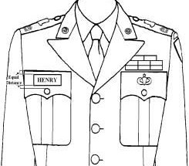
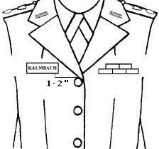

ASU-Nametape Male

ASU- Nametape Female

Ribbons: only authorized ribbons will be worn. Only cadet or enlisted ribbons will be worn, not both. Ribbons will be worn in the order of precedence from the wearer's s right to left in one or more rows either with no space or a 1/8-inch space between rows. No more than four (4) ribbons will be worn in any one row.

- Male personnel will wear their ribbons centered 1/8 inch above the left breast pocket in as many rows as necessary.
- Female personnel will wear them centered on the left side with the bottom row positioned parallel to the bottom edge of the name plate. Placement of the ribbons may be adjusted to the individual’s figure differences.
Other Insignia, Badges and Tabs. See CCR 670-1 and AR 670-1 for instruction on wear.
Shoulder cords (similar to foragers). The number of cords worn at any one time is limited to one; shoulder cords will be worn on the left shoulder as prescribed by the Battalion Commander and are limited to the following groups and colors within an ROTC unit:
- Musical Units - Teal Blue.
- Color Guards - White.
- Tiger Platoon – Orange/White.
- AUSA - Black/Gold/White.
- Pershing Rifles – Purple/White.
- Scabbard and Blade – Blue/Red.
- Honor organizations, including national or local military societies – Old Gold.
- Rifle teams - Buff.
Medals and ribbons with metal pendants awarded by the National Rifle Association and the National Board for the Promotion of Rifle Practice may be worn on the ROTC uniform only for special ceremonies and official functions as directed by the Battalion Commander. They are not to be authorized for general wear on the ASU white shirt, (short and long sleeve). The short and long sleeve shirt can only be worn with the necktie or neck tab. Name plate and cloth shoulder boards with embroidered cadet rank will be worn on both uniform shirts.

Wear of Distinctive Unit Insignia (DUI) on shoulder loops
- DUI authorized for wear on the shoulder loops in the same manner as prescribed for the current Green Service Uniform (AR 670-1, 28- 22f.)
- DUI will be worn by enlisted personnel and Cadets only. Officers will continue to wear the same shoulder boards on their ASU as is worn on the current dress blue uniform.

Trousers
- New low-cut waist trousers with belt loops will be worn with black belt and brass belt buckle as worn with the current Green Service Uniform.
- Officers and enlisted personnel in the rank of CPL and above will wear the trousers with a gold braid sewn on the outside seam of each leg.

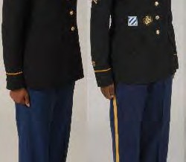

SPC and Below vs. Officer/NCO trousers

The current Dress Blue service cap is authorized for wear by Soldiers in the rank of CPL and above when directed or when wearing the Dress Blue ASU prior to retreat.
Females are authorized to wear skirt for commissioning ceremony Black four in hand tie (males) or neck tab (females)
Types of ASU (Dress Blue, Class A, Class B)

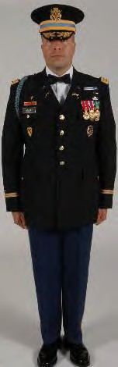
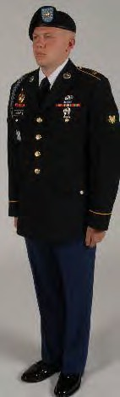

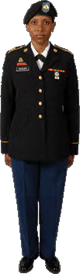

ROTC Class B Uniform
The Army’s service Dress tropical uniform (Class “B” w/Ribbons) as a Class “A” Equivalent uniform for hot weather wear. It will serve as appropriate wear for parades, ceremonies, reviews when special honors are being paid, and official visits. The uniform is intended for seasonal hot weather wear only and not appropriate for wear outside hot weather climates. PMS will determine the period of wear for this uniform.
In lieu of wearing all authorized ribbons, Cadet/Soldiers have the option of wearing three authorized ribbons on the uniform only. Selected ribbons must be worn in order of precedence. The badges and insignias currently authorized for wear on the ASU are authorized to be worn on the service dress tropical uniform.

Class B uniform consists of the following:
- Male - Beret, white shirt (short or long sleeve), black necktie (optional with short sleeve shirt), black wool pullover sweater (optional), black all weather coat (optional), black oxford shoes, black socks, Army blue trousers, black belt with brass buckle, uniform brass and accessories.

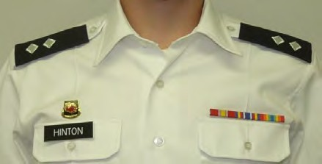
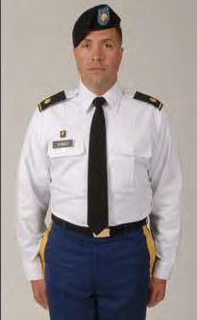
Army’s service Dress tropical uniform (Class “B” w/Ribbons) Class “B” with four in hand tie

- Female - Beret, white shirt (short or long sleeve), black neck tab (optional with short sleeve shirt), black wool pullover sweater (optional), black all weather coat (optional), black oxford shoes or black pumps, Army blue skirt or slacks, uniform brass and accessories.

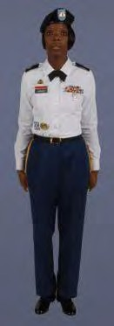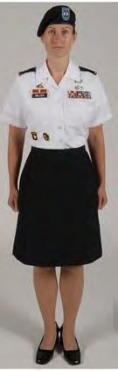
Army white shirt, short and long sleeve. The short sleeve shirt can be worn with or without the necktie or neck tab. The long sleeve shirt can only be worn with the necktie or neck tab. Name plate and cloth shoulder boards with embroidered cadet rank will be worn on both uniform shirts. Ribbons may be worn.
Black Sweater. The black sweater is an optional uniform item. It can be worn with either shirt. If the long sleeve shirt is worn, you must wear a necktie or neck tab. The collar of the
short sleeve shirt is worn out when no tie is worn. Cloth shoulder boards with embroidered cadet rank are also worn on the sweater. The name plate is worn centered on the black patch except when wearing the Distinctive Unit Insignia. When wearing a DUI, the nameplate will be worn 1/2 inch above the bottom of the black patch with the DUI centered above the nameplate.
Umbrella. Soldiers may carry a plain, black umbrella, only during inclement weather, when wearing the service (Class A and Class B), dress, and mess uniforms. Umbrellas are not authorized in formations or when wearing field or utility uniforms. Commanders may further restrict Soldiers' use of umbrellas as appropriate.
The following is a summary of general fitting guidelines:
- Black all weather coat:
- Male. The length of the sleeve will be 1/2 inch longer than the service coat. The bottom of the coat will reach to a point 1 and 1/2 inches below the midpoint of the knee.
- Female. The length of the sleeves will be 1/2 inch longer than the service coat. The bottom of the coat will reach a point 1-inch below the skirt hem but not less than 1 and 1/2 inches below the crease in the back of the knee.

- Uniform coats and jackets (male and female). The sleeve length will be 1 inch below the bottom of the wrist bone.
- Trousers and slacks:
- Trousers are to be fitted and worn with the lower edge of the waistband at the top of the hipbone, plus or minus 1/2 inch. The front crease of the trousers will reach the top of the instep and be cut on a diagonal line to reach a point approximately midway between the top of the heel and the top of the standard shoe in the back. The trousers may have a slight break in the front.
- Slacks will be fitted and worn so that the center of the waistband is at the natural waistline. The front crease of the slacks will reach the top of the instep and be cut on a diagonal line to reach a point approximately midway between the top of the heel and the top of the standard shoe in the back. The slacks may have a slight break in the front.
- Knee-length skirts and dresses: Skirt and dress lengths will not be more than 1 inch above or 2 inches below the crease in the back of the knee.
- Long sleeve shirts: The sleeve length will extend to the center of the wrist bone. Other: Appropriate undergarments will be worn with all uniforms.

ROTC Class C Uniform (ACU)

ACU top
- The coat has a zippered front closure, tilted chest pockets with hook and looped closure, hook and looped sleeve cuff closure (which must be closed at all times), integrated blouse bellows for increased upper body mobility, and shoulder pockets with hook and loop.
- The coat is worn hook and looped and zipped
- Shoulder Sleeve Insignia(SSI) unit patch. The SSI is centered on the hook and loop-faced pad already provided on the left sleeve of the ACU coat.
- Skill badges. Pin on. Soldiers may wear up to five (5) badges on the ACU. All skill badges will be worn above the U.S. army tape. Badges will be worn in order of precedence from the wearer's left as follows: One badge, worn 1/8 inch above and centered on the U.S. army tape. If you have two or more badges have ¼ inch between badges.
- U.S. flag insignia - the U.S. flag insignia (full color or subdued) is worn on the right shoulder pocket flap of the ACU coat. The flag insignia is placed directly on top of the hook and loop-faced pad already provided with the ACU coat shoulder pocket flap. The subdued U.S. flag insignia is worn as directed by the commander under tactical or field conditions.
- Last name/U.S. army tape- last name/U.S. army tapes are 5 inches in length, have a hook and loop-faced pad, and are worn immediately above and parallel with the top of the slanted chest pocket flaps. The background of the last name/U.S. army tape will universal camouflage pattern.
- The mandarin collar will be normally worn in the down position.
- Soldiers are authorized to wear the mandarin collar in the up position when wearing body armor or when weather conditions dictate the wear as prescribed by the commander.
- The elbow pouch for internal elbow pad inserts must be closed at all times.

- Permanent infrared feedback squares affixed to each shoulder for nighttime identification will be covered when insignias are not worn on the pocket flaps.
- Sleeves will be worn down at all times, and not rolled or cuffed.
- The moisture wicking tan t-shirt or cotton t-shirt is worn underneath the coat and it is tucked inside the trousers at all times.
- The coat is normally worn outside the trousers, and the trousers are worn with a belt. The coat may also be worn inside the trousers when directed by the commander (i.e., when wearing IBAs, MOOP gear, etc.).
- The coat will not extend below the top of the cargo pocket on the trousers and will not be higher than the bottom of the side pocket on the trousers.

Trousers:
- Soldiers will wear the trousers tucked into the top of the boots or bloused using the draw strings at the bottom of the trousers or commercial blousing devices.
- Personnel will not wrap the trouser leg around the leg tightly enough to present a pegged appearance or insert any items inside the trouser leg to create a round appearance at the bottom of the trouser leg.
- When bloused, the trousers should not extend below the third eyelet from the top of the boot.
- The knee pouch with hook and loop closure for internal knee pad inserts and the bellowed calf storage pocket with hook and loop closure on the left and right legs will be worn closed at all times.

Headgear
- The patrol cap is worn with the ACU when the Kevlar helmet is not worn, on work details. Soldiers will wear the ACU Patrol Cap straight on the head so that the cap band creates a straight line around the head, parallel to the ground. The Patrol Cap will fit snugly and comfortably around the largest part of the head without distortion or excessive gaps. The cap is worn so that no hair is visible on the forehead beneath the cap. Sewn or pin on rank is worn on the ACU Patrol Cap. The last name will be centered on the back of the cap with Velcro fasteners to the Velcro panel that is pre-sewn onto the cap.
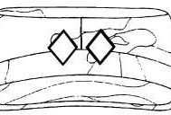
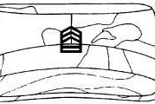

Patrol cap Officer

Patrol cap Enlisted

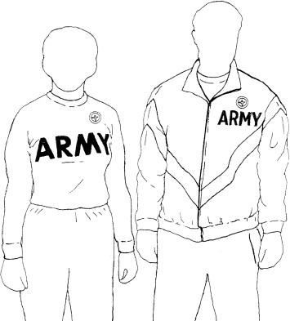
The Micro Fleece Grey/black Cap is not authorized for wear in garrison with the ACUs unless weather reaches temperatures below 30 degrees with wind chill factor. Fleece cap may be worn under the Kevlar or when PMS authorizes it.

Wear of Desert Boot
- Black boots are NOT authorized for wear with the ACU’s.
- Coyote boots are NOT authorized for wear with UCP patterned ACU’s.
- Army Combat Boots – (Hot Weather and temperate weather) are made of flesh-side out cattlehide leather with a plain toe and tan or coyote outsoles. The boots are laced diagonally, the color of the boot laces will match the color of the boot, with the excess lace tucked into the top of the boot under the bloused trousers, or wrapped around the top side of the boot. Metal cleats and side tabs or sewn in or laced in zippers are not authorized. Only boots with tan rubber outsoles are authorized for wear.
- Soldiers may wear commercial boots of a design similar to that of the Army Combat Boot (tan or coyote), 8 to 10 inches in height as authorized by the commander. The boots must be made of tan or coyote flesh-side out cattlehide leather, with a plain toe, and a soling system matching the color of the tan or coyote upper materials. Rubber and polyether polyurethane are the only outsole materials that are authorized. The soling materials will not exceed 2 inches in height, when measured from the bottom of the outsole, and will not extend up the back of the heel or boot or over the top of the toe. The exterior of the boot upper will not contain mesh but will be constructed of either all leather or a combination of leather and nonmesh fabric.
- NO STEEL TOE!!!!!!!

Assembly and Wearing of TA-50
- Kevlar Helmet will be worn during any field training, when riding or operating military vehicles and as otherwise directed by the PMS. Kevlar will be worn with camo cover, cat eyes, and chin strap properly assembled. See ANNEX I for more information.
- Load Bearing Equipment (LBE)/ Modular Lightweight Load-carrying Equipment (MOLLE) will be worn during any field training. When properly assembled, the LBE will have 2 canteens w/ covers, 2 ammo pouches, 1 compass w/ case, 1 first aid pouch, and 1 elbow flashlight with red lens installed. See ANNEX M for more information.

Improved Physical Fitness Uniform (IPFU)
- The IPFU consists of the following components during April to September time frame.
- Trunks, running, black, moisture-wicking.
- T-shirt, gray, short sleeve, moisture-wicking.
- Footwear, appropriate running shoes
- Socks, white and must be above the ankle
- Reflective belt (Orange for Cadets and Yellow for Cadres)

During October to March time frame IPFU consist of:
- Jacket, running, gray and black.
- Pants, running, black.
- T-shirt, gray, long sleeve, moisture-wicking
- Micro Fleece Cap- Grey
- Footwear, appropriate running shoes
- Socks, white/black and must be above the ankle with no logos
- Reflective belt (Orange for Cadets and Yellow for Cadres)

Accessories.
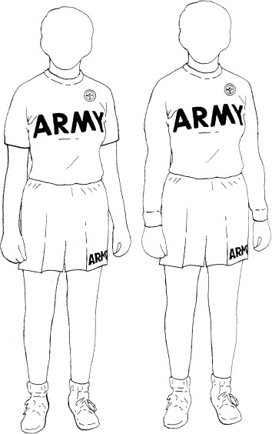
- Commanders may authorize the wear of commercial running shoes, calf-length or ankle-length, plain white socks with no logos, gloves, reflective belts or vests, long underwear, and other items appropriate to the weather conditions and type of activity. If Soldiers wear long underwear or other similar items, they must conceal them from view with the running jacket and pants.
- Soldiers are authorized to wear commercially purchased gray or black spandex shorts under the IPFU shorts. The length of the shorts must end above the knee or higher. The commercial shorts must be plain, with no logos, patterns, or obtrusive markings. Soldiers are not required to buy the spandex shorts.

Occasions for wear
- The IPFU is authorized for wear on and off duty, on and off the installation, and in combination with civilian attire when authorized by the commander.

General guidelines
- When Soldiers wear the IPFU as a complete uniform, they will keep the sleeves down on the jacket, the legs down on the pants, and they will tuck the T-shirt inside the trunks. Soldiers may not roll or push up the sleeves of the IPFU jacket.
- Soldiers will wear the grey fleece cap pulled down snugly on the head, with the bottom edge of the cap folded up; Soldiers will not roll the edge of the cap.
- There are no restrictions on the combination of IPFU items worn, unless the commander has prescribed a particular combination for formation.

Occupational Physical Assessment Test (OPAT)
A series of physical performance tests used to assess a Soldier’s physical capabilities. The OPAT provides measurements of upper- and lower-body muscular strength, endurance, power output, and aerobic capacity. The OPAT standards are not adjusted for age and physiological differences between the sexes.

Tests include:
- Standing long jump
- Medicine ball put
- Squat lift
- Beep test (shuttle run)
All tests completed on the same day and in the order listed above. Soldiers should be wearing a PT Uniform for all events.

Physical Fitness
Physical Fitness Training (PFT) – Physical fitness is an integral component of the battalion training plan and a key element in your personal total fitness plan. PFT is conducted two days a week at 0600; Tuesday and Thursday.
APFT Standards – The Army Physical Fitness Test (APFT) is a tool used by the commander to determine an individual’s level of fitness. The APFT consist push-ups and sit-ups (as many as you can do in 2 minutes, each) and completing a two-mile run in the shortest time possible. The Army standard for passing the APFT is 60 points in each of the three events for a total of 180 points. All scholarship Cadets must achieve this standard each semester to retain their scholarship benefits.
APFT Goals – As a Cadet at Clemson University, and a future Army Officer, it is imperative that you achieve and maintain a high level of fitness. PFT two days a week will not accomplish this. Physical fitness is an individual responsibility and one must be self-disciplined to achieve and maintain a high level of fitness. To assist Cadets with their fitness needs we have established APFT Goals for each class. Contracted Cadets that do not meet these goals will be required to attend enhancement PFT on Monday, Wednesday and Friday. The APFT Goals are listed below:

PT GOALS | FALL Semester | SPRING Semester
MLI | 180 (60 pts each event) | 210 (70 pts each event)
MLII | 210 or (70 pts each event) | 240 or (80 pts each event)
MLIII | 240 or (80 pts each event) | 270 or (90 pts each event)
MLIV | 270 average | 280 average

Weight Control – Maintaining the proper weight in accordance with Army Regulation 600-1 is a cadet’s responsibility. You must pass army height and weight standards before you can receive scholarship money, attend Cadet Summer Training (CST), or receive your commission. Failure to do so can result in immediate disenrollment and repayment of scholarship benefits. The cadet chain of command will conduct a weigh-in after each APFT under cadre supervision. Weight control will be supervised by the NCOIC and executed by the cadet chain of command.

Swimming – Since passing the Combat Water Survival Test (CWST) and the Swimming Test is a commissioning requirement, the test will be administered each school year. Cadets who are weak swimmers or unable to pass the test will be afforded the opportunity to attend swimming lessons with either cadre or an outside organization established through the battalion.

Conducting Physical Fitness
Intro to Physical Fitness: Physical Fitness is the ability to function effectively in physical work, training, and other activities and still have enough energy left over to handle any emergencies which may arise.
There are 5 basics components of physical fitness:
- Cardiorespiratory Endurance (CRE) – CRE is the efficiency with which the body delivers oxygen and nutrients needed for muscular activity and transports waste products from the cells. The goal of CRE is to increase your stamina. Long distance running, swimming, and cycling are some methods of increasing your stamina. You may conduct aerobic workouts every day. To make dramatic improvements, you should exercise aerobically 5-6 times a week.
- Muscular strength (MS) – MS the greatest amount of force a muscle or muscle group can exert in a single effort. Since muscular strength exercises are difficult to conduct during PFT due to resource constraints, most PFT sessions are a hybrid of muscular strength and muscular endurance and are referred to as MSE.
- Muscular endurance (ME) – ME is the ability of a muscle or muscle group to perform repeated movements with a sub-maximal force for extended periods of times.
- Flexibility – the ability to move the joints (for example, elbow, knee) or any group of joints through an entire, normal range of motion.
- Body composition – the amount of body fat a Soldier has in comparison to his total body mass.
During most PFT sessions we will train the first four components. Improving the first three components of fitness listed above will have a positive impact on your body composition.
The Army ROTC physical fitness program intent for your ML I and ML II years is to give you the knowledge and experience to pursue self-improvement. It is to establish within you a fitness ethos. This will make you a better leader, reducing stress, improving health, and making you a stronger person. Your training will introduce you to the tools of physical fitness during selected class times. This ranges from an introduction to weight equipment to learning running fundamentals. Additionally, it involves creating an individual workout regimen and goals, then tracking progress through the use of a fitness journal. You should shoot for a minimum of 250 or higher on the Army Physical Fitness Test (APFT). Additionally, ML II’s will be competing for slots to Airborne, Air Assault, and other summer programs. Physical fitness is vital for success in these programs.
The Army ROTC physical fitness program intent for your junior year is to give you the knowledge, ability, and experience to conduct organized athletics. You will be involved in short range planning, and lead group exercises and sporting events. This is critical for Army

lieutenants, as well as other leaders. You should set a goal of at least 270. This will stand you in good stead for the Cadet Summer Training.
The Army ROTC physical fitness program intent for your ML IV year is to give you the knowledge, ability, and experience to evaluate and achieve organizational athletic goals. You will be involved in long range planning, organizing and conducting evaluation of individual progress, as well as unit progress. You will gather feedback and continue to make adjustments to ensure organizational goals are met. These goals will include individual targets for formal APFT scoring, camaraderie, and unit morale. You should set a goal of at least 280 for your APFT score; you will soon be an officer leading Soldiers.

Execution
- Command Presence. Command presence is essentially presenting yourself as someone in authority, trusted and respected. This is partially done through the message conveyed by how you look, how you carry yourself, how you act, and how you speak. When in charge, take charge. Be in the right uniform, know and understand your task (this requires rehearsals) and be prepared to execute.
- Importance of Commands. Indifferent commands produce indifferent performance. Give your commands confidently and concisely, with energy, rhythm, and snap. Your troops will respond in kind. (NOTE: See FM 3-21-5 for detailed instruction in using command voice).
- Preparatory Commands and Commands of Execution: The preparatory command tells Soldiers what they must do and the command of execution directs them to do it. The interval between the two commands is long enough to permit the average Soldier to understand the first one before the second one is given. All preparatory commands are given with a rising inflection.
- Task, Conditions and Outcome. Every training event requires task, conditions and standards, this includes PFT sessions. This will ensure that everyone involved in the training understands what is about to take place and what is expected of them.

Ability Group Runs (AGRs)
The AGR trains Soldiers in groups of near-equal ability. Each ability group runs at a prescribed pace intense enough to produce a training effect for that group and each Soldier in it. Leaders should program these runs for specific lengths of time, not miles to be run.

Toughening Phase AGR Assignments | Sustaining Phase AGR Assignments
A Group 7:15 and faster | A Group 6:30 and faster
B Group 7:16 to 8:15 | B Group 6:31 to 7:15
C Group 8:16 to 10:15 | C Group 7:16 to 8:00
D Group 10:16 and slower | D Group 8:01 and slower

Some Soldiers may make the cut off times to qualify for an ability group but are unable to maintain the prescribed running pace listed in the PRT schedule. If this occurs, they may drop down to the slower group and progress later to the faster running group.

Road Guards
- Road guards will remain 20m in front and to the rear of running formations
- There will always be a road guard at the front and rear of the formation
- When approaching an intersection, a front road guard will stop and cover the right side of the road
- A rear road guard will sprint up to the front to cover the left side of the road
- The remaining front and rear road guard will remain at the same pace and positions 20m to the rear and in front of the formation
- Once the run group has passed, the front road guard that just rested while protecting the right side of the formation will sprint back up to the front
- The rear road guard that just sprinted up to protect the left side of the formation will rest as the run group moves through the intersection and will rejoin at the rear of the formation
- After passing the intersection, rear road guards should still be at the rear and front guards should still be at the front
- Front and rear pairs should take turns guarding the flanks of the group
- Road guards can always be used, but are required with formation of 10 or more.

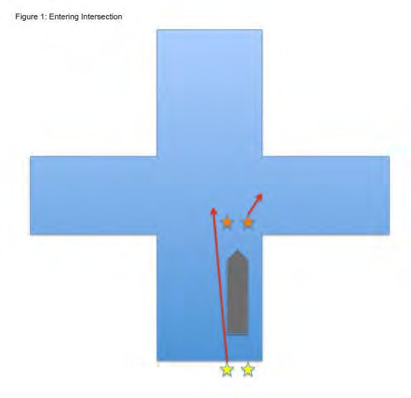

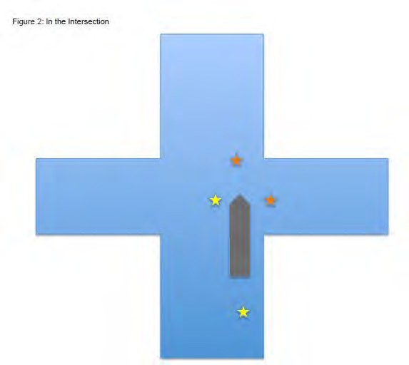
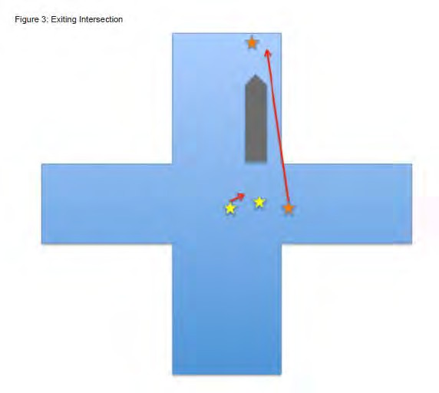

ANNEX A - Army Values and Leadership Dimensions

ATTRIBUTES – What an Army Leader is

A Leader of Character
Army VALUES – Values reflect the individual’s sense of obligation to and attitudes about other people, concepts, and the profession of arms, and are possessed to varying degree by all individuals. The goal of leader development is to define and instill
Army Values in the individual, reflecting standards of performance exceeding those of society in general. The leader faithfully adheres to Army values at all times, even to the point of personal sacrifice when necessary. Values are often most visibly demonstrated when personal cost is incurred. As a defender of the Constitution, the country, and others not capable of defending themselves, the leader demonstrates commitment through values, earning the trust of the nation.
- LOYALTY (LO) – Allegiance to those who are reliant on the leader for support. Loyalty is required to ensure the success of the chain of command and subordinates, and generates loyalty and support in return.
- DUTY (DU) – Fulfilling professional obligations with a strong work ethic; personal initiative compels the leader to exceed minimum standards. Leaders with a strong sense of duty demonstrate and enforce high professional standards.
- RESPECT (RE) – Treating people as they should be treated. The leader demonstrates the value of dignity and human worth, creating a positive climate of command and projecting cultural tolerance.
- SELFLESS SERVICE (SS) – Putting the welfare of the nation, the Army, and subordinates before self. The leader is willing to forego personal comforts for the sake of others, with no prospect of reward.
- HONOR (HO) – Demonstrating a keen sense of ethical conduct; compelled to do the right thing. The honorable leader protects the reputation of the profession through personal actions.
- INTEGRITY (IT) – Consistently adheres to moral and legal obligations. The leader is truthful and upright at all times.
- PERSONAL COURAGE (PC) – Overcoming personal fears, both physical and psychic. While fears are a necessary component of human behavior, the leader is able to weigh the potential costs against the greater need, put fear (both real and imagined) aside and do what is necessary to complete the mission.
EMPATHY – Is the propensity of an individual to experience something from another person’s point of view. Possessing the ability to identify with and enter into another person’s feelings and emotions. Competent and empathetic leaders take care of Soldiers by giving them the training, equipment, and all the support they need to keep them alive in combat and accomplish the mission.

WARRIOR ETHOS - The Warrior Ethos refers to the professional attitudes and beliefs that characterize the American Soldier. It echoes through the precepts of the Code of Conduct and reflects a Soldier’s selfless commitment to the Nation, mission, unit, and fellow Soldiers. The Warrior Ethos was developed and sustained through discipline, commitment to the Army Values, and pride in the Army’s heritage. Lived by Soldiers and supported by dedicated Army civilians, a strong Warrior Ethos is the foundation for the winning spirit that permeates the institution. U.S Army Soldiers embrace the Warrior Ethos as defined in the Soldier’s Creed. The Warrior Ethos are:

I WILL ALWAYS PLACE THE MISSION FIRST I WILL NEVER ACCEPT DEFEAT

I WILL NEVER QUIT

I WILL NEVER LEAVE A FALLEN COMMRADE

A Leader with Presence

- MILITARY BEARING – Projecting a commanding presence, a professional image of authority
- PHYSICALLY FIT – Possessing sound health, strength, and endurance, which sustain emotional health and conceptual abilities under prolonged stress.
- COMPOSED, CONFIDENT – Projecting self-confidence and certainty in the unit’s ability to succeed in whatever it does; able to demonstrate composure and outward calm through steady control over emotion.
- RESILENT – Showing a tendency to recover quickly from setbacks, shock, injuries, adversity, and stress while maintaining a mission and organizational focus.

A Leader with Intellectual Capacity
- MENTAL AGILITY – Mental agility is a flexibility of mind, a tendency to anticipate or adapt to uncertain or changing situations. Agility assists thinking through second- and third-order effects when current decisions or actions are not producing the desired effects. It helps break from habitual thought patterns, to improvise when faced with conceptual impasses, and quickly apply multiple perspectives to consider new approaches or solutions.
- SOUND JUDGEMENT – Judgment goes hand in hand with agility. Judgment requires having a capacity to assess situations or circumstances shrewdly and to draw feasible conclusions. Good judgment enables the leader to form sound opinions and to make sensible decisions and reliable guesses. Good judgment on a consistent basis is important for successful Army leaders and much of it comes from experience.

- INNOVATION – Innovation describes the Army leader’s ability to introduce something new for the first time when needed or an opportunity exists. Being innovative includes creativity in the production of ideas that are original and worthwhile.
- INTERPERSONAL TACT - Effectively interacting with others depends on knowing what others perceive. It also relies on accepting the character, reactions, and motives of oneself and others. Interpersonal tact combines these skills, along with recognizing diversity and displaying self-control, balance, and stability in all situations.
- DOMAIN KNOWLEDGE – Domain knowledge requires possessing facts, beliefs, and logical assumptions in many areas. Tactical knowledge is an understanding of military tactics related to securing a designated objective through military means. Technical knowledge consists of the specialized information associated with a particular function or system. Joint knowledge is an understanding of joint organizations, their procedures, and their roles in national defense. Cultural and geopolitical knowledge is awareness of cultural, geographic, and political differences and sensitivities.

CORE LEADER COMPETENCIES – What an Army Leader does

Leads

- LEADS OTHERS – Involves influencing Soldiers or Army civilians in the leader’s unit or organization. This competency has a number of components including setting clear direction, enforcing standards, and balancing the care of followers against mission requirements so they are a productive resource. Leading within an established chain of command with rules, procedures, and norms differs from leading outside an established organization or across commands.
- EXTENDS INFLUENCE BEYOND THE CHAIN OF COMMAND – Requires the
ability to operate in an environment, encompassing higher and lower command structures, and using one’s influence outside the traditional chain of command. This includes connecting with joint, allied, and multinational partners, as well as local nationals, and civilian-led governmental or nongovernmental agencies. In this area, leaders often must operate without designated authority or while their authority is not recognized by others.
- LEADS BY EXAMPLE – Is essential to leading effectively over the course of time. Whether they intend to or not, leaders provide an example that others consider and use in what they do. This competency reminds every leader to serve as a role model. What leaders do should be grounded in the Army Values and imbued with the Warrior Ethos.
- COMMUNICATES – Ensures that leaders attain a clear understanding of what needs to be done and why within their organization. This competency deals with maintaining clear focus on the team’s efforts to achieve goals and tasks for mission accomplishment. It helps build consensus and is a critical tool for successful operations in diverse multinational settings. Successful leaders refine their communicating abilities by developing advanced oral, written, and listening.

Develops

- CREATES A POSITIVE ENVIRONMENT – The leader must create a positive environment that fosters teamwork, promotes cohesion, and encourages initiative and acceptance of responsibility. A leader should also maintain a healthy balance between caring for people and focusing on the mission.
- PREPARES SELF - The leader must seek self-improvement. To master the profession at every level, a leader must make a full commitment to lifelong learning. Self-improvement leads to new skills necessary to adapt to changes in the leadership environment. Self-improvement requires self-awareness. In no other profession is the cost of being unprepared as unforgiving, often resulting in mission failure and unnecessary casualties.
- DEVELOPS OTHERS – The leader must invest adequate time and effort to develop individual subordinates and build effective teams. Success demands a fine balance of teaching, counseling, coaching, and mentoring. Developing individuals and teams will make the organization more versatile.

Achieves
- GETS RESULTS - Getting results embraces all actions to get the job done on time and to standard:
- Providing direction, guidance, and clear priorities involves guiding teams in what needs to be done and how.
- Developing and executing plans for mission and task accomplishment involves anticipating how to carry out what needs to be done, managing the resources used to get it done, and conducting the necessary actions.
- Accomplishing missions consistently and ethically involves using monitoring to identify strengths and correct weaknesses in organizational, group, and individual performance.

ANNEX B- The Army as a Profession

The Army profession has two broad categories of professionals—uniformed military and non-uniformed members. These professionals comprise two complementary and mutually supporting communities within the Army Profession: The Profession of Arms and the Army Civilian Corps.
Profession of Arms: Uniformed members of the Army Profession—Soldiers. This includes the Regular Army, Army National Guard, and Army Reserve.
The Army Ethic: An evolving set of laws, values, and beliefs, deeply embedded within the core of the Army culture and practiced by all members of the Army Profession to motivate and guide the appropriate conduct of individual members bound together in common moral purpose.


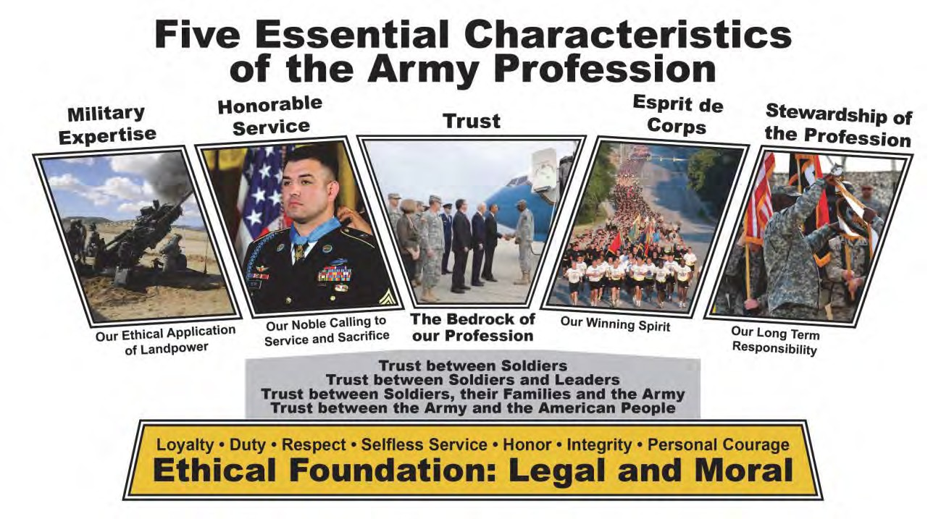

What it means to be a Soldier
The Army is an honorable Profession founded on a bedrock of Trust—trust between Soldiers; trust between Soldiers and leaders; trust between Soldiers and Army Civilians; trust between Soldiers, their Families, and the Army; and trust between the Army and the American people.
To sustain this Trust, the Army Profession is committed to an ethos of Honorable Service built on core, moral beliefs that are expressed in our Army Values; our Soldier, and noncommissioned officers (NCO) creeds; and the Warrior Ethos. These beliefs guide our decisions and actions as we perform our duties and continuously develop in Character, Competence, and Commitment.

How We Conduct Ourselves
Army Professionals are responsible for developing and maintaining moral character and competence, on and off duty, while following their commitment to work that is more than a job; it is a calling to serve in the defense of the Nation. Army Professionals develop through education, training, and experience, and adhere to the highest ethical standards. As stewards of this honorable profession, all Army Professionals must conduct themselves and hold each other accountable in a manner consistent with the Army Ethic and worthy of their professional status.
Army Professionals treat each other with dignity and respect; treating others as they should be treated. They build Trust within the Profession and with the Nation through Honorable Service. Trust is belief and confidence in the, Character, Competence, and Commitment of Army Professionals to ethically and efficiently accomplish the mission. All members of the Army Profession are our comrades. Acts of sexual harassment, sexual assault, and hazing are corrosive to our culture, breaking the bonds of trust that are essential to our Profession. These acts destroy morale and

Who We Are Not
Army Professionals do not engage in or tolerate acts of misconduct or unethical decisions. Actions such as sexual harassment, sexual assault, and hazing are dishonorable and contrary to the Army Values and the Army’s Professional Ethos and destroy Esprit de Corps. One incident is one too many.
Sexual Harassment is a form of gender discrimination that involves unwelcome sexual advances, requests for sexual favors, and other verbal or physical conduct of a sexual nature.
Sexual Assault is a crime. Sexual assault is defined as intentional sexual contact, characterized by use of force, threats, intimidation or abuse of authority, or when the victim does not or cannot consent. Sexual assault includes rape, forcible sodomy and other unwanted sexual contact that is aggravated, abusive, or wrongful or attempts to commit these acts. This includes touching of the breasts, buttocks, genitalia or any other part of the body to satisfy sexual desires. During training, there is no such thing as consensual relationships. So keep your hands to yourself!
Hazing is defined as any conduct whereby one military member or employee, regardless of Service or rank, unnecessarily causes another military member or employee, regardless of Service or rank, to suffer or be exposed to an activity that is cruel, abusive, or harmful.

ANNEX C – Soldier’s Creed, Cadet Creed, Alma Mater

Soldiers Creed
I am an American Soldier
I am a warrior and a member of a team I serve the people of the United States And live the Army Values
I will always place the mission first I will never accept defeat
I will never quit
I will never leave a fallen comrade
I am disciplined, physically and mentally tough Trained and proficient in my Warrior Task and Drills
I will always maintain my arms, my equipment and myself I am an expert and I am a professional
I stand ready to deploy, engage, and destroy the enemies of the United States of America in close combat.
I am a guardian of freedom and the American way of life.
I am an American Soldier.
Cadet Creed
I am an Army Cadet, soon I will take an oath and become an Army Officer committed to DEFENDING the values which make this Nation great; HONOR is my touchstone, I understand MISSION first and PEOPLE always.
I am the PAST; the spirit of those WARRIORS who have made the final sacrifice.
I am the PRESENT; the scholar and apprentice Soldier enhancing my skills in the science of warfare and the art of leadership.
But above all, I am the FUTURE; the future WARRIOR LEADER of the United States Army. May God give me the compassion and judgment to lead and the gallantry in battle to WIN.
I WILL do my duty.

Clemson University Alma Mater
Where the Blue Ridge yawns its greatness, Where the Tigers play,
Here the sons of dear old Clemson Reign supreme alway.
CHORUS
Dear old Clemson we will triumph, And with all our might,
That the Tiger's roar may echo O'er the mountain height.

ANNEX D – Cadet Song and Army Song

Army Song
“The Army Goes Rolling Along” (Based upon “The Caisson Song”
by Brig. Gen. E. L. Gruber, written and adopted by H. W. Arberg)
Verse: March along, sing our song, with the Army of the free. Count the brave, count the true, who have fought to victory.
We’re the Army and proud of our name! We’re the Army and proud to proclaim
Verse: First to fight for the right, And to build the Nation’s might, And The Army Goes Rolling Along Proud of all we have done,
Fighting till the battle’s won, And the Army Goes Rolling Along.
Refrain: Then it’s Hi! Hi! Hey!
The Army’s on its way.
Count off the cadence loud and strong (TWO! THREE!) For where e’er we go,
You will always know
That The Army Goes Rolling Along.

Verse: Valley Forge, Custer’s ranks, San Juan Hill and Patton’s tanks, And the Army went rolling along Minute men, from the start,
Always fighting from the heart, And the Army keeps rolling along. (Refrain)
Verse: Men in rags, men who froze, Still that Army met its foes,
And the Army went rolling along. Faith in God, then we’re right, And we’ll fight with all our might, As the Army keeps rolling along.
(Refrain)

Cadet Song
“A Bar of Gold on Army Green”
CHORUS:
A Bar of Gold on Army Green, A Bar of Gold on Army Green,
If you’re looking for a leader One who’s heard as well as seen,

Look to the one whose earned respect And a Bar of Gold on Army Green.
A Bar of Gold on Army Green

ANNEX E – General Rules of Conduct
Cadets are responsible for knowing and observing the rules of conduct contained in the Tiger Orange Book and special official notices posted on the ROTC information board classes.

Cadet Code of Ethics:
- I will not lie, cheat, or steal nor tolerate anyone who does.
- I will not commit any unnecessary act that would prove detrimental to myself or to others.
- I will not do or say anything that would unduly discredit Clemson University, the U.S. Army or the United States of America.
- I will strive to better myself in every way possible and will help others do the same.
- I will be accountable for my actions at all times.
- I will perform my assigned duties to the best of my abilities.
- I will treat others with the proper courtesy and respect at all times.
- I will not use the powers vested in me for personal gains.
Each Cadet is responsible for Federal, State and University property issued or assigned to him, including his room and its furnishings and equipment. In case of loss of such property or damage thereto, the cadet is individually responsible and accountable.

Army General Orders:

- I will guard everything within the limits of my post and quit my post only when properly relieved.
- I will obey my special orders and perform all my duties in a military manner.
- I will report violations of my special orders, emergencies, and anything not covered in my instructions, to the commander of the relief.

ANNEX F - Unit Crest and Command Patch History

Unit Crest:
In accordance with the provisions of paragraph 4-6, AR 145-1, a shoulder loop insignia is authorized for wear by SROTC Cadets enrolled at Clemson University.
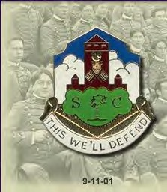
Description: A gold color metal and enamel device 1 3/8 inches (3.49 cm) in height overall consisting of a white cloud formation on a blue shield with a gold base. The shield is surmounted by a maroon building façade, the central tower bearing a tiger face between a clock above with hands set at 4:00 and the two U.S. flags crossed below. Overall in base a green stylized stone charged with a gold palmetto tree between the letters “S” and “C”, also gold. Attached below the device a white scroll inscribed “THIS WE’LL DEFEND” in gold letters.
Symbolism: Burnt orange (gold), white and northwest purple (maroon) are the traditional colors of the University. The building signifies Tillman Hall, the main building of Clemson
Agricultural College, established 1893. The hands of the clock are set at 4:00 p.m., the time of daily drill for the Cadets and reflect the long heritage of ROTC at the University. The Bengal Tiger is the school mascot. The American flags symbolize the Cadets’ dedication to state and country. The foundation stone, bearing the state tree, and the abbreviation, “S” and “C” indicate the prominence of the University within the state.

THE CADET COMMAND (ROTC) PATCH
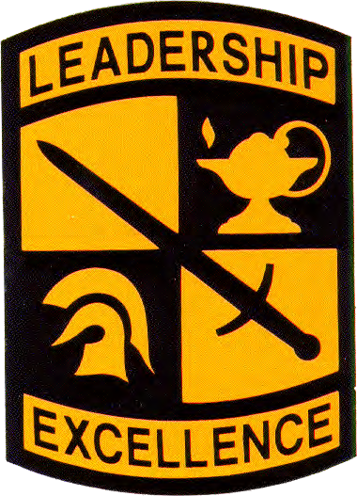
The Cadet Command Shield symbolizes the Army mission of National Defense and is divided into quarters representing the four traditional Military Science Courses comprising the Senior ROTC curriculum. The Sword signifies courage, gallantry, and self-sacrifice intrinsic to the profession of arms. The Lamp denotes the pursuit of knowledge, higher learning, and the partnership of Army ROTC with American colleges and universities. The Greek Helmet is symbolic of the ancient civilization concept of the Warrior Scholar. The motto "Leadership Excellence" expresses the ultimate responsibility of Army ROTC in the discharge of its moral responsibility to the Nation. Approved 22 AUG 1986

ANNEX G – History and Traditions of the Clemson Corps of Cadets

Clemson Agricultural College of South Carolina:
- Founded in 1889 as an agricultural college
- Fort Hill Plantation donated by Thomas G. Clemson for the purpose of educating farmers and mechanics of SC
- “Fall In:”
- Board of trustees decided that Clemson would use a system of military discipline modeled after Mississippi State as most land grant colleges of the time. Students were required to wear uniforms that they had to buy.
- First class, all male, arrived on 5 July 1893.
- Board of Trustees asked War Department for the detail of an officer to act as Commandant, responsible for life of Cadets outside of the classroom. Lt. T. Q. Donaldson, graduate of West Point, of the 7th Cavalry was first Commandant.
- From the beginning, hazing was not officially allowed at Clemson.
- Cadets in Wartime:
- In 1917, the entire senior class sent President Woodrow Wilson a telegram, volunteering for the World War I effort.
- During World War II, Clemson supplied more Army officers than any other institution except Texas A&M.
- Clemson also had the largest infantry ROTC program in the country.
- End of Clemson as a military college:
- After World War II, returning veterans were excused from drill and other forms of military life on campus.
- In 1955, the Corps of Cadets was officially abolished and the student body became civilian. ROTC was compulsory education for the freshman and sophomore years until 1969-70, when it became all voluntary.

Time Line of the Clemson Corps of Cadets
- 1888: Thomas Clemson dies, Fort Hill Plantation established a college of scientific agriculture & mechanical arts.
- 1893: Accepts the first freshman class; it is a land grant college (Military College)
- 1917 WWI: Senior class volunteered en masse; Total of 1,549 saw service; 25 killed in action;
- Medals of Honor: Ensign Daniel Sullivan and Sergeant Erans Foster
- 1929: The Senior Platoon formed
- 1933: K-7 Scabbard and Blade formed
- 1936: Clemson first to have ROTC Infantry Brigade
- 1940: Clemson has 2000 Cadets
- 1941-1945, WWII: Clemson provided more Army officers for the war than any other university except Texas A&M; Total of 6,475 saw service; 370 killed; Medal of Honor: LTC Jimmy Dyess (Class of ’31)
- 1942: Tiger football team begins running down the hill
- 1946: C-4 Pershing Rifles formed
- 1948: 4th Regimental Headquarters formed

- 1950-1953 Korea: Total of 1,500 saw service; 20 killed; 180 veterans enrolled at Clemson in fall of 1953
- 1955: Clemson becomes a civilian institution, ROTC mandatory for all male freshmen and sophomores
- 1955: Renamed “Clemson College”
- 1950-1972: Vietnam
- 1960: Senior Platoon retired
- 1962: Counter Guerrillas Tactical Unit formed
- 1964: Counter Guerrillas Renamed “Clemson Rangers” and Clemson College Renamed “Clemson University”
- 1969: ROTC no longer mandatory
- 1971: ROTC becomes elective; opened to women
- 1974: First female commissioned at Clemson
- 1996: Military Heritage Plaza established
- 1998: Clemson Corps Alumni formed
- 1999: ROTC recognized as an academic minor and Cadet Life Gardens established
- 2000: Regimental Room & Tiger Orange Book Established
- 2000: Pass-In-Review for president’s inauguration
- 2000: Senior Platoon (Tiger Platoon) Reactivated

Traditions of the Clemson Corps of Cadets
- Drill & Ceremony conducted on Bowman Field. Named for one of Clemson’s original assistant coaches and faculty members, R.T.V. Bowman, this area served as the traditional parade ground for Clemson Cadets as well as the annual agricultural fair. Through the years, Bowman has become an irreplaceable, unmistakable part of campus life.
- Guarding Howard’s rock with the 24-hour drum beating prior to USC game at Clemson.
- Cadets salute officers and greet with the motto, “This We’ll Defend, Sir/Ma’am!”
Officers respond with “Go Tigers!”
- When a formation is dismissed, Cadets will sound off with, “Go Tigers!”
- Upon commissioning, lieutenants are presented a battalion coin with their commissioning number engraved.

ANNEX H - Cadet of the Month Boards
Each month, the Cadet battalion conducts a Cadet of the Month board to recognize outstanding Cadets for their dedication, knowledge, and performance. Cadet of the Month Boards will be held on the first Friday of every month. This is a competitive event where each Company will send their best ML I, II, and III Cadets to be recognized by the battalions. Winners will be announced to the battalion and awarded the Cadet of the Month Award ribbon. Company Commanders will recommend one cadet from each ML class to compete at the board. Uniform for the board will be Class A uniform unless otherwise directed by the C/Battalion Commander. The battalion staff will be responsible for publishing a Memorandum of Instruction (MOI). ML IV’s will comprise the board members.
Possible questions at the board

ML Is
- All Tiger Orange Book information
- Military Clubs on Campus
- Your ML IV Chain of Command to include your PL, CO, and BC
- The Army Chain of Command

ML IIs
- All ML I questions
- Staff positions (i.e. S-1, S-1, S-3, and what they do)
- US Chain of Command (on wall in HQ foyer)
- Entire ML IV Chain of Command

ML IIIs
- All the above
- TLPs/FM 3-21.8 questions
- Leadership dimensions

Board Procedures
Reporting in
- When it is your turn to present yourself before the board, you will knock on the door.
- The chairman of the board will grant permission to enter.
- You will then enter the room and march by the most direct route until you reach the front of the table. You should position yourself so that you are centered and two steps in front of the table.
- There you will report in by saluting and saying “Cadet reporting as ordered, Sir or Ma’am.” (You will probably be reporting in the C/Battalion Commander).
- Wait for their salute to drop yours, and then remain at attention until you are given further instructions.

During Board Questioning
- There may be someone walking around you examining your uniform. Pay them no attention.
- Always look straight ahead unless answering a question. Then you may turn your head and eyes toward the member of the board who addressed you.
- The answers to all questions should begin and end with "Whoever is asking the question.” For example, Sergeant, Sergeant Major or Sir/Ma’am.

Dismissal
- When questioning is completed, you will be informed that the board is concluded
- You will then salute, sounding off with “GO TIGERS” and wait for the chair to return it, then leave by the most direct route.
- If you have any questions regarding these procedures or the questions you should be prepared to answer, contact your Company Commander or Platoon Leader.

ANNEX I – Army ROTC Accessions Process (changes yearly, PML to brief)

Accessions
- ​Academic Outcomes (50%)
  - Standardized Tests
  - CLA+ (5.0)
  - MAT (5.0)
  - Accessions GPA (cumulative through spring semester junior year) (25.0)
  - Cadet Developmental Assessment (6.0)
  - Academic Discipline (4.0) { ADM4 = 4 pts; ADM3 = 2 pts }
  - Command Interest Items
  - Writing (2.0)
  - Speaking (2.0)
  - Community Awards (1.0)
- Leadership Outcomes (35%)
  - PML Experience Based Observations
  - ML III Cadet OER, PML Rating of Potential (12.5)
  - ML III Cadet OER, PML Ranking (12.5)
  - Cadet Training/Extracurricular Activities (5.0)
  - Language/Cultural Awareness (5.0)
- Physical Outcomes (15%)
  - APFT
  - Campus (most current fall semester) (6.5)
  - Campus (most current spring semester) (6.5)
  - Athletics
  - Varsity, Intramural, or Community Team (2.0)

Talent Management
  - The Talent Management (TM) program aims to match talent requirements identified by Army branch proponents with Cadet Talents identified by the Cadets themselves, their Cadre, and from results of a standardized test which helps to identify each Cadet’s unique talents. While performance has been rewarded based on the academic, physical, and military pillars which determine our overall outcome metrics, unique talents (knowledge, skills, and behaviors) Cadets possess and the specific talent priorities sought by each of our 17 basic branches will now be considered.

Implementation is intended to:
  - Objectively evaluate Cadet Talent and develop attribute priorities required by Army branches.
  - Better mentor Cadets in order to improve self-development of attributes which correlate with Army talent requirements.

  - Better inform Cadets regarding branch and component opportunities and suitability.
  - Synchronize branching board decision efforts and Cadet Branch selection choices to align the right officer in the right branch.

Three assessment tools:
  - Cadet File
  - Talent Assessment Battery (TAB)
  - Cadet Talent Evaluation (CTE; cadre evaluation)
The TAB is only in TM, not the Accessions OML (no involvement in component selection). Results from the TAB, CTE and Cadet files drive the Cadet’s branch talent score for each branch. Also, drives the recommendation to the Cadet on what branches they should consider listing as their top preferences. Branch Talent Score is one of multiple inputs to DABM; “Human Board” validates DABM results.
Due to the rapid changes of OML and Branching, the PML will brief the yearly changes.

ANNEX J - Simultaneous Membership Program (SMP)

The ROTC/SMP is a volunteer Officer training program designed to increase the number of ROTC Officers available for Reserve Forces Duty (RFD). It encourages enrollment and participation in the ROTC Advanced Military Course and provides the future Officer with leadership and reserve unit experience. The purpose of the SMP Program is to: (1) give eligible enlisted members of the Army National Guard and Army Reserve an opportunity to participate in the Advanced ROTC Program; (2) provide Non-scholarship, Reserve Forces Duty scholarship, Military Junior College scholarship, or Dedicated Army National Guard scholarship students an opportunity to serve in an Army National Guard/Army Reserve unit while participating in ROTC. The intent of the SMP is to increase Officer Accessions into the Army National Guard/Army Reserve Components by increasing ROTC enrollment from enlisted RC members who are attending college. The SMP also reinforces training on the role of the commissioned Officer in the Army and gives Cadets the experience of working with Soldiers and Non-Commissioned Officers. Upon completion of Basic Training, or equivalent qualification (MLI & MLII, CIET), an Army National Guard/Army Reserve Component Soldier or ROTC Cadet, who has 30 credits towards their major and 3yrs or less to graduation, can contract in the Basic (MLII) or Advanced ROTC Program and earn a commission as an Officer in the United States Army while completing their college degree.

ANNEX K – Oath

ARMY OATH OF ENLISTMENT (ROTC CONTRACTING OATH)
The Army Oath of Enlistment reads—
  - I, , do solemnly swear (or affirm) that I will support and defend the Constitution of the United States against all enemies, foreign and domestic; that I will bear true faith and allegiance to the same; and that I will obey the orders of the President of the United States and the orders of the officers appointed over me, according to regulations and the Uniform Code of Military Justice. So help me God.

COMMISSIONED OFFICERS OATH OF OFFICE
  - The Army Oath of Commissioned Officers reads—
  - I, , having been appointed an officer in the Army of the United States, as indicated above in the grade of do solemnly swear (or affirm) that I will support and defend the Constitution of the United States against all enemies, foreign and domestic, that I will bear true faith and allegiance to the same; that I take this obligation freely, without any mental reservations or purpose of evasion; and that I will well and faithfully discharge the duties of the office upon which I am about to enter; So help me God.

ANNEX L – Code of Conduct

CODE OF CONDUCT FOR MEMBERS OF THE UNITED STATES ARMED FORCES
As members of the Armed Forces of the United States, Soldiers protect the Nation. It is a Soldier’s duty to oppose all enemies of the United States in combat or, if a captive, in a prisoner of war compound. A Soldier’s behavior is guided by the Code of Conduct, which has evolved from the heroic lives, experiences, and deeds of Americans from the Revolutionary War to the present. As a U.S. citizen and a member of the Armed Forces of the United States, your obligations stem from the traditional values that underlie the American experience as a nation. These values are best expressed in the U.S. Constitution and Bill of Rights that all Soldiers have sworn to uphold and defend. All U.S. Soldiers would have these obligations—to country, service, and unit as well as fellow Americans—even if the Code of Conduct had never been formulated as a high standard of general behavior.
The Code of Conduct is an ethical guide. Its six articles deal with a Soldier’s chief concerns as an American in combat; these concerns become critical when a Soldier must evade capture, resist while a prisoner, or escape from the enemy.
  - Article I: I am an American, fighting in the forces which guard my country and our way of life. I am prepared to give my life in their defense.
  - Article II: I will never surrender of my own free will. If in command, I will never surrender the members of my command while they still have the means to resist.
  - Article III: If I am captured I will continue to resist by all means available. I will make every effort to escape and aid others to escape. I will accept neither parole nor special favors from the enemy.
  - Article IV: If I become a prisoner of war, I will keep faith with my fellow prisoners. I will give no information or take part in any action which might be harmful to my comrades. If I am senior, I will take command. If not, I will obey the lawful orders of those appointed over me and will back them up in every way.
  - Article V: When questioned, should I become a prisoner of war, I am required to give name, rank, service number and date of birth. I will evade answering further questions to the utmost of my ability. I will make no oral or written statements disloyal to my country and its allies or harmful to their cause.
  - Article VI: I will never forget that I am an American, fighting for freedom, responsible for my actions, and dedicated to the principles which made my country free. I will trust in my God and in the United States of America.

ANNEX M – Uniform/TA-50/MOLLE Information Wear of the MOLLE vest
Eye protection w/clear lenses
CADET

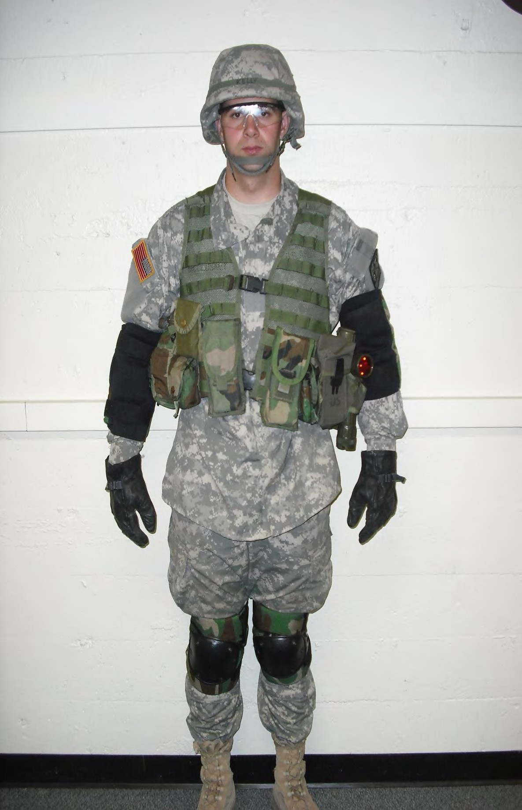
camouflagecamouflageCadet Handbook (Inside pocket of FLC)

Compass in grenade pouch secured to waist belt

Right Cargo: MAP,
Protractor
Camo Stick, Blank Adapter, Mini Mag or Army Elbow type Flashlight, Ear Plug Case, Pen/Pencil, Bee Sting Kit (if issued)

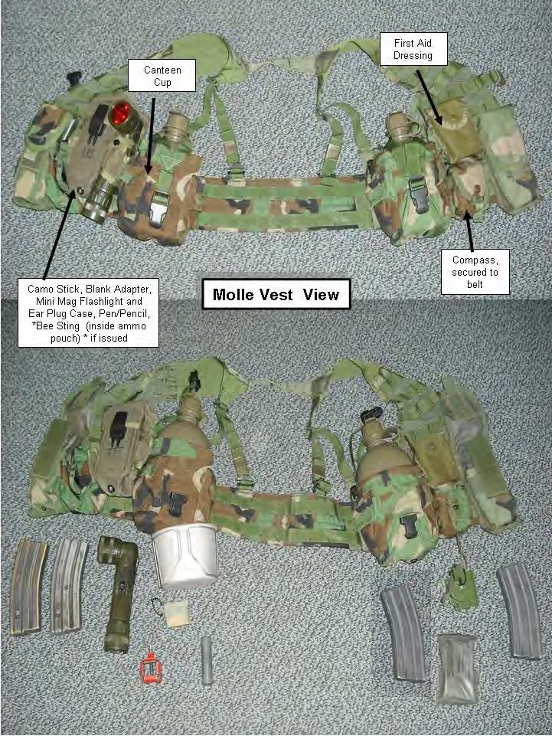

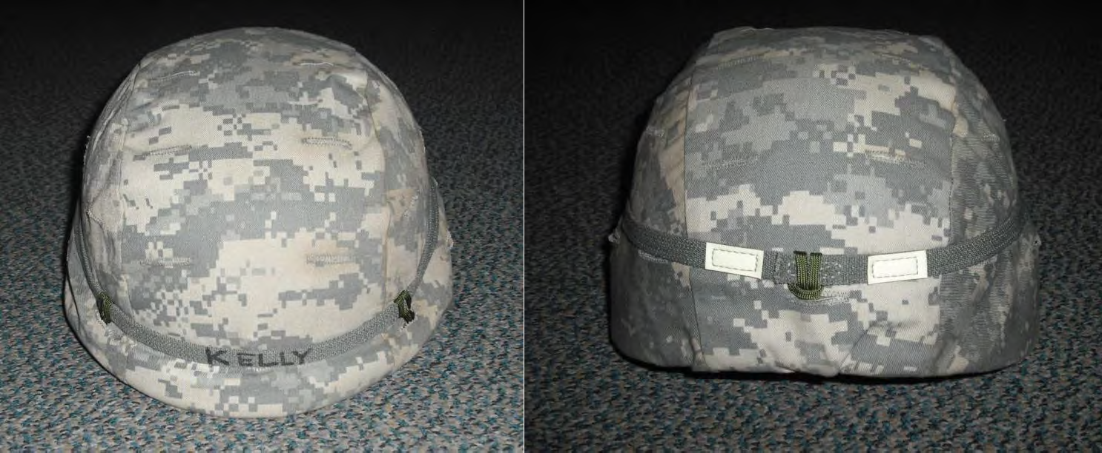

ANNEX N – Summer Training

Cadet Summer Training (CST)
The summer following their junior year, Cadets attend the Cadet Summer Training (CST), a five-week summer camp at Ft. Know, Ky. It is designed to evaluate a cadet's leadership abilities while providing additional leadership and individual skills instruction.
During CST each cadet is given several opportunities to serve in leadership positions such as squad leader, platoon sergeant, platoon leader, first sergeant, executive officer, or company commander. These positions allow the cadet to demonstrate his/her leadership ability and skills. The cadet's performance in this area, along with scores from the Army Physical Fitness Test, land navigation test, and tactics, make up the cadet's final grade for camp. During CST, a cadet will be exposed to many areas of Army doctrine and skills. This includes: Nuclear-Biological-Chemical (NBC) warfare, engineering (mines and obstacles), communications, land navigation, fire support, small unit tactics, and patrolling.
CST also features special training consisting of individual movement techniques, offensive and defensive operations, water survival, and more. One of the most exciting training events is Recondo Certification. This is a block of training that builds motivation and self-confidence in each cadet. A cadet will be challenged by the slide for life, Recondo obstacle course, forty-foot rope drop, and fifty-five foot rappel tower.
The evaluation a cadet receives has an effect on his/her future role in the U.S. Army. For this reason, Cadets should put forth their maximum effort and be fully prepared. All material required will be covered during a cadet's training in Army ROTC, so the cadet must ensure that he/she is ready to lead the way!
All transportation, room, and board expenses paid by the Army. Cadets receive approximately
$20/day less deductions.
For more information on LDAC please visit: http://warriorforge.wordpress.com
Or http://www.goarmy.com/rotc/courses-and-colleges/curriculum/leader-development-and-assessment.html
Leaders Training Course (LTC)
Leader's Training Course is the Army’s 2-year ROTC Program entry point. Through the Leader's Training Course, students without ROTC Basic Course experience can examine the Army without incurring an obligation, and qualify for Advanced Course entry. The Army observes these students and determines their officer potential in a leadership oriented, challenging, and motivating 28-day training program
The Leader's Training Course Concept
Leader's Training Course is an intensive 28-day training experience for college students unable to meet the basic course requirements on campus.

Leader's Training Course is the Army’s 2-year ROTC Program entry point. Through the Leader's Training Course, students without ROTC Basic Course experience can examine the Army without incurring an obligation, and qualify for Advanced Course entry. The Army observes these students and determines their officer potential in a leadership oriented, challenging, and motivating 28-day training program.
A successful camp begins with recruitment of quality students who have a desire to learn about ROTC and an Army Officer career. Training during camp educates, challenges, motivates, and demonstrates to the student the demands and rewards of being an Army Officer. Leader's Training Course is the student’s and the Army’s vehicle for determining future ROTC involvement.
The camp philosophy is based on an action-oriented training plan. Emphasis is hands on, outdoor training with rapid, constructive feedback to the cadet. Above all else, Leader's Training Course is a leadership experience. The training program is designed to inspire students to become outstanding leaders with a sound understanding of traditional leadership values. At the Leader's Training Course, students are trained to lead and develop their officer leadership potential.
Training at the Leader's Training Course (LTC).
The Leader's Training Course will give you some very special skills while simultaneously presenting you a combination of mental and physical challenges. Challenges that are specifically designed to bring out your leadership potential. It's full of adventure, excitement and it's
fun. An added benefit is the opportunity it provides to meet many other college students and establish some valuable and potentially lifelong relationships. In many ways, this course will raise your leadership stock in an amazingly short period of time --twenty -eight days.
The 28-day leader's Training Course is conducted during the summer at Fort Knox, Kentucky and it consists of three phases --the "Future leader" phase, "Bold Leader" phase and "Discover Gold" phase.
During the "Future Leader" phase you'll rappel, participate in a leadership reaction course, learn water survival and stream crossing techniques, first aid, weapons and how to navigate on land using a map and compass during the day and night. You'll be challenged physically throughout this entire phrase. You'll learn when to lead and when and how to follow.
During phase two, the "Bold Leader" phase we'll teach you small unit tactics. We'll put you through a self-confidence building obstacle course, rock climbing, paintball and the Tarzan assault course. With your newly established confidence in water survival you'll participate in small boat or raft operations. Additionally, this phase highlights the importance of teamwork and a balanced lifestyle of work and recreation.
Finally, during the "Discover Gold" phase you'll participate in some very entertaining social events, a family day and the culmination of the course -- the graduation ceremony.
Visit the LTC website: http://www.leaderstrainingcourse.com/0

You may attend Leader's Training Course if you:
- Have not completed all four semesters of Military Science I and II.
- Are medically qualified to attend.
- Are transferring from a school that did not have ROTC.
- Are a junior or community college transfer entering a ROTC school and have no prior active or Reserve component military experience.
- Are a graduate student, starting a two-year program.
- Are a high-school graduate entering a military junior college.
- Students with prior military service, or who have taken Junior ROTC, may be given credit for Basic Course completion and would not be required to attend Leader's Training Course
- Travel expenses are covered and students are paid a modest amount for their time at LTC.

Scholarship Opportunities:
- Students who attend the Leader's Training Course may compete for a Two-Year Army ROTC scholarship while at camp. These merit scholarships are awarded to the most qualified students who apply.

Cadet Troop Leader Training (CTLT) / Drill Cadet Leader Training (DCLT)
CTLT is a three-week leadership experience conducted at units in the Continental US, Alaska, Hawaii, and Europe. Students are placed in charge of a regular Army platoon of approximately 35 Soldiers. The student's objective is to perform the leadership and management tasks necessary to train the platoon's Soldiers and maintain its equipment.
While in CTLT, Cadets continue to receive a rate of pay and allowances equivalent to that received at Advanced Camp. Transportation to and from the unit is provided. In addition, Cadets stay in the Bachelor Officer Quarters and eat meals in the unit's dining facilities.
The experiences, insights and firsthand knowledge received will better prepare the cadet for his/her future as an officer. To attend CTLT a cadet must:
- Have successfully completed Advanced Camp training.
- Be selected by the Professor of Military Science.
This is the best way to "check out" a branch before selecting your branch assignment in the fall of your senior year.
DCLT is similar to CTLT. The unit will be either Basic Combat Training or Advanced Individual Training. The assignment affords Cadets the opportunity to enhance their small unit leadership skills in a number of different areas. Under supervision of a senior NCO/Drill Sergeant, the cadet will learn and practice the duties of a mid-grade noncommissioned officer. The cadet will train new Soldiers in such skills as drill and ceremonies, physical readiness training, and basic rifle marksmanship. Cadets will have the opportunity to cultivate and practice instructional techniques and improve performance-counseling skills. This assignment is very challenging with a large demand placed on the cadet’s time, self-discipline, and physical endurance. Long hours and hard work can be expected. The training experience of Drill Cadet Leader Training will reward Cadets throughout their military careers.

For more information about CTLT/DCLT visit:
CTLT: http://www.rotc.usaac.army.mil/training/ctlt.aspx DCLT: http://www.rotc.usaac.army.mil/training/dclt.aspx Cadet Practical Field Training (CPFT)
CPFT is a summer training program that affords highly qualified and motivated Cadets to attend some of the Army’s specialty schools during the summer. The Cadet Command goal for attendance to any CPFT school is 75% ML II and 25% ML III. ML I’s can attend but require a waiver from the PMS approved by the brigade commander. The various specialty schools are listed below:
Airborne School. There is nothing like leaping from an aircraft in flight with 600 of your closest buddies. Airborne School is a three-week course held at Fort Benning, Georgia. You will learn how to successfully parachute from various Army and Air Force aircraft. At the end of the course, you make 5 static-line jumps onto Fryar Drop Zone and earn the coveted parachutist badge. Airborne!
Air Assault School. "Stand up, hook up, slide down the rope!" This school combines the utility of rappelling with the excitement of riding in helicopters. Also, students learn how to hook objects like howitzers and Humvee (HMMWV-High Mobility Multipurpose Wheeled Vehicle) underneath hovering helicopters. Air Assault is as mentally challenging as it is physically demanding. It requires the student to be strong in both mind and body before attending. The reward for ten days of hard work is the coveted air assault badge.
Sapper Leader Course. Like to blow stuff up? This course trains select individuals in leadership skills, combat engineer and infantry battle drills, and specialized engineer and infantry techniques required to perform as a member of a Sapper Battalion. The course is also designed to build unit cohesion and Esprit de corps by training Soldiers in troop leading procedures, demolitions (conventional and expedient), mountaineering operations, aerial operations, foreign weapons, land navigation, waterborne operations and contingency threats. The course culminates in an intense field training exercise that reinforces the use of battle drills and specialized engineer techniques learned throughout the course.
Mountain Warfare Training. This school is not for the faint of heart. Mountain Warfare is a two-week school taught at Ethan Allen Firing Range in Jericho, Vermont. The course covers rappelling, rock climbing, mountain survival, land navigation, first aid, and knots. The course is physically and mentally demanding, and you should definitely train up for it.
Northern Warfare Cadet Orientation Course. Spend part of your summer climbing mountains and glaciers. This three-week course is held at Fort Greeley, Alaska, and is designed to teach you mountaineering, rock and glacier climbing, knots, and cold-weather survival.
Cadet Field Training. Eight-week program of instruction conducted by the United States Military Academy to develop the leadership skills of sophomore Cadets. Seven-weeks of Cadet Field Training will be at Camp Buckner, with one week at Fort Knox, Kentucky for Mounted Maneuver Training.

For more information about CPFT
Visit: http://www.rotc.usaac.army.mil/training/cadet-practical-field-training.aspx

Cultural Understanding and Language Proficiency Program (CULP)
The Army recognizes the need for young leaders to develop more cultural awareness and foreign language proficiency skills. Now more than ever, cultural awareness training is a vital component to the ROTC curriculum. Overseas immersions help educate future leaders in ways the classroom cannot.
Cadets now receive opportunity to compete for immersion in more than 30 countries. These opportunities expose them to everyday life in different cultures and intensify language study, which helps produce commissioned officers who possess the right blend of language and cultural skills required to support global operations in the 21st Century.
For more information please visit: http://www.rotc.usaac.army.mil/culp/

Internship Programs
There are many different types of internships offered in the summer through ROTC. The internships are listed below. For a detailed description, location and prerequisites for each please visit: http://www.goarmy.com/benefits/education-benefits/army-education/army-college-programs/internships.html
  - Army Science Board
  - Cadet internship Program
  - Lawrence Livermore National Laboratory
  - National Ground Intelligence Center
  - Research Internship Program
  - Specialized Internships
  - AMED Internship Program
  - Central Identification Laboratory Internship Program
  - Chaplaincy Internship Program
  - Engineering Internships
  - Health facilities planning agency internship program
  - Judge Advocate General Internship Program

ANNEX O – ROTC affiliated clubs

Scabbard and Blade Society – Open to Army and Air Force ROTC Cadets by invitation.
  - The Scabbard and Blade organization represents the highest military fraternity at Clemson University. The purpose of this organization is to promote interest in the military and to promote a closer relationship between the students and the military departments. Membership in Scabbard and Blade is open to a select number of Army and Air Force Cadets not to exceed the top 10% of the Corps of Cadets. New members are selected by active individual qualities of leadership ability and exemplary character.
  - K Company’s core of activities revolves around the professional development of its members, the Clemson Corps, and Cadets. Our activities range from hosting speaking engagements featuring military professionals from all services and ranks as well as political and defense specialists. We are the keepers of the History of the Clemson Corps at Clemson University. We provide watch over all the historical monuments that are dedicated to the Cadets that have passed through the pillars of excellence into the Armed Forced of the United States.
  - Each year K-Co sponsors the annual Clemson University Scabbard and Blade Military Ball. This evening of formal dinner and dance is held in the spring of each school year.

Ranger Club – Open to all Clemson University students, no ROTC affiliation required.
  - Founded in 1956, the Clemson Rangers are a military affiliated organization dedicated to enhancing each member’s leadership abilities, fidelity, bravery, integrity, self-discipline and character. Training includes field training exercises, physical training, marksmanship, and rappelling. All interclub training is focused on familiarizing members with small unit infantry tactics, orienteering, and improving each individual’s physical abilities and ability to survive under adverse conditions.
  - Over the past 55 years the Clemson Rangers have helped countless Patriots prepare to serve in all branches of the United States military. Graduated Clemson Rangers are currently serving with the 75th Ranger Regiment, 82nd Airborne Division and have deployed with the 101st Airborne Division.
  - Membership in the club is attained through completion of the six-week indoctrination (MEAT) phase held annually in the fall. During MEAT phase, prospective candidates are instructed and trained in areas of physical development and knowledge acquisition. In order to gain entry into the Clemson Rangers, each candidate must pass a series of tests concentrating on physical fitness and relevant military knowledge.
  - Throughout the Battalion, the Clemson Rangers are easily recognizable in the “Black Tee” worn weekly at battalion PT sessions, as well as their distinctive unit patch, worn on the right shoulder in the ACU and Class A uniforms. The Ranger’s emphasis on PT and small unit tactics results in the majority of members branching into the combat arms; additionally many Rangers each year successfully complete the Army Airborne and Air Assault schools.

Pershing Rifles – Open to all students at Clemson University.
  - “The purpose of Pershing Rifles is to foster a spirit of friendship and cooperation among the men in the military department and maintain a highly efficient drill company.” –as stated by General John Joseph Pershing.
  - Chartered March 19, 1946, Company C-4 has a long tradition of excellence. Most recently this includes National Drill meet Champion in 2008 & 2009. Performing at functions throughout the Nation, the drill team and color guard have distinguished themselves.
  - Members distinguish themselves in drill and ceremonies, Rifle Drill and Color Guard.
  - Over the years since 1939, Company C-4 has established an unparalleled record of achievement. Each past company has contributed to the reputation and success of the unit- as will each successive unit. Although small in number, Company C-4 will always continue to strive for excellence in all it does.

Tiger Platoon – Open to all University students, Army and Air Force ROTC.
  - Purpose: Provide an opportunity to all students interested in practicing drill and ceremonies.
  - The first Clemson A&M College Fancy Drill Platoon was organized in the spring of 1929 by Cadet Frank Burdick Farr, class of 1930. The Citadel had a drill platoon that competed at ROTC summer camp with platoons from other schools. Farr’s brother, a Citadel cadet, told him that the only way to settle the argument on who was best was for Clemson to organize a platoon and compete with the Citadel Platoon at camp.
  - In the spring of 1929, Cadet Farr was the highest-ranking junior Cadet at Clemson. He called for members of the junior class to try out for the platoon and about 150 reported for the competition. The platoon consisted of five squads of eight men each, two guides, a leader, and an alternate squad of eight men. Fifty-one members were chosen by competitive drills. At ROTC camp in the summer of 1929, the drill platoons of all fourth Corps area schools competed. The Clemson Platoon won the area championship. The purpose of the platoon was accomplished. However, instead of disbanding, the members decided to remain organized and put on exhibition drills.
  - Clemson’s Senior Platoon had the enviable reputation of being the only one of its kind in the United States. During the early 30’s, the platoon was referred to as The Fancy Prize Drill Platoon or the Junior Platoon. In 1934, the name Clemson Senior Platoon was adopted.
  - In 1960, the Clemson Senior Platoon was deactivated and reactivated in the fall of 2000.

ANNEX P –MEDEVAC REQUEST

- Collect all applicable information needed for the MEDEVAC request.
  - Determine the grid coordinates for the pickup site.
  - Obtain radio frequency, call sign, and suffix.
  - Obtain the number of patients and precedence.
  - Determine the type of special equipment required.
  - Determine the number and type (litter or ambulatory) of patients.
  - Determine the security of the pickup site.
  - Determine how the pickup site will be marked.
  - Determine patient nationality and status
  - Obtain pickup site nuclear, biological, and chemical (CBRN) contamination information, normally obtained from the senior person or medic.

Note: CBRN line 9 information is only included when contamination exists.
- Record the gathered MEDEVAC information using the authorized brevity codes.
Note: Unless the MEDEVAC information is transmitted over secure communication systems, it must be encrypted, except as noted in step 3b(1).
  - Location of the pickup site (line 1).
  - Radio frequency, call sign, and suffix (line 2).
  - Numbers of patients by precedence (line 3).
  - Special equipment required (line 4).
  - Number of patients by type (line 5).
  - Security of the pickup site (line 6).
  - Method of marking the pickup site (line 7).
  - Patient nationality and status (line 8).
  - CBRN contamination (line 9).

- Transmit the MEDEVAC request.
  - Contact the unit that controls the evacuation assets.
    - Make proper contact with the intended receiver.
    - Use effective call sign and frequency assignments from the SOI.
    - Give the following in the clear "I HAVE A MEDEVAC REQUEST;" wait one to three seconds for a response. If no response, repeat the statement.
  - Transmit the MEDEVAC information in the proper sequence.
    - State all line item numbers in clear text. The call sign and suffix (if needed) in line 2 may be transmitted in the clear.

Note: Line numbers 1 through 5 must always be transmitted during the initial contact with the evacuation unit. Lines 6 through 9 may be transmitted while the aircraft or vehicle is en route.

    - Follow the procedure provided in the explanation column of the MEDEVAC request format to transmit other required information.

    - Pronounce letters and numbers according to appropriate radio/telephone procedures.
    - Take no longer than 25 seconds to transmit.
    - End the transmission by stating "Over."
    - Keep the radio on and listen for additional instructions or contact from the evacuation unit.

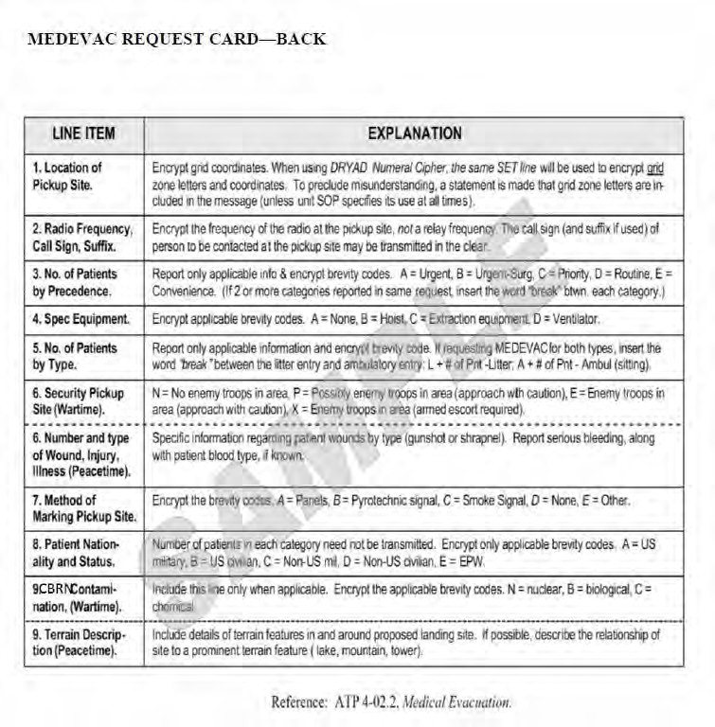

ORDERS PROCESS

The orders process is integral in the dissemination of information from the c/Battalion Commander (BN CDR) down to each individual Cadet. This process begins when the c/BN CDR issues planning guidance to his staff a minimum of two weeks out from issuing an operations order (OPORD). The c/battalion staff will develop plans based on training guidance and get final approvals of the plan from the c/ BN CDR NLT one week out from issuing the OPORD. The following week, the c/battalion staff will issue the OPORD to the company leadership. This will begin the dissemination of information, through the chain of command, using the basic military OPORD. Below describes what an OPORD is:
Operations Orders
- An Operations Order, often abbreviated as OPORD, is a text that describes a military operation. An Operations Order will describe the situation facing the unit, the mission of the unit, and what activities the unit will conduct to achieve the mission goals. Normally an Operations Order will be generated at the regiment, brigade, or division level of the organization and then given to lower echelons to implement. The lower echelons in turn will develop their own Operations Order which provides more details as to what the subunits will do, how they will do it, and with what equipment and support. So, an Operations Order at a particular level of the military organization will trigger units involved in the operation to develop their own Operations Order which will borrow from the Operations Order given to them so far as the situation and mission but will then add additional details for the activities a specific unit is to conduct.
- A standardized multi-paragraph format is used by the United States Department of Defense's armed services and most other military forces. An OPORD is designed to lay out the generals and specifics of a mission into five paragraphs: Situation, Mission, Execution, Service Support, and Command and Signal.
OPORD Variations
- WARNORD – Given in advance of the OPORD to let Soldiers under the command know that they may be receiving an Operations Order. The WARNORD contains a few basic details of the situation and what the mission may entail however much of the pertinent information for a proper Operations Order is still forthcoming.
- FRAGORD – Once an OPORD is given the situation may change before the mission is begun or during the operation the situation may change so that the Operations Order must be modified. In these cases, the commander will issue a Fragmentary Order, or FRAGORD. The FRAGORD will state exactly how the situation and/or mission has been changed and what must be done to make up for the change.

- Situation
OPORD Shell
OPORD Skeleton

  - Enemy: are operating in VIC and estimated to be
in size. They are and their moral is .
    - Their probable COA is

    - Most dangerous COA is

  - Friendly
    - Higher will
    - Left Unit will
    - Right Unit will
- Mission
  - Our mission squad conducts (KOB, MTC, ATK, Ambush, Recon) NLT on OBJ in VIC to

- Execution
  - Concept of Operation:
    - We will travel in squad (wedge, column, file) formation in (traveling overwatch, bounding overwatch).
    - We will travel meters at an azimuth of degrees.
    - We will cross LD NLT and travel along route to OBJ .
    - Rally points will be set every meters and will be METT-TC dependent. Set up an ORP meters from the OBJ.
    - Fire support: we are in the priority for
  - Task to Maneuver units
    - A team will provide (Pace/ compass, assault, A&L, EPW, Demo, COB, R&S, S&O, MOB).
      - and
    - B team will provide (Pace/ compass, assault, A&L, EPW, Demo, COB, R&S, S&O, MOB).
      - and
  - Scheme of Maneuver
    - Terrain Model
  - Coordinating instructions:
    - PIR: weapons, communication equipment, type of vehicle, number of personnel,

    - Reports: Crossing LD, Contact, captured EPW, ACE after consolidation, crossing LDA, SITREPS, and SALUTE reports as needed.
- Service Support:
  - General: Company trans located in CO AA @ VIC

  - Material and services
    - Supply: No resupply for 24 hours.
    - Class cycle is M-M-M
    - Top off water in your current positions before moving out
    - Trans: None
    - Services: None
    - Medical: Casualty collection point in VIC MEDEVAC available on request
    - Personnel: EPW collection point in VIC and at assault position
- Command and Signal
  - Command:
    - moves with PL moves with squad
    - Succession of command is
  - Signal
    - Call sign is:
      - PL)
      - PSG)
      - FO)
      - 1SL)
      - 2SL)
      - 3SL)
      - WSL)
    - Number Combo:
    - Challenge Password
    - Running Password

