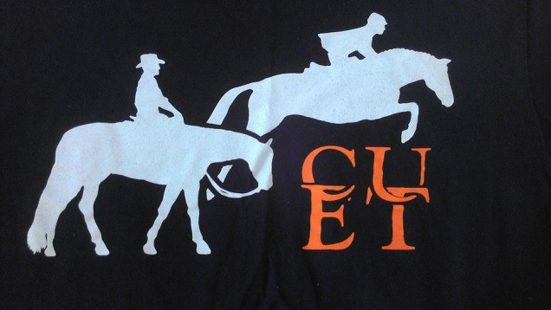

Tiger’s Choice

Equestrian Camp
at the Clemson University Equine Center

Your guide to everything you need to know!

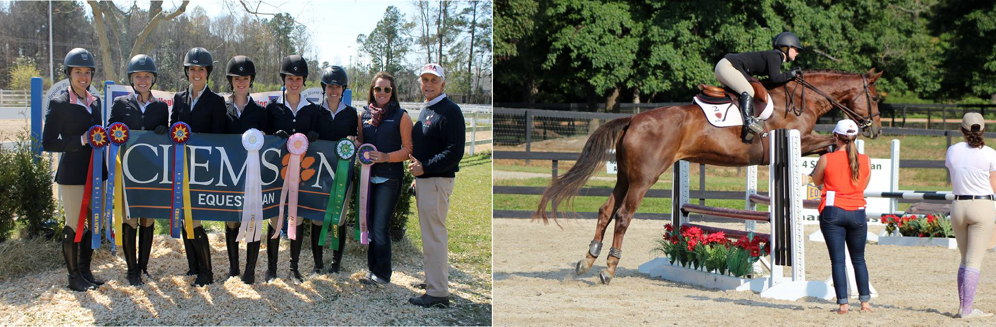

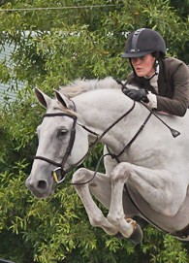
Contents

General Information and Rules ……. 2
Camper Needs ……. 5
Tentative Schedule of Activities ……. 6
Sample Rider Placement Form ……. 9

About our coaches:
Head Coach
A South Carolina upstate native, Jamie Grant Rowland grew up submerged in a horse- crazed childhood. She was a typical lesson barn rat before channeling her energy toward the hunter/jumper show scene as a teenager. Pursuing endless working student positions, Jamie earned the opportunity to show through her junior years in the hunter, jumper and equitation classes. While completing the Equine Business program at Clemson, she continued to develop her industry experience by working professionally riding and grooming for many reputable trainers in the southeast. After graduation, it took Jamie only a short time to return to her Clemson roots to become their Hunt Seat coach in January 2013. Years of hard work in the industry gained her the opportunity to ride many horses with great professionals, and she expects the same diligence from her students.
Her teaching style emphasizes the dedication to horsemanship and its way of producing safe, poised and effective riders. Jamie enjoys not only coaching team riders at the Clemson University Equine Center but also developing horses and riders at her personal farm, Chestnut Grove Farm, in Seneca, South Carolina.

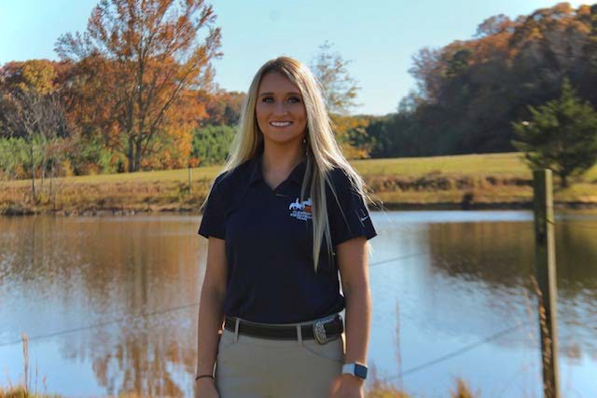

Assistant coach
Lexi is a graduate student at Clemson University. During her undergraduate studies, she competed on both the hunt seat and western IHSA teams here at Clemson and successfully competed at Nationals during her senior year. Lexi’s riding experience is quite broad, though now her focus is in the Hunters, Equitation, and Reining.

General Information and Rules
Purpose: Tiger's Choice is an intensive riding camp that lets riders experience what it’s like to ride for Clemson's IHSA (Intercollegiate Horse Show Association) Equestrian Team. Campers ride Clemson Equestrian Team horses in IHSA format daily, while also experiencing the culture of Clemson University from a student perspective and meeting other equestrians.

Dates: Announced annually on our website and Facebook page.

Location: Clemson University Equine Center & Clemson University Campus
Cost: Camp tuition is $950. Camp fees include breakfast, lunch, and dinner daily (beginning with dinner on the first evening and concluding with lunch on the final day), lodging, a variety of horses/ponies to ride, the use of all tack and equipment, twice daily riding instruction, and various educational and recreational activities.
Camper Eligibility: Riders must be at least 16 years of age at the time of camp
and at least a rising high school junior.

Registration: Registration opens annually on February 15th at 9:00 a.m. Registration is first come, first served. Campers are encouraged to register early, as spots are limited and fill quickly. Registration can be made online following the link at https://www.clemson.edu/cafls/departments/equine- center/outreachresearch/index.html under the Tiger’s Choice Equestrian Camp heading.
Once registered, campers have until May 1 to complete and submit all required forms.
Horses: Participants will ride Clemson Equestrian Team horses. Horses are allocated for specific IHSA levels and disciplines. Riders will be assigned an appropriate mount prior to each riding session, with each rider given the opportunity to ride a variety of horses. This variety will help prepare riders for participation in a collegiate riding program or team.

Equipment: Clemson University Equine Center will provide all necessary tack and equipment. Riders are responsible for providing appropriate riding attire, including an ASTM/SEI certified helmet and tall boots or paddock boots with half chaps.
Although it is not required, campers may bring a personally owned saddle.

Insurance: All campers must have primary health insurance.

Overnight Housing and Transportation: Campers will be transported using vans or university vehicles when shuttling between the campus/dorms and Clemson University Equine Center. Overnight accommodations are provided at the dormitories on main campus. Campers are assigned a roommate based on age appropriateness and availability. Roommate requests will be accommodated as long as the camp director has been notified of requests by both parties by May 1.
Departure Procedures: Parents are requested to arrive for pick-up of campers on Saturday, the final day of camp, at 1:00 PM. Pickup of campers and their luggage will be at the Equine Center, where parents and riders can enjoy a brief closing ceremony with a camp video prior to departure. No camper will be allowed to leave until they are officially signed out with the camp director.
Activities: a major part of camp activities are riding instruction. Other horsemanship activities may include the following demonstrations and workshops:
- IHSA Riding Format
- Video review of riding sessions
- Tack/equipment care
- Equine career opportunities
- Stable Management Demonstrations

Activities related to the student culture of Clemson University will include a student’s perspective of a freshman living situation, including staying in a campus dorm, eating and shopping in downtown Clemson, and much more! This camp gives prospective and soon-to-be students a taste of what it is like to be a Clemson Tiger.
Behavior Policy: Safety will be emphasized at all times. To ensure a safe atmosphere, campers must strictly comply with camp personnel and policies. Failure to adhere to these rules will result in the camper being sent home at the parents' expense. The following misconduct WILL result in a camper being sent home:

  - Deliberate cruelty to animals
  - Deliberate destruction of facilities or equipment
  - Possession of alcoholic beverages or illegal drugs
  - Blatant discourtesy to camp personnel
  - Disregard of camp personnel’s requests to obey rules and regulations
  - Disrespectful or dangerous behavior towards other campers
or staff
  - Unacceptable or dangerous conduct
  - Possession or use of fireworks
  - Use of inappropriate language

The following items are not allowed at camp:

  - Tobacco
  - Alcohol
  - TVs and/or electronic games
  - Illegal drugs
  - Knives, guns, or other weapons
  - Fireworks

Family/Guest Visitation: In order for all campers to get the most out of their camp experience, no parent, guardian, family member or guest may visit the campers during camp unless expressly pre-approved by the camp director. Please be sure all the supplies that the camper needs during camp are delivered and stored before you leave on check-in day. If you are concerned about your child or just want to check in with camp staff, please feel free to contact the camp director, Mary Schultz-Rathbun, at cuec@clemson.edu or 864-646-3554.
Policy on Headgear Safety Equipment: The Clemson University Equine Center requires that all riders wear protective headgear that meets or surpasses current ASTM/SEI standards while riding. The headgear must be properly fitted and worn on the top of the head with the strap or harness securely fastened.
It is the responsibility of the rider, and the parent or guardian of the rider, to confirm that the headgear worn by the rider complies with the safety standards set forth above; is properly fitted and fastened; and is in sufficiently good condition that it will protect the rider in the event of an accident. All campers are required to wear a helmet regardless of riding level or discipline.

Camper Needs for Equestrian Camp
Personal Items:

- Soap
- Shampoo
- Clothing (see below)
- Sunscreen
- Insect repellent
- Personal toiletry items
- Bedding (Twin XL sheets or a sleeping bag, and pillow)
- Shower shoes
- Money for souvenir shopping
- Towels
- Laundry bag
- Water bottle
Riding Apparel: Show clothes are not needed, but all campers should ride in neat and professional-looking apparel. Fitted shirts, polo shirts, or other fitted riding tops are preferred (sleeveless polos are allowed, but no tank tops). Shirts should be worn tucked into breeches or riding tights. Either tall boots or paddock boots worn with half chaps are acceptable. Rider must also provide a personally owned helmet. Clothes with holes, shorts, wide leg pants, halter tops or tank tops and other unsuitable clothes are not permitted in the stable area.
General Apparel: Shorts, jeans, t-shirts, polos, blouses, tennis shoes, etc. are acceptable away from the barn area. Tank tops should have a minimum of a 1" strap. Revealing clothes are not acceptable during recreational activities, at the dormitories, or on campus.

- Light jacket
- Clothes and swimsuits (tentative) to participate in recreational activities/games
- Rain gear
- Sweat shirt
- Ball cap/sun hat
- Ample socks & undergarments
Please do not bring expensive jewelry, cameras, radios, coolers, or excessive amounts of money to camp. We cannot be responsible for lost or stolen items.

Food and Snacks: Breakfast, lunch, and dinner will be provided daily, along with snacks to take back to the dorms overnight. Personal snacks from home are permitted but must be disposed of properly in trash receptacles. Snacks/drinks can also be purchased on main campus from vending machines. Campers with food allergies should let camp personnel know by May 1 so arrangements can be made.

Tentative Schedule of Activities

Tuesday (first day)

3:00 – 5:00 PM

4:00 PM

5:00 PM

6:00 PM

10:30 PM

Wednesday - Friday

7:00 AM

8:00 AM

9:00 AM – 12:00 PM
12:00 PM

1:00 PM
5:30 – 8:00 PM

8:00 PM

Check in/move in at on campus dormitory Orientation for campers/parents
Parents dismissed, campers head to CU Equine Center

Dinner, orientation, and evening activities at CUEC

In rooms for lights out

Roll call in lobby; depart for CUEC

Breakfast served at CUEC; receive horse assignments

Riding lessons & auditing of riding sessions Lunch
Daily recreational activity followed by free time Riding lessons & auditing of riding sessions Dinner served around assigned ride time
Put away horses, clean tack, etc.

9:00 PM

10:30 PM

Saturday

7:00 AM

7:30 AM

8:30 AM – 12:00

PM 12:00 PM

1:00 PM

1:30 - 2:00 PM
Depart for campus

In rooms for lights out

Roll call in lobby and load luggage; depart for CUEC

Arrive at CUEC, eat breakfast

Mock horse show or other special final riding activity Lunch at Equine Center
Parents arrive for closing ceremonies

Camper check-out and departure from CUEC

CLEMSON EQUESTRIAN CAMPS RIDER PLACEMENT WORKSHEET

Rider Name:

Please summarize number of years of experience in each discipline and category:
 | Riding | Lessons | Showing | USEF  Showing | 4H  Showing | International  Competition | AQHA  Showing | Breed  Showing | NRHA  Showing | APHA  Showing | USDF  Showing | USEA  Events
Hunter Seat
Flat
Hunter Seat
Over Fences
Jumpers
Dressage
Eventing
Other
(explain)
Please give a brief description of previous riding experience, including any details you think may help the coach determine appropriate riding level. You may also include the rider's riding goals for attending this camp:

