Environmental Engineering
and Earth Sciences

EEES Department Seminar

Power and People

Frank Holleman
Senior Attorney
Southern Environmental Law Center

About the speaker:

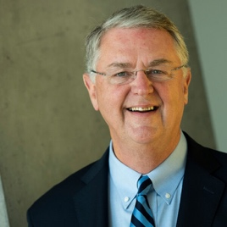
Frank Sharp Holleman, III is an attorney from South Carolina, and a former United States Deputy Secretary of Education.

Holleman was born in Seneca, South Carolina and attended Furman University in Greenville, South Carolina. He graduated from Harvard Law School and served as a law clerk for Judge Harrison Lee Winter of the Fourth Circuit and Supreme Court Justice Harry Blackmun. He then worked as a partner at Wyche, Burgess, Freeman and Parham in Greenville, South Carolina.

Holleman is now a senior litigating attorney at the Southern Environmental Law Center, where he has led the effort to litigate against power utilities over the disposal of coal ash, especially in the wake of the 2014 Dan River coal ash spill.

2:30 PM
Friday, February 11, 2022
Brackett Hall 100

In-person attendance is mandatory for graduate students enrolled in EES 8610, EES 9610, and GEOL 8510. You can join online via Zoom only if you have tested positive for COVID-19 and requested an absence or have obtained prior approval for another valid reason.

For those attending online, please join via:
https://clemson.zoom.us/j/5783910968

