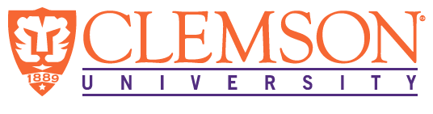
Environmental Engineering
and Earth Sciences

EEES Department Seminar

The NRC: Who We Are and What We Do

Commissioner David A. Wright
U. S. Nuclear Regulatory Commission

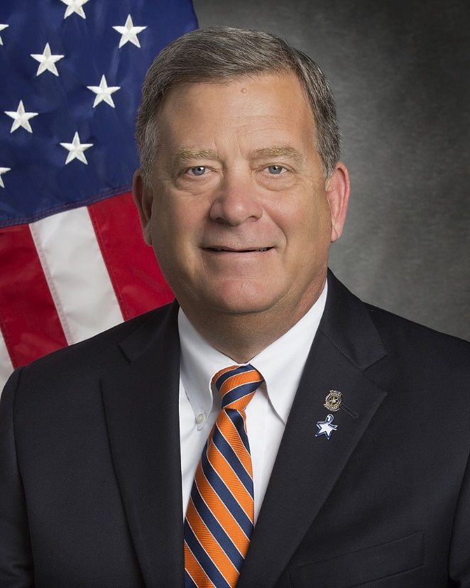
The Honorable David A. Wright graduated from Clemson University in 1977 with a B.A. in political science and communications. In 1996, he received South Carolina's highest citizen honor, the Order of the Palmetto.

David A. Wright was first sworn in as a Commissioner of the U.S. Nuclear Regulatory Commission on May 30, 2018. He is currently serving a term ending on June 30, 2025.

Commissioner Wright was Owner/President of Wright Directions, LLC, a strategic energy and water consulting and communications business. During this time, he also was a member of the Advisory Council of the Bipartisan Policy Center's Nuclear Waste Initiative; and an Ex Officio Member and Chairman Emeritus of the Nuclear Waste Strategy Coalition, an ad hoc organization representing the interests of industry, state officials, local governments and tribes, and consumer advocates.

From 2004-2013, Commissioner Wright served the South Carolina Public Service Commission in a variety of capacities, including Vice Chairman and Chairman. From 2011-2012, he served as President of the National Association of Regulatory Utility Commissioners; he had previously served the association in other capacities, including as a member of the Executive Committee and Board of Directors. From 2010-2013, Commissioner Wright was a member of the Advisory Board of the Board of Directors of the Electric Power Research Institute.

2:30 PM
Friday, March 18, 2022
Brackett Hall 100

In-person attendance is mandatory for graduate students enrolled in EES 8610, EES 9610, and GEOL 8510. You can join online via Zoom only if you have tested positive for COVID-19 and requested an absence or have obtained prior approval for another valid reason.

For those attending online, please join via:
https://clemson.zoom.us/j/5783910968

