Environmental Engineering
and Earth Sciences

EEES Department Seminar

“Dancing with Models”– The Journey of Building Deep Neural Network Models in Surface Hydrology

Dr. Vidya Samadi
Assistant Professor
Agricultural Sciences Department, Clemson University
Abstract
Deep neural networks (DNNs) have increasingly been used in complex hydrological simulations, demonstrating strong performance improvements over traditional models. However, these algorithms cannot fulfill their decision-support potential on their own. Rather, they must be utilized in partnership with equally sophisticated software that links models with big data acquired at gauging stations as well as with uncertainty assessment to reduce errors and interact with the algorithms (“dancing with models”). As they “dance” with models, these partner software can be engineered to accomplish tasks such as hypothesis-driven simulation, optimization, uncertainty quantification, and decision-making. The importance of model partnership is not nearly as widely appreciated in surface water modeling as it should be. Hydrologists often build DNN models that aren’t integrated with data analytics, take too long to run, and do not provide comprehensive uncertainty assessment support for the wide range of ancillary tasks that decision-support modeling requires. This presentation will discuss the importance of building DNNs with data analytics and uncertainty assessment as partner software that can fulfill the decision-making potential. Two examples of building partner software including daily streamflow simulation across the continental US as well as flood simulation at the local scale will be discussed. These partner software are developed by Clemson Hydrosystem and Hydroinformatics Research (HHR) group with easy-to-use workflows following Findable, Accessible, Interoperable, and Reusable (FAIR) principles.

Vidya Samadi, Ph.D., A.M. ASCE
Assistant Professor, Department of Agricultural Sciences, Clemson University, USA.

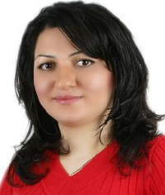
BIO – Dr. Vidya Samadi is an Assistant Professor and Director of Hydrosystem and Hydroinformatics Research (HHR) group at Clemson Department of Agricultural Sciences. Her research focuses on leveraging advances in hydroinformatics and cyber-physical systems to address challenges associated with water resources modeling systems. Prior to joining Clemson University in the spring of 2020, Dr. Samadi was a Research Assistant Professor at the Department of Civil and Environmental Engineering at the University of South Carolina (UofSC) and a Postdoctoral Scholar with the NOAA center for the Carolina Integrated Sciences and Assessments (CISA-UofSC). She was also a Research Fellow (Postdoc) in Civil Engineering at the Department of Architectural, Civil & Environmental Engineering, School of Engineering, Cardiff University, United Kingdom. Dr. Samadi received her Ph.D. and MS degrees in Water Resources Engineering respectively, from Research and Science University and the University of Tehran (Iran). Her research is funded by NSF, USGS, Savannah River National Lab, NOAA, USDA, and SCDOT. Dr. Samadi is the founder of the “WomeninAI4Water” initiative that educates and strengthens the diversity of female representation and participation in AI for water science and engineering.

Random Get-to-Know-Me Facts!

What is your favorite aspect of what you currently do as a scientist?
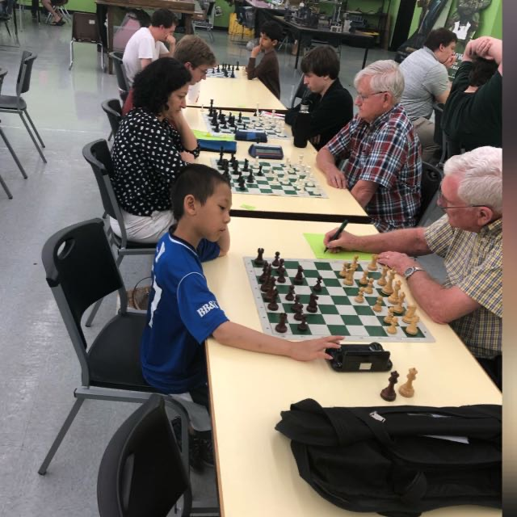
Seeing students learn to develop, answer, and communicate their science using rapidly evolving observational and computational intelligence is the most exciting part of being a teacher for me. I particularly enjoy leading student research in hydro informatics that requires initiative and creativity such as learning water data science by combining mathematics, statistics, water engineering, and computer science—seeing students grow in their research and move on to success.

What are one or two things you do for fun?
I play chess and frequently attend chess clubs around the area. Back in the days when I moved to South Carolina and joined the Columbia chess club, I was the only woman in the club (this picture 👉 justifies it:)!).
I also love to travel and do outdoor activities with my family, and of course take in the unique rivers and water resources systems that are around the world.

Is “being a female in engineering” really as tough for you as we’ve read?
Being a woman in engineering can be challenging because the academic culture of engineering is perceived as more of masculine culture. Giving women equal opportunities to pursue — and thrive in — engineering careers helps narrow the gender gap, enhances women’s economic security, and ensures a diverse and talented STEM workforce that will be better prepared to tackle real world problems and participate in civil society.

2:30 PM
Friday, March 31, 2023
Brackett Hall 100
In-person attendance is mandatory for graduate students enrolled in EES 8610, EES 9610, and GEOL 8610.
Refreshments following seminar.

