Environmental Engineering
and Earth Sciences

EEES Department Seminar

Developing Ex-Situ Smoldering Remediation Systems

Kyle Barber, P.E.
Engineer
Savron Solutions
Denver, CO

Smoldering combustion is a low-cost, energy efficient thermal technique for the treatment of contaminated soils and process wastes. This approach is commercially available as the STAR (in situ) and STARx (ex- situ) technologies and has traditionally been used for the treatment of heavy hydrocarbons. For these contaminants, the smoldering reaction propagates in a self-sustaining manner following a short duration, low energy input ‘ignition event’ as the energy released from the reacting contaminants is used to pre-heat and combust contaminants in adjacent areas, provided that a sufficient flux of air is supplied.

STARx began in a research lab at University of Western Ontario, the process has developed into a full-scale remediation technology. Savron has recently completed construction of two full scale STARx plants designed to treat oil/sludge wastes generated during remedial activities at an operating oil field in Kuwait and a former oil terminal in the Bahamas. Operations at both project sites began in 2022.

The presentation will focus on STARx Plant design and implementation, including site selection criteria, full-scale case studies, and a look into the future of STARx technology.

About the speaker:
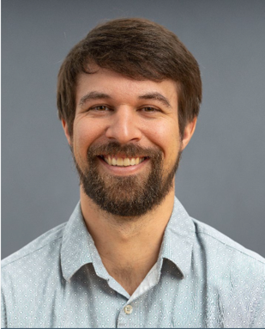
Kyle Barber is an Engineer with Savron, a division of Geosyntec Consultants International, Inc., based in the firm’s Lakewood, Colorado office. Mr. Barber leverages his engineering knowledge and field experience when designing and implementing STAR/STARx solutions for clients. Mr. Barber joined Geosyntec/Savron in 2018 and was immediately involved with Savron’s largest STAR project. He has been actively involved in the engineering, implementation, and operation of pilot and full-scale applications of in-situ (STAR) and ex-situ (STARx) systems, across North America and the Middle East. Based on his experience implementing and operating these systems, he has contributed to the development of several improvements for STAR/STARx system design, fabrication, and operation.

2:30 PM
Friday, April 21, 2023
Brackett Hall 100
Attendance is mandatory for graduate students enrolled in EES 8610, EES 9610, and GEOL 8610.
Refreshments after seminar.

