Environmental Engineering
and Earth Sciences

EEES Department Seminar

TIGER Grant Symposium
School of Civil and Environmental Engineering and Earth Sciences (SCEEES)

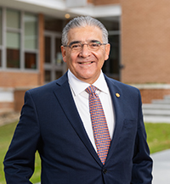
2.30 pm Welcome; introduction to the three 2021-22 TIGER Grant Awardee Teams

Jesus de la Garza, SCEEES Director

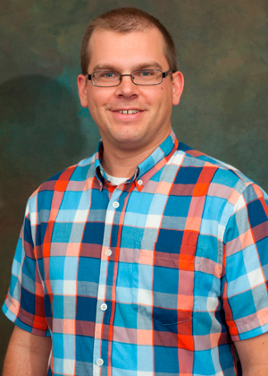
2.35 pm Making Buildings Safer by Improving Indoor Air Quality

Andrew Metcalf (EEES), Nigel Kaye (CE), Mik
Carbajales-Dale (EEES), Vincent Blouin (Arch/MS&E),
Ehsan Mousavi (CSM), Chris Post (FEC)

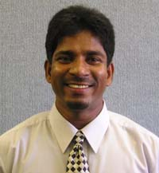
2.55 pm Understanding the non-linear hydromechanical effects of extreme events to improve performance and reduce costs
of infrastructure foundations

Ravi Ravichandran (CE), Larry Murdoch (EEES)

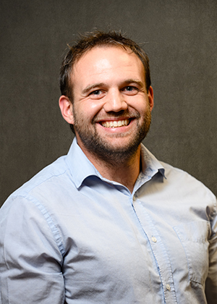

3.15 pm Laying down roots: Mimicking Root Architecture to Develop Innovative Cost-Effective Foundations for Tall Wind Turbines

Brady Flinchum (EEES), Ravi Ravichandran (CE)

2:30 PM
Friday, September 9, 2022
Rich Laboratory Auditorium
Attendance is mandatory for graduate students enrolled in EES 8610, EES 9610, and GEOL 8610.
Refreshments following the seminar.

