Environmental Engineering
and Earth Sciences
EEES Department Seminar

Biomining – Critical Minerals and Materials Recovery Using Microorganisms

Robin L. Brigmon
Savannah River National Laboratory

Rare earth elements (REEs) are an essential part of many high-tech devices, thus of critical and strategic importance. Currently, the major mining approach of REEs is and creates large waste streams. The objective of this project is to develop cost-effective, environmentally friendly technologies for bioextracting and bioaccumulating REEs from mined bastnaesite (Ce, La)CO₃F), rhyolite (silica rich felsic volcanic rock), and apatite (Ca5(PO4)3(OH,F,Cl)) and phosphogypsum using microorganisms. Microorganisms tested for bioextraction include Bacillus cereus, Gluconobacter oxydans, Cupriavidus basiliensis SRS, a bacterium isolated from the Savannah River Site, and BioTiger®, a microbial consortium patented by SRNL. B. cereus and BioTiger® exude biosurfactants (e.g., rhamnolipids) that enhance the extraction of multivalent cations. With the bastnaesite C. basiliensis SRS extracted REEs cerium (Ce), lanthanum (Ln), neodymium (Nd), significantly higher (>20ppb) than the other cultures. Bioextracting worked better using the natural mined material rather that autoclaved mining material, suggesting a potential role for the native microbiota in biomining success. Siderophores were identified as a potential biomining mechanism for C. basiliensis SRS. Next-generation sequencing of 16S rRNA genes was used to monitor microbial population changes associated with biomining. When added to natural mining material, C. basiliensis SRS was highly competitive, dominating 99% of the microbial population in the extracted material. In biosorption studies, C. basiliensis SRS sorbed >90% Ce and Ln from solution over controls. Using bioaugmentation along with heat treatment, it was demonstrated that Cupriavidus SRS can bioextract select REEs from mined materials at ppm concentrations. In separate environmental testing, C. basiliensis SRS also successfully extracted Uranium (U) and Nickel (Ni) from contaminated SRS stream sediments. C. basiliensis SRS genome annotation reveals numerous putative proteins responsible for metal acquisition and homeostasis, including 10 TonB-dependent siderophore transporters, 3 TonB proteins, 3 ExbB/ExbD proteins, 2 ferric iron ABC transporters, 4 magnesium and cobalt transport proteins, 8 extracytoplasmic function (ECF) sigma factors, and 7 heavy metal efflux pumps (lead-, cadmium-, zinc-, and mercury-transporting ATPases/copper-transporting P-type ATPases). The presence of these putative metal uptake- and metal efflux-related proteins in C. basiliensis SRS supports this organism application for bioremediation and bioextraction studies. Analytical and molecular testing for C. basiliensis SRS biomining REEs is ongoing.

About Dr. Brigmon:
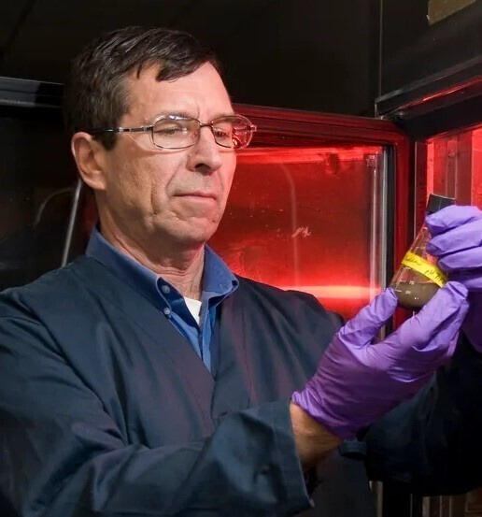
Dr. Brigmon received his BS in Microbiology and PhD in Environmental Engineering from the University of Florida, Gainesville. Dr. Brigmon has over 40 years of research expertise in environmental engineering, bioremediation, nanomaterials for antimicrobial applications, toxicology and microbiology. Currently, as a Senior Fellow Engineer in the Savannah River National Laboratory Advanced and Bio Materials Group Dr. Brigmon oversees several applied research and development projects funded by the US Department of Energy (DOE), US Department of Agriculture, and the National Nuclear Security Agency (NNSA). These projects include monitoring microbial corrosion in high level processing and waste storage facilities, evaluating the effects of tritium on the soil biome and its restoration potential, and the role of microbial biosurfactants in uranium mobility in SRS soils. Dr. Brigmon is a subject matter expert on Legionella pneumophila in cooling towers and currently is responsible for monitoring 20 cooling towers at SRS for this disease-causing microorganism. Dr. Brigmon serves as Chair of the SRS Institutional Biosafety Committee (IBC). He is an Adjunct Professor in the Clemson University Department of Environmental Engineering and Earth Sciences and the University of South Carolina. Dr. Brigmon has over 93 peer reviewed publications, 36 technical reports, and four patents. He currently has international bioremediation project collaborations ongoing in Canada and Colombia. Dr. Brigmon serves as an instructor on weapons of mass destruction (WMD) to US Department of Homeland Security (DHS) Customs and Border Patrol (CBP) and Immigration and Customs Enforcement (ICE), US Department of State (DoS) as well as the US Department of Defense (DOD) and has received letters of commendation for his work. He is an Adjunct Professor in the Clemson University Department of Environmental Engineering and Earth Sciences and the University of South Carolina.

2:30 PM
Friday, October 21, 2022
Rich Laboratory Auditorium
Attendance is mandatory for graduate students enrolled in EES 8610, EES 9610, and GEOL 8610.

