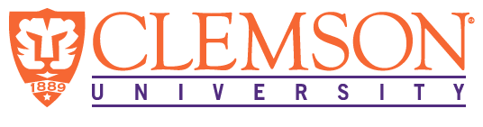
Environmental Engineering
and Earth Sciences
EEES Department Seminar

Finding Value in Your Work

Sudeep Popat
Clemson University

Dr. Popat organizes the departmental seminar series, and occasionally, volunteers fill in an open slot. Usually, this would be a technical talk on topics such as anaerobic digestion and the wonderful world of anaerobic microorganisms and their interactions or using electrode-based reactions to manipulate conditions in wastewater, for example, to recover nutrients from source-separated urine. This time will be a bit different. Instead of a technical talk, this week will be an informal, perhaps philosophical, discussion on finding value in one’s work.

About Dr. Popat:

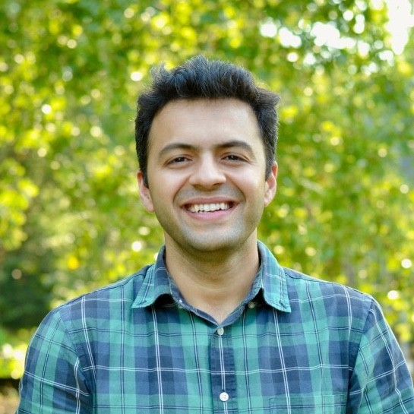
Dr. Sudeep Popat is an Associate Professor in the Department of Environmental Engineering and Earth Sciences at Clemson University. Before coming to Clemson in 2016, he spent six years in the Swette Center for Environmental Biotechnology at the Biodesign Institute of Arizona State University, first as a postdoctoral research associate and then as a research scientist. Dr. Popat has a Ph.D. in Chemical and Environmental Engineering from the University of California, Riverside, and a B.S. in Chemical Engineering from Sardar Patel University, India.

Dr. Popat’s group works on wastewater treatment technologies focusing on resource recovery. Current areas of interest include anaerobic digestion to recover energy from waste organics and electrochemical technologies to recover nutrients from specific wastewater streams. Ongoing projects in Dr. Popat’s lab include work funded by Renewable Water Resources in Greenville, SC, and Gwinnett County Water Resources in Gwinnett County, GA, on anaerobic co-digestion of wastewater sludge with fats, oils, and grease (FOG), wherein the focus is on the understanding of the conversion of long-chain fatty acids under anaerobic conditions. Dr. Popat’s lab also focuses on NASA-funded work on using electrochemical peroxide production for applications such as the stabilization of source-separated urine to enable the recovery of nitrogen and phosphorus.

2:30 PM
Friday, November 11, 2022
Rich Laboratory Auditorium
Attendance is mandatory for graduate students enrolled in EES 8610, EES 9610, and GEOL 8610.

