Environmental Engineering
and Earth Sciences

EEES Department Seminar

In situ observations of the carbon and albedo climate benefits of switchgrass versus loblolly pine bioenergy plantations

Dr. Tom O’Halloran
Forestry & Environmental Conservation
Clemson University

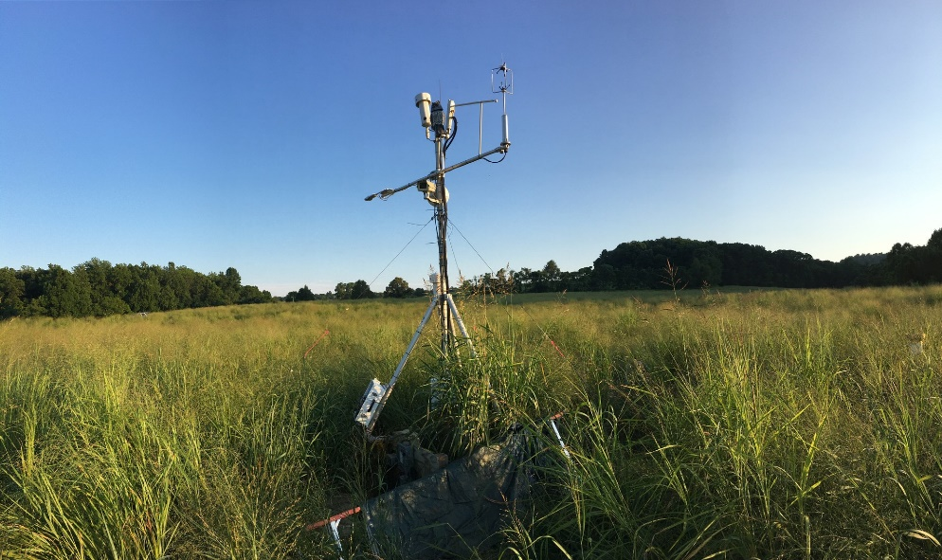
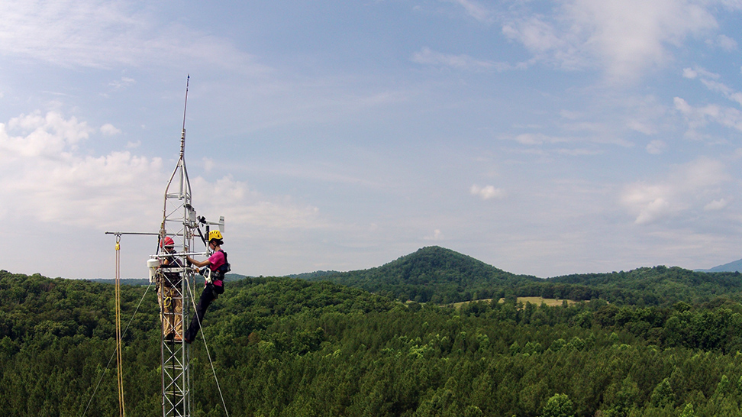
Reducing carbon emissions from fossil fuels by substituting bioenergy has been identified as an important component of climate change mitigation. A fundamental assumption in this strategy is that bioenergy feedstocks are effectively carbon neutral. However very few studies have examined this assumption in only a limited number of feedstocks and in relatively narrow geographies. Here we present results from five years of in situ measurements of landscape scale carbon, water, and energy fluxes in co-located switchgrass (Panicum virgatum) and loblolly pine (Pinus taeda) plantations in central Virginia in order to quantify the atmospheric carbon sequestration performed by each of these bioenergy ecosystems. Since switchgrass is a perennial grass that can be harvested to produce bioenergy each year and loblolly pine is a woody tree species that would normally be harvested after 15+ years, we extrapolated beyond our single site observations with literature values from other sites to compare these ecosystems over a full pine harvest cycle. Since switchgrass and pine also have very different albedo values (solar energy reflectance), we also evaluated the CO₂ equivalence of the albedo radiative forcing that would be created by choosing one of these bioenergy feedstocks over the other. Results indicate that identifying the system with the most climate benefits is highly sensitive to the albedo effect and the fate of harvested carbon.

Dr. Tom O’Halloran is an Assistant Professor at the Baruch Institute of Coastal Ecology and Forest Science in the Department of Forestry and Environmental Conservation at Clemson University in South Carolina. His research examines the effects of ecosystem disturbances and land management on land-atmosphere interactions in the coupled biosphere-climate system. He conducted postdoctoral research at the National Center for Ecological Analysis and Synthesis (NCEAS) in Santa Barbara, CA and in the Department of Forest Ecosystems and Society at Oregon State University. He has B.A., M.S., and Ph.D. degrees from the Department of Environmental Sciences at the University of Virginia. He lives with his wife and two daughters in Pawleys Island, South Carolina.

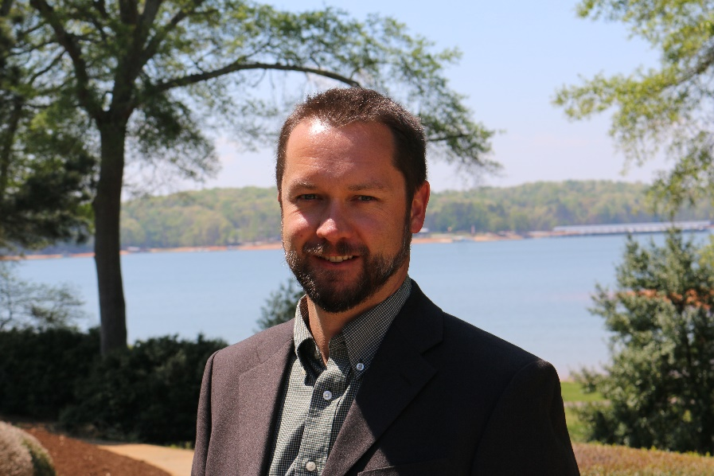

2:30 PM
Friday, November 19, 2021
Rich Lab Auditorium

Also available online via Zoom:
https://clemson.zoom.us/j/5783910968

Attendance is mandatory for graduate students enrolled in EES 8610, EES 9610, and GEOL 8510.

