Environmental Engineering
and Earth Sciences
EEES Department Seminar

Remediation Strategy to Address TCE Contamination

Craig Zeller
Remedial Project Manager
United States Environmental Protection Agency
Atlanta, Georgia

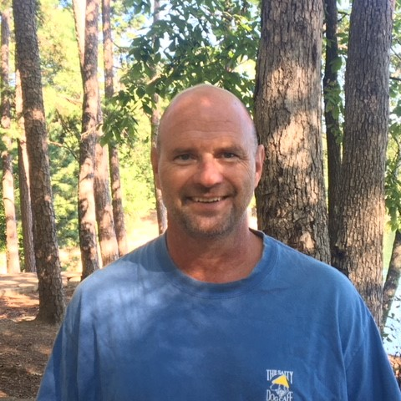
Craig Zeller is a Registered Professional Engineer and has been a Remedial Project Manager in the Superfund Division of the Atlanta Office (Region 4) of the United States Environmental Protection Agency since 1990. His seminar presentation will discuss the remediation strategy employed to address TCE contamination in groundwater at the CTS National Priorities List (NPL) site in Asheville, North Carolina. A combination of Electrical Resistance Heating (ERH) and In-Situ Chemical Oxidation technologies were utilized to destroy TCE in an approximate 3.1-acre plume above the bedrock interface. A total of 9,000,000 kilowatt-hours and 350,000 pounds of Potassium Permanganate were introduced into the subsurface to achieve a 95% reduction in the TCE concentration as measured from pre- to post-treatment.

2:30 PM
Friday, December 9, 2022
Rich Laboratory Auditorium
Attendance is mandatory for graduate students enrolled in EES 8610, EES 9610, and GEOL 8610.

