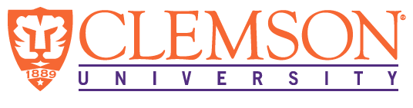
Environmental Engineering
and Earth Sciences
EEES Department Seminar

“expanding the versatility of membrane distillation via materials innovation”

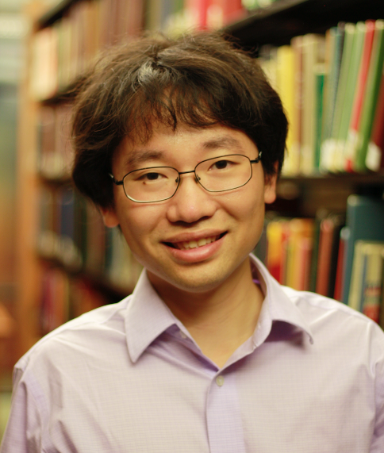

PRESENTED BY
Dr. Shihong Lin
Assistant Professor – Vanderbilt University
Department of Civil and Environmental Engineering
Department of Chemical Biomolecular Engineering

Abstract: Membrane distillation (MD) is an emerging membrane based thermal desalination process utilizing a microporous hydrophobic membrane as the barrier for liquid transfer and the medium for vapor transfer. The distinct advantages of MD include the possibility of harnessing low-grade thermal energy, such as waste heat and geothermal energy, for desalination, and the capability of treating super-saline feed water that reverse osmosis (RO) cannot treat. However, the applications of current MD technology are limited to feed waters that are free of hydrophobic and amphiphilic contaminants because these constituents interact strongly with the hydrophobic membrane and lead to membrane failure by either fouling or wetting. In this presentation, I will discuss two novel and effective strategies to impart wetting resistance and fouling resistance to MD membranes. These approaches leverage on the tremendous progress of materials science in developing interfacial materials with special wetting properties, and highlight the importance of tailoring membrane surface morphology and chemistry. The fabricated MD membranes with robust fouling and wetting resistance can significantly expand the application ranges of MD and may potentially advance MD to the next stage of technology development.
Bio: Dr. Shihong Lin is an assistant professor in the Department of Civil and Environmental Engineering as well as the Department of Chemical and Biomolecular Engineering at Vanderbilt University. Dr. Lin grew up in China and received his bachelor degree from Harbin Institute of Technology in 2006, and his M.S and Ph.D. from Duke University in 2011 and 2012, respectively. He worked with Prof. Mark R. Wiesner for his doctoral dissertation on the topic of nanoparticle deposition. After finishing graduate school, Dr. Lin spent two years at Yale University working with Prof. Menachem Elimelech who introduced him to the area of membrane processes. He then joined Vanderbilt University as an assistant professor in 2015.Throughout his education and professional training, Dr. Lin has developed a strong and coherent interest in physiochemical processes in environmental engineering which has now evolve to include (1) membrane processes at water-energy-environment nexus, (2) environmental surface science, and (3) environmental application and implication of nanotechnology. Dr. Lin is the recipient of the ACS Environmental Chemistry Graduate Student award in 2013.

2:30 PM
Friday, March 11, 2016 - 201 Kinard Hall
Refreshments following Seminar

